**Data Analysis on Post-HCT (Hematopoietic Cell Transplantation) Outcomes among Sickle Cell Disease Patients**

BIS687: Data Science Capstone

Team Number: 2

Group Member:

Wanjing Chen

Yi Li

Bo Zhang

Scott (Sizhe) Zuo

Date: May.1.2024

**Project Summary**

This project aims to leverage the comprehensive research database established by the Center for International Blood and Marrow Transplant Research® (CIBMTR) for hematopoietic cell transplantation (HCT) in 2021 to identify features that affect survival performance regarding clinical outcomes of HCT for sickle cell disease (SCD) patients. The project is divided into three specific aims: an exploratory analysis of enrolled patients to understand demographic and clinical characteristics, a survival analysis focusing on the time from HCT to eight different endpoints, and the development of an R Shiny application for dynamic and interactive visualization of study results. This initiative seeks to enhance understanding of post-HCT outcomes, identify factors influencing survival post-transplant, and facilitate data accessibility for clinicians and researchers alike, ultimately contributing to improved patient care and outcomes in the field of cellular therapies.

**Project Narrative**

Sickle cell disease (SCD) is a group of inherited red blood cell disorders affecting millions of people throughout the world. In someone with Sickle Cell Disease (SCD), their red blood cells contain abnormal hemoglobin, causing them to become misshapen, resembling a sickle. These cells die prematurely, constantly decreasing the body’s red blood cell count. They can also block blood flow in small vessels, triggering pain, and severe complications like infections, acute chest syndrome, and stroke. Despite a variety of strategies including supportive care, drug therapies, and red blood cell transfusions are able to potentially alleviate symptoms and extend lifespan of SGD patients, allogeneic hematopoietic cell transplantation (HCT) is the only established potential cure for SCD. Nevertheless, post- HCT SCD patients continue to face severe health challenges because HCT is associated with life-threatening complications most of which occur within the first 2 years after transplantation such as graft-versus-host disease (GVHD) and mortality. However, there is limited study on exploring features of post-HCT SGD patients that affect the outcomes for time to significant endpoints including last contact or death, graft failure, neutrophil engraftment, platelet recovery, acute and chronic graft-vs-host disease (GVHD), post-transplant lymphoproliferative disorder (PTLD), and second malignancy. Moreover, no standardized data analysis platforms have been established for clinical investigators to efficiently interact with and generate insight from the database of post-HCT SCD patients.

**Specific Aims**

**A. Exploratory Data Analysis** **of Enrolled Patients**

We performed exploratory analyses on variables included in the datasets to obtain an overview of the baseline characteristics of patients who received HCT and explore the features that are potentially associated with the survival outcomes of the patients. Specifically, the dataset categorizes the variables into 3 categories: disease-related, patient-related, and transplant-related. By summarizing information on variables in the dataset, we are able to learn the distribution of baseline variables that could facilitate further processing of the data, and provide initial insights on identifying important predictors contributing to predicting the clinical outcomes of patients.

**B. Survival Analysis**

We performed a survival analysis to assess the time from HCT to 8 endpoints, including last contact or death, graft failure, neutrophil engraftment, platelet recovery, acute and chronic graft-vs-host disease (GVHD), post-transplant lymphoproliferative disorder (PTLD), and second malignancy. These analyses help identify key predictors of survival outcomes which serve as potential factors that could enhance the quality of care for patients undergoing HCT treatment.

**C. Shiny App Development for Results Visualization**

Finally, an R Shiny application was developed to not only make findings interactive and accessible for clinical investigators but also serve as a standardized platform to generate results accordingly with a more updated database in the future. This interactive tool allows users to explore the data dynamically, visualize survival curves, compare outcomes across different patient groups, and potentially identify new areas for research or intervention. The R Shiny application is considered as a crucial tool designed to visualize and interpret complex datasets to enhance the understanding and management of Sickle Cell Disease (SCD) post-hematopoietic cell transplantation (HCT).

**Research Strategy**

**A. Significance**

Recognizing the significance of HCT as the only established treatment of SGD and the post-HCT potential health obstacles, our team aims to explore crucial patient-related, disease-related, and transplant-related factors contributing to clinical outcomes after HCT among SGD patients by utilizing the database from Center for International Blood and Marrow Transplant Research (CIBMTR) in 2021. The project initiative is to specify the granularity for both evaluating success and subsequent health threats post-HCT and assist clinical professionals with the decision on establishing a more comprehensive treatment plan for SGD patients by taking key patient-related, disease-related, and transplant-related features into consideration.

**B. Innovation**

1. **Analysis Innovation**

For the survival analysis of this project, the targeted time-to-events include not only outcomes with implications of HCT failure such as “time to GVHD” and “time to PTLD(Post-transplant lymphoproliferative diseases)” but also implications of HCT success such as “time to neutrophil engraftment” and “time to platelet recovery”. In this way, we are able to have a more comprehensive understanding to assess the HCT performance for SGD patients.

1. **Technology Innovation**

In this project, we plan to create a standardized and interactive visualization platform to illustrate the analysis results via an R shiny web application. Besides the ease of exploring and engaging with research outcomes, we also recognize the advantage of an R shiny web application to serve as a standardized tool for assisting future researchers to expand upon this project by feeding more recent data to this platform and obtaining more updated results.

**C. Data Pre-processing**

After comparing the dataset from 2020 to 2021, our team has decided to focus on the dataset from 2021 due to its enhanced data completeness and inclusiveness of the dataset from 2020. To ensure the quality of analysis, columns for variables excluding outcomes with over 20% missing data were removed. In addition, variables with unchanging values were disregarded and rows with any missing data were excluded and resulted in the removal of most patients who received the transplant before 2008. In the end, we have the following numbers of variables in addition to patient ID (*see Appendix - Section A, Table 1-3*):

1. 11 patient-related variables
2. 1 disease-related variable
3. 10 transplant-related variables
4. 8 time-to-event variables/endpoints
5. 14 categorical variables related to time-to-event variables

**D. Specific Aim 1: Exploratory Analysis of Enrolled Patients**

1. Hypothesis

The exploratory data analysis aims to characterize the distribution of baseline variables and to initially assess associations between the distribution of baseline characteristics and the occurrence of clinical endpoint events.

1. Rationale

Conducting exploratory analyses allows us to understand the structure and the pattern in the data, and thus facilitates the process of identification of potentially unbalanced variables and the decision whether to keep these variables in downstream analyses. By testing associations between outcome variables and response variables, we could gain initial insights into characteristics that might be clinically relevant in HCT patients.

1. Experimental Approach

In this aim, we primarily focused on categorical variables which entirely cover the information provided in our dataset. Specifically, for each categorical variable, we calculated the count and proportion of each value level. For continuous variables, we calculated the mean and standard deviation. We then examined the association between occurrence of clinical endpoints and explanatory variables by either Fisher’s test or Pearson’s Chi-squared test if the counts of all cells in the 2-way table were greater than 5 .

Summary tables were created by processing the data with R packages dplyr and tidyr and presented with the package gt. When examining associations between explanatory variables and outcome variables, we implemented Pearson’s Chi-squared test by the R function chisq.test and Fisher test by the R function fisher.test.

**E. Specific Aim 2: Survival Analysis**

1. Hypothesis

The time from hematopoietic cell transplantation (HCT) to various clinical endpoints (last contact or death, graft failure, neutrophil engraftment, platelet recovery, acute and chronic graft-vs-host disease (GVHD), post-transplant lymphoproliferative disorder (PTLD), and second malignancy) significantly differ among patient groups defined by specific demographic and clinical characteristics.

1. Rationale

Understanding the time to key post-HCT outcomes is crucial for several reasons. First of all it enables the prediction of patient prognosis by providing estimates on when significant post-transplant events might occur, thus informing both patients and clinicians about possible recovery paths and any potential complications that could arise. Besides, insights gained from analyzing the timing of events such as graft-versus-host disease (GVHD) are instrumental in guiding clinical decisions.Last but not least, by identifying the factors that influence the speed of recovery or the occurrence delayed complications, adjustments can be made to the transplant process itself.

1. Experimental Approach

Cox Proportional Hazards (CoxPH) Model: To adjust for potential confounders and assess the impact of various predictors on the time to each endpoint, CoxPH models were fitted. A test of the proportional hazard assumption was conducted based on stratified survival plots. Variables included patient demographics, disease characteristics, transplant-related factors, and pre-transplant comorbidities.

Kaplan-Meier (KM) Survival Curves: For each of the eight endpoints, KM survival curves were generated to visualize the unadjusted probability of reaching each endpoint over time post-HCT.

**F. Specific Aim 3: R Shiny App Development for Results Visualization**

1. Hypothesis

This application serves as an interactive platform for clinicians, researchers, and policy-makers, enabling them to dynamically explore and analyze the wealth of patient-related, disease-related, and transplant-related variables and their impact on post-HCT outcomes.

1. Rationale

The rationale behind this application is twofold. Firstly, given the complexity and multi-dimensionality of the data, traditional static methods of data presentation are insufficient for capturing the nuanced relationships between variables such as age, ethnicity, disease genotype, transplant type, and conditioning regimen. An interactive tool will allow for a more comprehensive and tailored exploration of these variables, fostering a deeper understanding of their interplay and impact on patient outcomes. Secondly, this application aims to democratize data access, allowing users to generate custom analyses and visualizations that can inform clinical decision-making and policy development.

1. Experimental Approach

The app was implemented using R Shiny, leveraging its capabilities for creating interactive, web-based data visualizations. Key features include the ability to filter and stratify data based on specific variables like age group, disease genotype, or transplant type, and visualize these in the form of survival curves and bar charts. For instance, users could compare survival outcomes between different age groups or analyze the impact of donor-recipient HLA matching on post-transplant complications. This approach enables users to interact with the data, providing immediate visual feedback and insights.

**Results & Interpretations**

**A. Specific Aim 1: Exploratory Analysis of Enrolled Patients**

1. Categorical Patient-Related Explanatory Variables (*See Appendix - Section B, Table 4*)

Predominantly, over 90% of the patients are identified as non-Hispanic or non-Latino, and a similar proportion applies to African Americans, representing the racial distribution. These skewed demographics may influence disease outcomes and the generalizability of our results. Additionally, more than 80% of the SCD patients exhibited high Karnofsky/Lansky scores, indicating minor or no restrictions with strenuous physical activity at the time of HCT. This suggests that a large segment of our patient population was in relatively good physical condition prior to undergoing transplantation. However, concerning the HCT comorbidity index, approximately 35% of patients had a score higher than 3, which is associated with poorer HCT performance, indicating that a significant portion of the cohort had less favorable prognostic expectations for clinical outcomes post-transplant.

1. Categorical Transplant-Related Explanatory Variables (*See Appendix - Section B, Table 5*)

Approximately 60% of the patients received transplants from HLA identical siblings, suggesting a preference or greater accessibility for this donor type. Regarding the type of graft used, bone marrow was the predominant choice, used in 70% of the cases.

In terms of conditioning intensity, the patients were equally divided with half receiving myeloablative conditioning, which is more intense and aims at completely eradicating the patient's bone marrow before the transplant, and the other half split between reduced-intensity and non-myeloablative conditioning.

Furthermore, donor-recipient HLA matching shows a high level of compatibility, with over 70% of the patients achieving the full score of compatibility (0 to 8 mismatches), which is indicative of careful donor selection and matching processes.

1. Categorical Disease-Related Explanatory Variable (*See Appendix - Section B, Table 6*)

In this dataset, disease genotype is the only variable that fulfills this category. Significant imbalance is identified for this variable with hemoglobin SS taking up 96% and hemoglobin S-beta-thalassemia taking up 4% among the patients.

1. Continuous Patient-Related Explanatory Variable (*See Appendix - Section B, Table 7*)

In this dataset, age is the only variable that fulfills this category. Over 90% of the patients at transplant were less than 30 years old, which were relatively young. The average age at transplant is 14.52 with 10.26 as the standard deviation.

1. Categorical Outcome-related Variables (*See Appendix - Section B, Table 9*)

Among patients in this dataset, the overall death rate is 6.45% which is extremely low. Meanwhile, for subcategories within death which focus on death outcomes with reason exclusions, death without neutrophil engraftment has the lowest event rate while death without graft-failure has the highest event rate. Furthermore, the results of the subcategories within death imply that there are overlaps for reason exclusions.

For the two positive outcomes including neutrophil engraftment and platelet recovery, both event rates are extremely high with at least 95 percent. Whereas for the 6 negative outcomes, the event rates are relatively low ranging from less than 1% to approximately 20 percent. Considering the high event rates for positive outcomes and low event rate for negative outcomes, the results are fairly consistent.

1. Continuous Outcome Variables (Time to Endpoints) (*See Appendix - Section B, Table 8*)

For the 8 target time to events, on average, the two positive events occur extremely early around 1 month after HCT. On the other hand, negative events occur around 3 years after HCT.

*Note:*

*For specific distribution plots, please refer to (See Appendix - Section B, Plot 1-43)*

**B. Specific Aim 2: Survival Analysis**

**Table A: Features Selected by Cox Hazard Models with LASSO for 8 Endpoints (Y: Selected)**

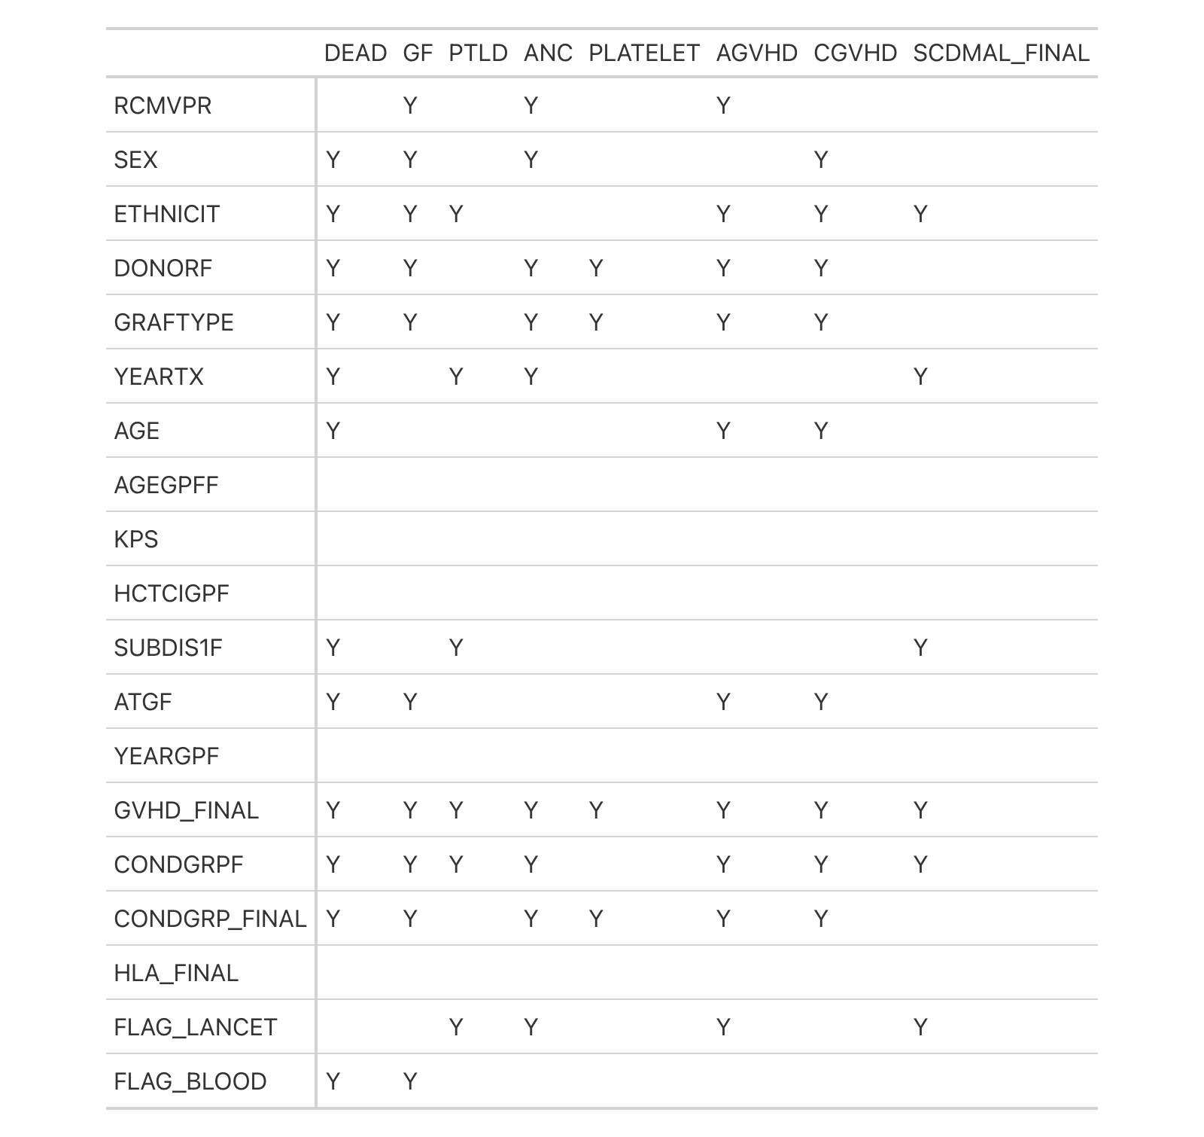

*Note: For variable definitions, please refer to (Appendix - Section A, Table 1-2).*

Based on the summary table on selected features within each of the endpoints by the Cox hazard model with LASSO feature selection, transplant-related variables have the most significant role in terms of the survival performance regarding the clinical outcomes. Specifically, GVHD prophylaxis is identified as a crucial feature for all of the 8 endpoints; conditional intensity is selected by 7 out of 8 models; conditioning regimen, donor type, and graft type are present as important features for 6 out of 8 models; if ATG or Alemtuzumab was given as conditioning regimen or GVHD prophylaxis is identified as an important feature in 4 out of 8 models; recipient CMV serostatus is selected by 3 out of 8 models. On the other hand, patent-related features are likely to have a moderate contribution to the Cox hazard models of the 8 endpoints. Specifically speaking, ethnicity is present in 6 out of 8 features and sex is selected as a crucial feature for 4 Cox hazard models. Furthermore, the disease genotype of a disease-related feature is selected by 3 out of the 8 times to outcomes, highlighting the contribution of a disease-related feature to clinical outcomes as well.

Intriguingly, opposite contributions of features on positive and negative outcomes are identified, which further implies consistency regarding the impact of features on clinical outcomes. For example, mismatched unrelated donor and cord blood as a specific donor type has a positive contribution with a coefficient estimation of 0.41 for time to chronic GVHD while it has a negative contribution with a coefficient estimation of -0.29 for time to platelet recovery. In addition, umbilical cord blood as a specific GVHD type has a negative contribution with a coefficient estimation of -0.56 for time to neutrophil engraftment while it has a positive contribution with a coefficient estimation of 0.2 for time to acute GVHD.

*Note:*

*For tables on coefficient estimation for selected features by 8 target endpoints, please refer to (See Appendix - Section C, Table 10-17)*

*For Survival plots, please refer to the “Survival Plots” tab of the R shiny application addressed in aim 3.*

**C. Specific Aim 3: R Shiny App Development for Results Visualization**

The Shiny app (link: https://github.com/annieliyi/bis687.2024/tree/master/aim3/app.R) was developed to serve as a dynamic exploration tool, seamlessly integrating the insights garnered from the first two aims. It enables users to interactively visualize and interrogate the rich dataset, drawing connections between patient demographics, transplant characteristics, and survival outcomes. Through the app, clinicians and researchers can manipulate the variables, filter the cohort, and instantly observe the effects on survival curves and other pertinent visualizations. Beyond visualizing results, the app is a springboard for hypothesis generation. It provides a sandbox for researchers to test conjectures about variable interplay and to discover novel patterns within the data. This empowers users to formulate new research questions and hypotheses directly from the interactive summaries and plots, potentially leading to breakthroughs in patient management and treatment strategies post-transplant.

Below is a succinct summary of the app functionality:

1. Tab - Variable Distribution Plots

This tab serves as a primary gateway for visual data interaction, where users can select a dataset and a variable to view its distribution. The resulting plots provide immediate visual feedback, facilitating a deeper understanding of individual variable characteristics within the patient cohort.

1. Tab - Variable Descriptions

A detailed tabular view lists all variables along with their descriptions, serving as a reference point to assist users in interpreting the variables used in analyses throughout the app.

1. Tab - Outcome and Categorical Variables Summaries

These tabs present comprehensive summaries of patient and transplant-related variables. They showcase the distribution of categorical factors such as race and donor type, as well as outcome variables, providing a snapshot of the cohort's demographic and clinical profile.

1. Tab - Event Coefficients & Event Features Summary

Offering a deeper dive into survival analysis, these tabs display the results of Cox proportional hazards modeling. Users can explore the influence of various features on survival outcomes, identifying which factors bear the most significant impact.

1. Tab - Survival Plots

A pivotal tab for the application, it provides stratified Kaplan-Meier survival plots that adhere to the proportional hazards assumption. As illustrated in the accompanying screenshot, users can select events and features to produce stratified survival curves, such as those comparing different graft types (*See Appendix - Section D, Illustration A*). This visualization aids in understanding how specific treatments and patient conditions influence survival probability over time.

For a hands-on exploration of additional survival plots and to understand how different variables interact to affect patient outcomes post-HCT, users are encouraged to navigate to the last tab of the app. Instructions within the app will guide users on utilizing inputs effectively to generate customized visual analyses tailored to their research questions.

**Conclusion**

In our study on post-hematopoietic cell transplantation (HCT) outcomes for sickle cell disease (SCD) patients, we conducted a comprehensive three-aim analysis that provided insightful conclusions. Aim 1 involved an exploratory analysis, revealing that while the distribution of positive outcomes like platelet recovery and neutrophil engraftment was high (>95%), negative outcomes such as graft failure occurred at a much lower rate (5%-20%). Notably, positive events typically occurred within one-month post-transplant, whereas negative events surfaced around three years later. The majority of patients at the time of transplant were younger than 30 years, with an average age of 14.52 years (SD: 10.26), indicating a relatively young cohort at high risk.

Aim 2 focused on survival analysis, identifying donor type, graft type, GVHD prophylaxis, conditioning regimen, and conditioning intensity as crucial variables. These factors were consistently highlighted in models for at least six outcomes based on LASSO feature selection, corroborating our findings from Fisher and Chi-squared tests in Aim 1. This alignment emphasizes the significant role of these variables and therefore transplant-related variables in influencing post-HCT outcomes.

Lastly, Aim 3 assessed tool standardization, where we utilized an R Shiny web application. This tool proved to be an effective means for users to interact with and visualize data, thereby enhancing the understanding and generation of insights regarding post-HCT outcomes for SCD patients. This comprehensive approach not only advances our understanding of the factors that influence post-transplant success but also provides a robust framework for future research and clinical application in this field.

**Limitations**

In our study, several limitations were identified that may affect the interpretation of the findings. First, data from before 2008 were irretrievably lost, and notably, this period includes over 300 patients who underwent hematopoietic cell transplantation (HCT), creating a gap in the historical data. Meanwhile, data imbalance is identified for all outcome variables and most of the explanatory variables. Additionally, the proportional hazard assumptions underpinning the Cox hazard model may over-rely on stratified survival plots, which were informed by features selected via the LASSO method. Hence, we suggest potential improvements like employing log-negative log survival plots and Schoenfeld residuals to further check the proportional hazard assumption. Furthermore, the format of our data visualization tool was identified as a limitation; it lacks detailed, user-friendly elements such as clear definitions of variables and a comprehensive user guide, which could hinder the accessibility and usability of the data presented.

**Future Work**

In the future, we aim to address the identified limitations of our current study and expand the scope of our research. A key focus will be the integration of advanced machine learning models to enhance our analysis and predictive capabilities. Specifically, we plan to incorporate survival random forest models, which can relax the stringent assumptions required by the Cox model. Additionally, we intend to explore the use of neural networks for prediction of outcomes, capitalizing on their ability to model complex non-linear relationships.

To facilitate the application of our project by other researchers and ensure its relevance with evolving data landscapes, we will develop a comprehensive guide. This guide will instruct users on how to effectively employ our methodologies and tools on the most updated datasets. By providing clear protocols and support, we hope to make our project a valuable resource for the broader research community, fostering further innovation and discovery in the field.

**Appendix**

Section A:

Table 1: List of Predictors

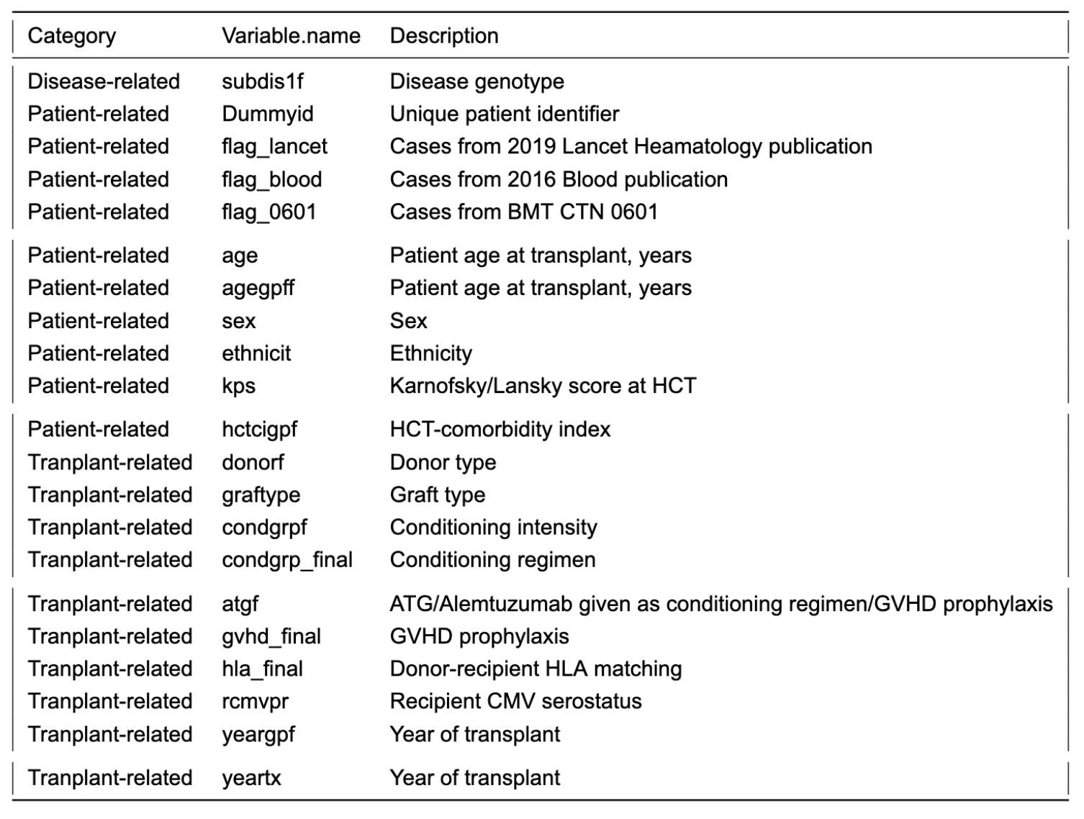

Table 2: List of Time-to-Event Variables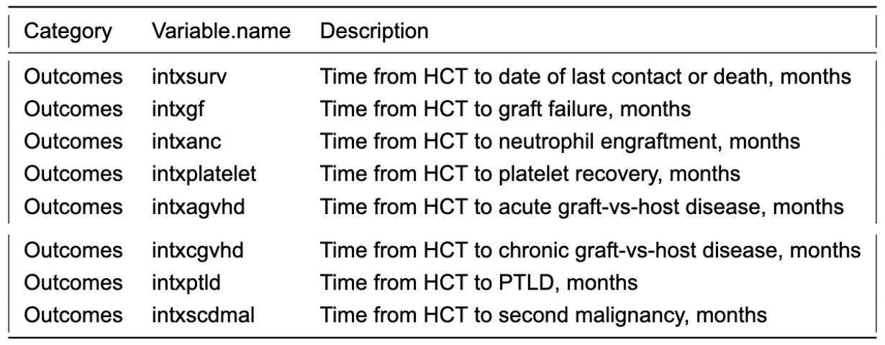

Table 3: List of Categorical Outcome Variables

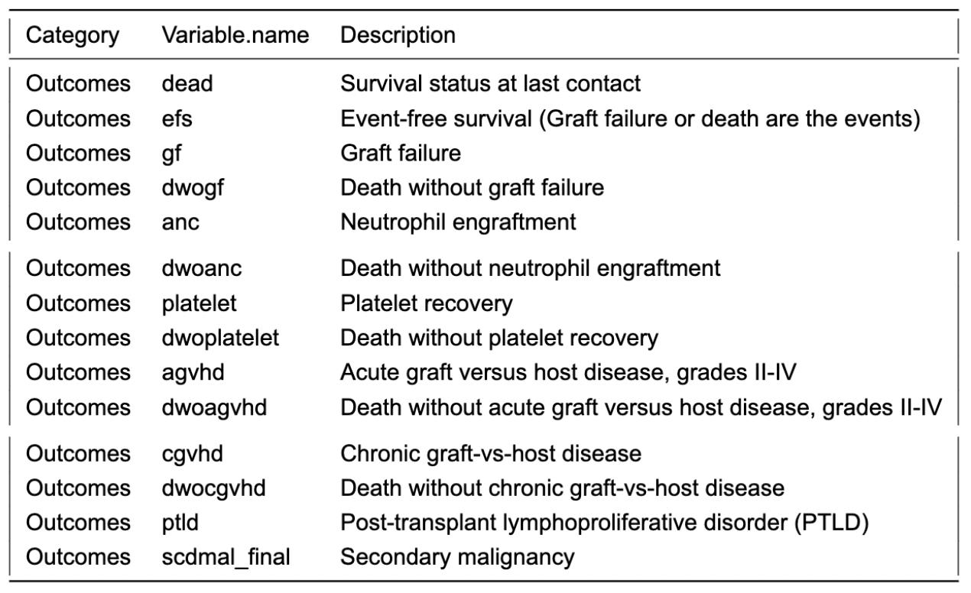

Section B:

Table 4:Patient-Related Categorical Variables Summary Table 5:Transplant-Related Categorical Variable Summary

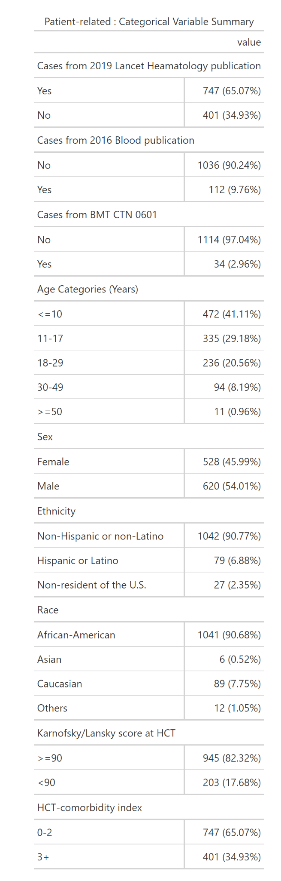 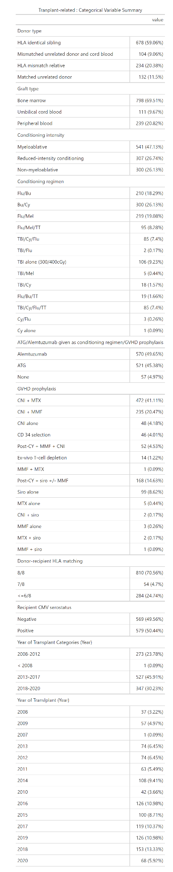

Table 6: Disease-Related Categorical Variable Summary

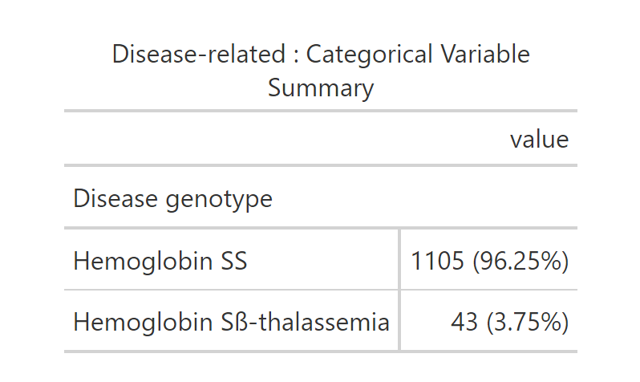

Table 7: Patient-Related Continuous Variable Summary

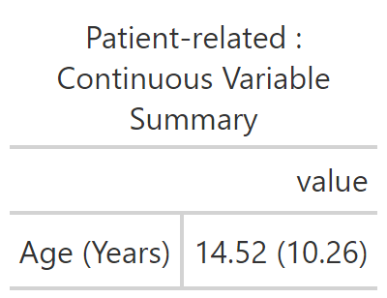

Table 8: Outcome-Related Continuous Variables Summary

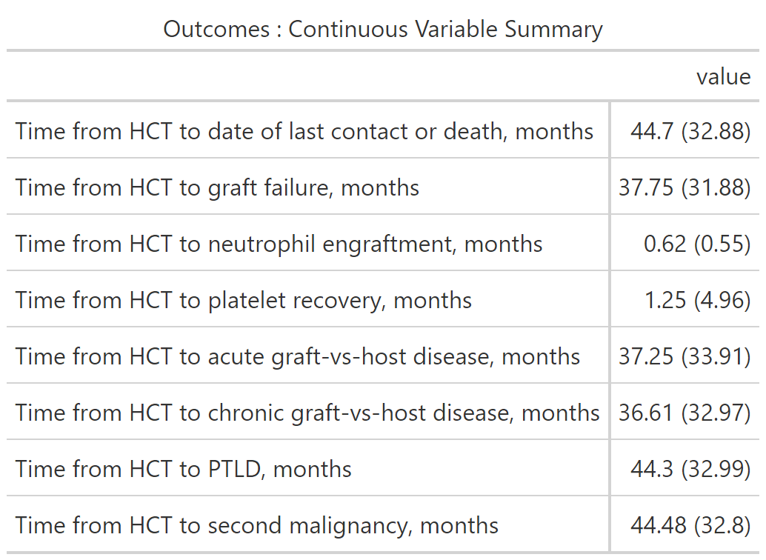

Table 9: Outcome-Related Categorical Variables Summary

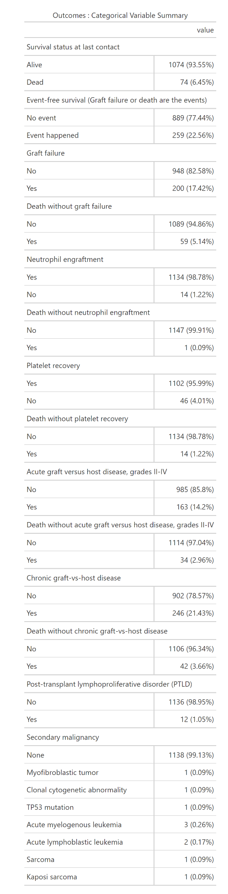

Plot 1: Distribution of Age

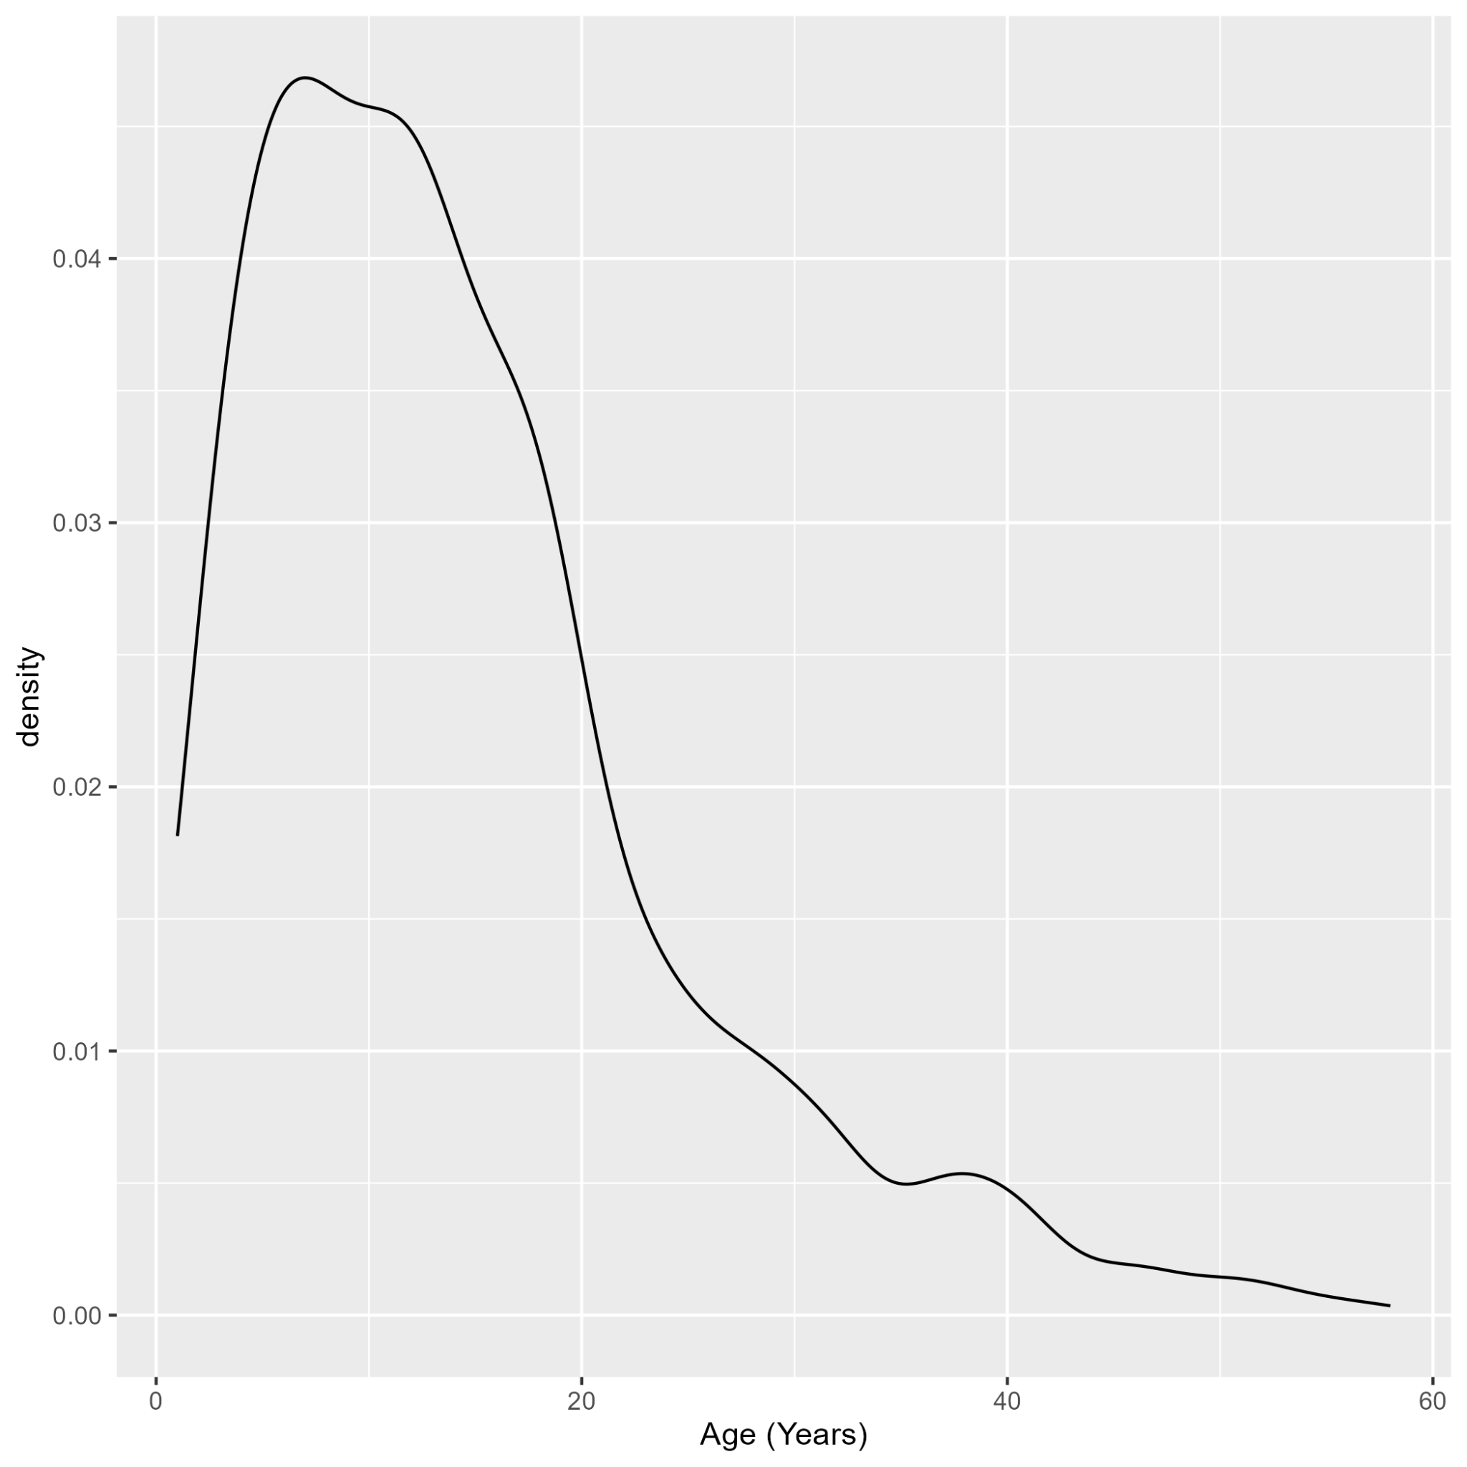

Plot 2: Distribution of Time from HCT to Acute GVHD

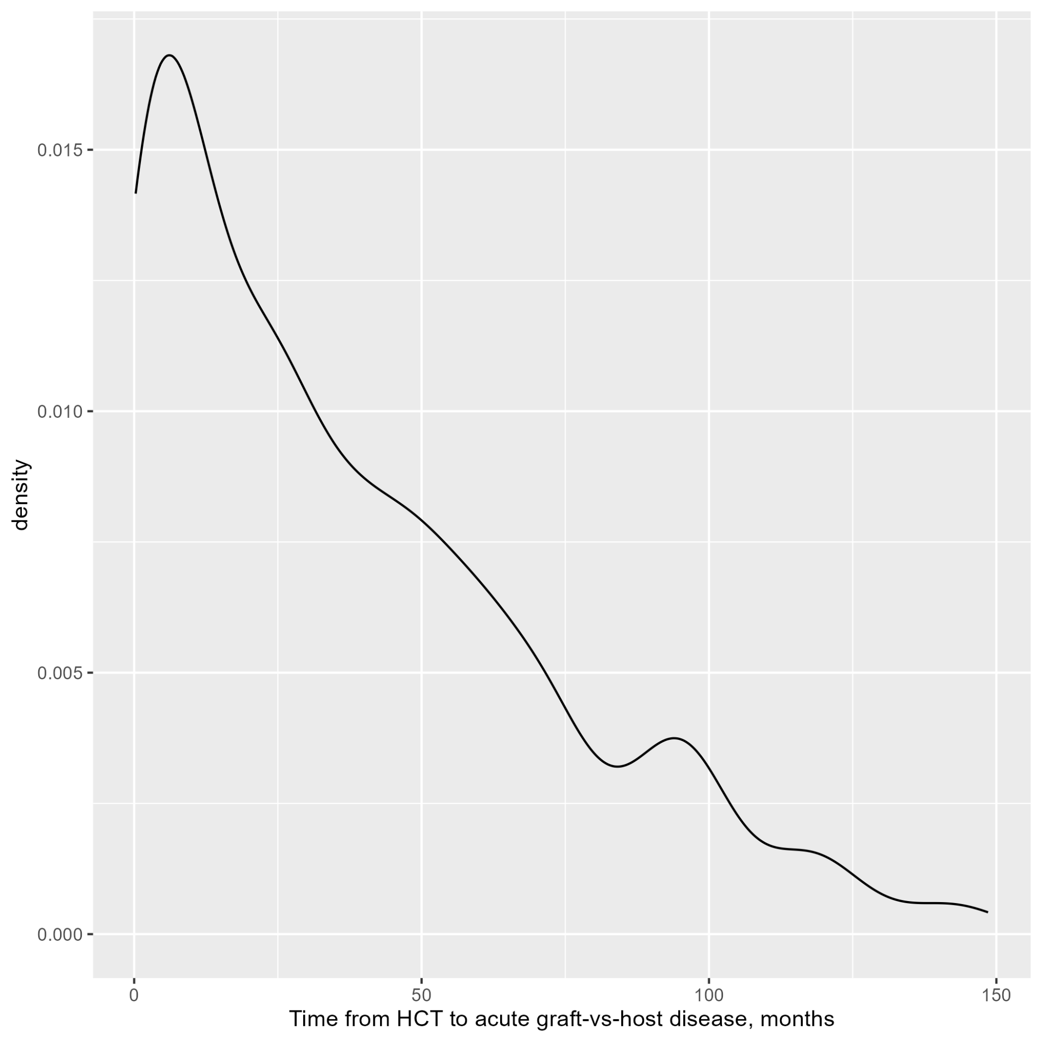

Plot 3: Distribution of Time from HCT to Neutrophil Engraftment

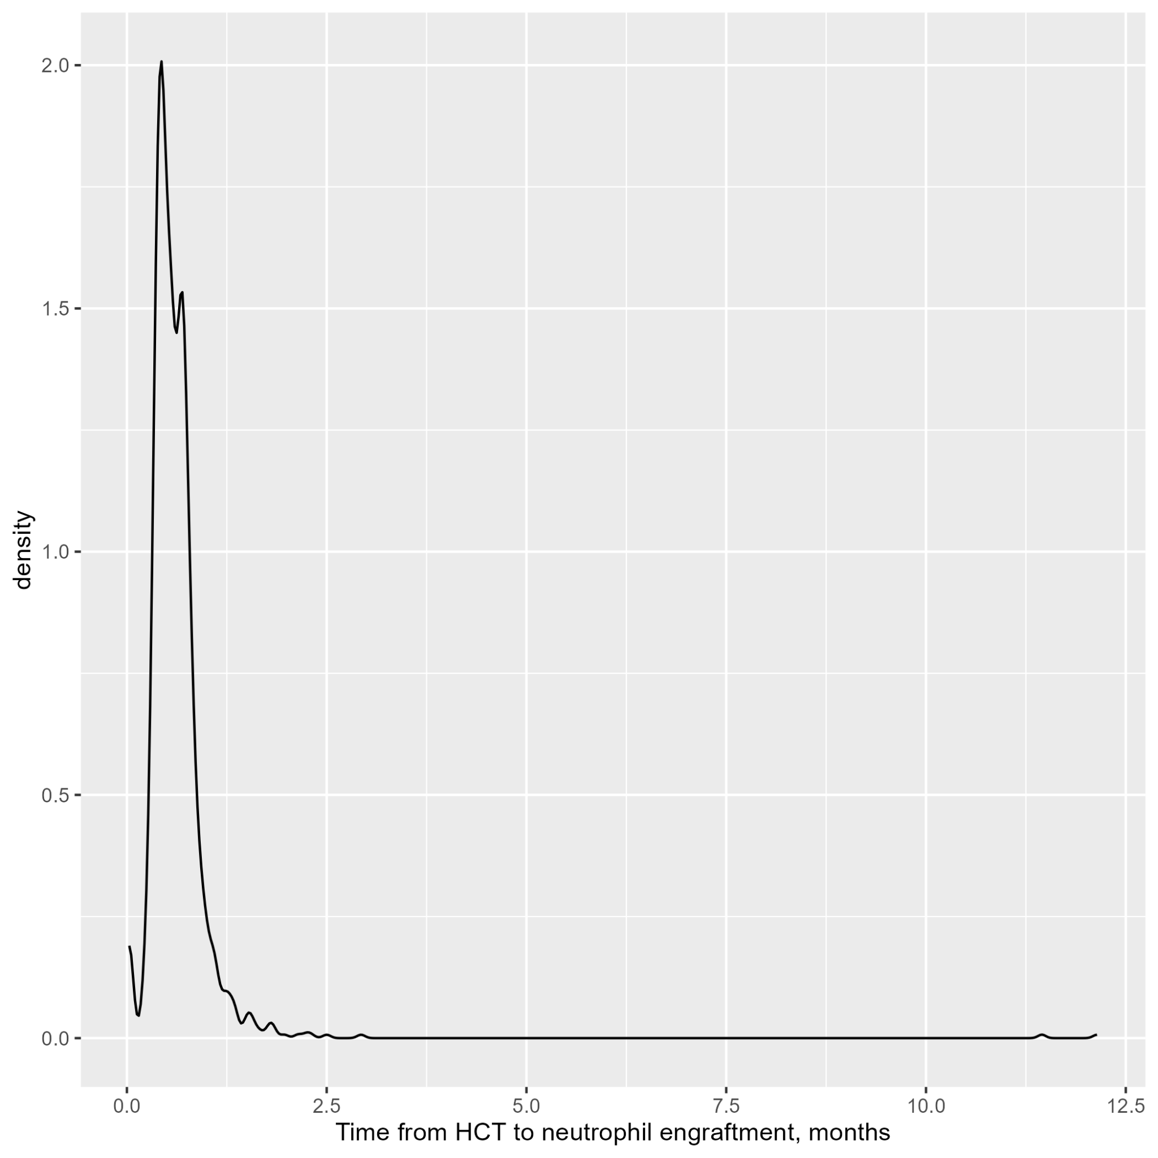

Plot 4: Distribution of Time from HCT to Chronic GVHD

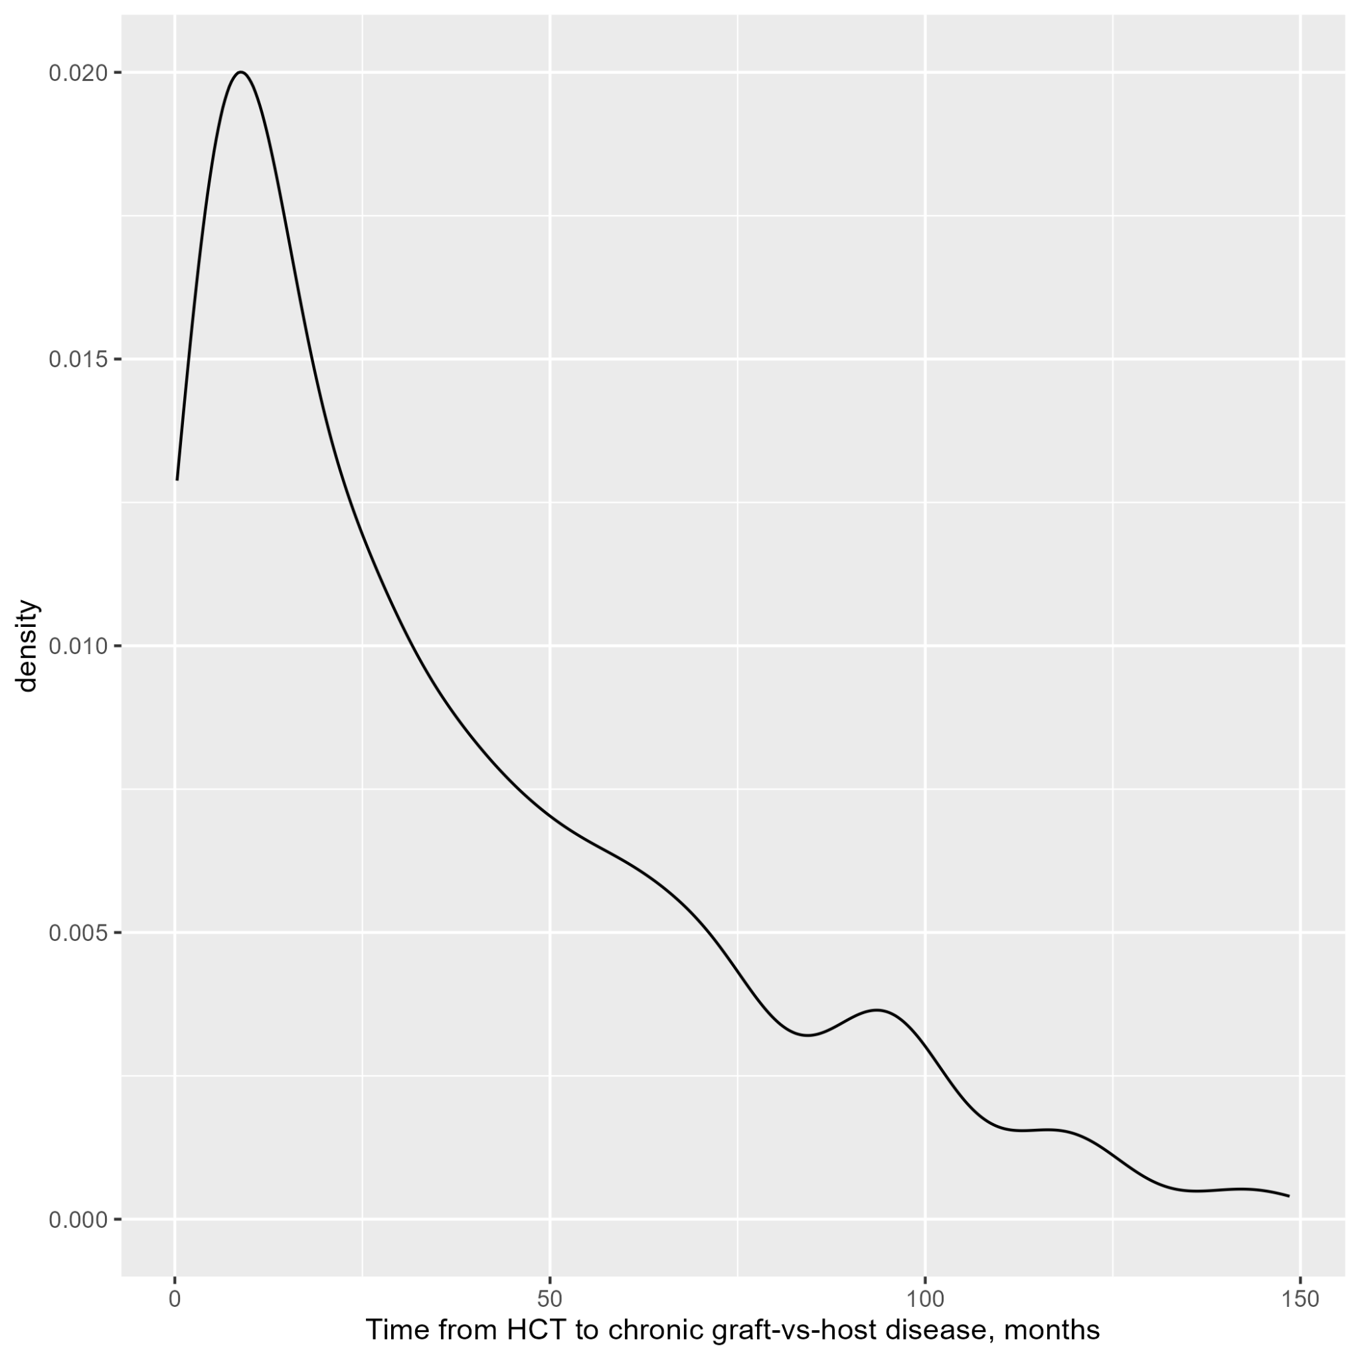

Plot 5: Distribution of Time from HCT to Graft Failure

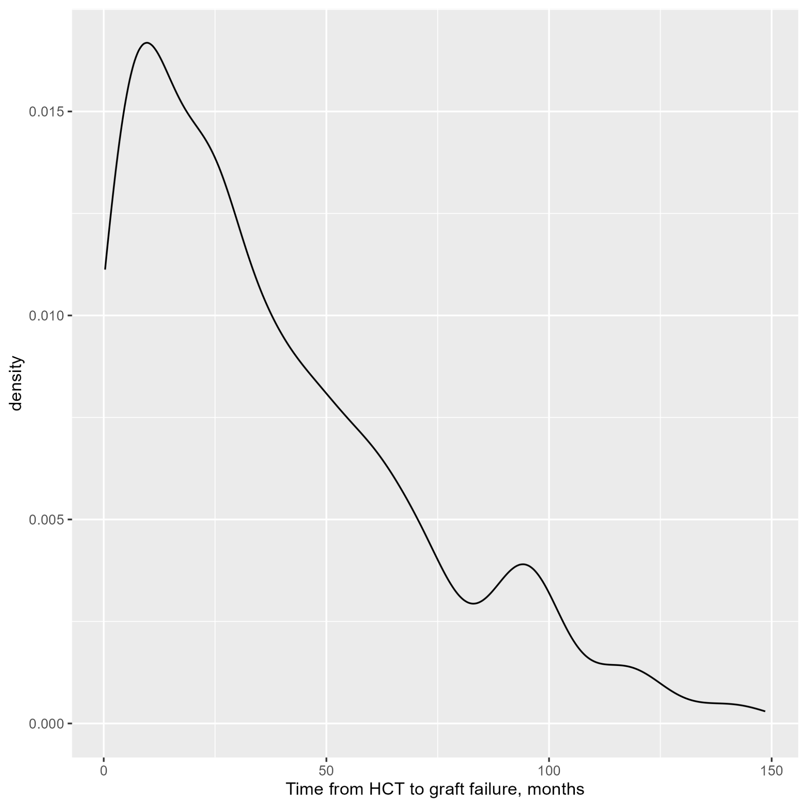

Plot 6: Distribution of time from HCT to Platelet Recovery

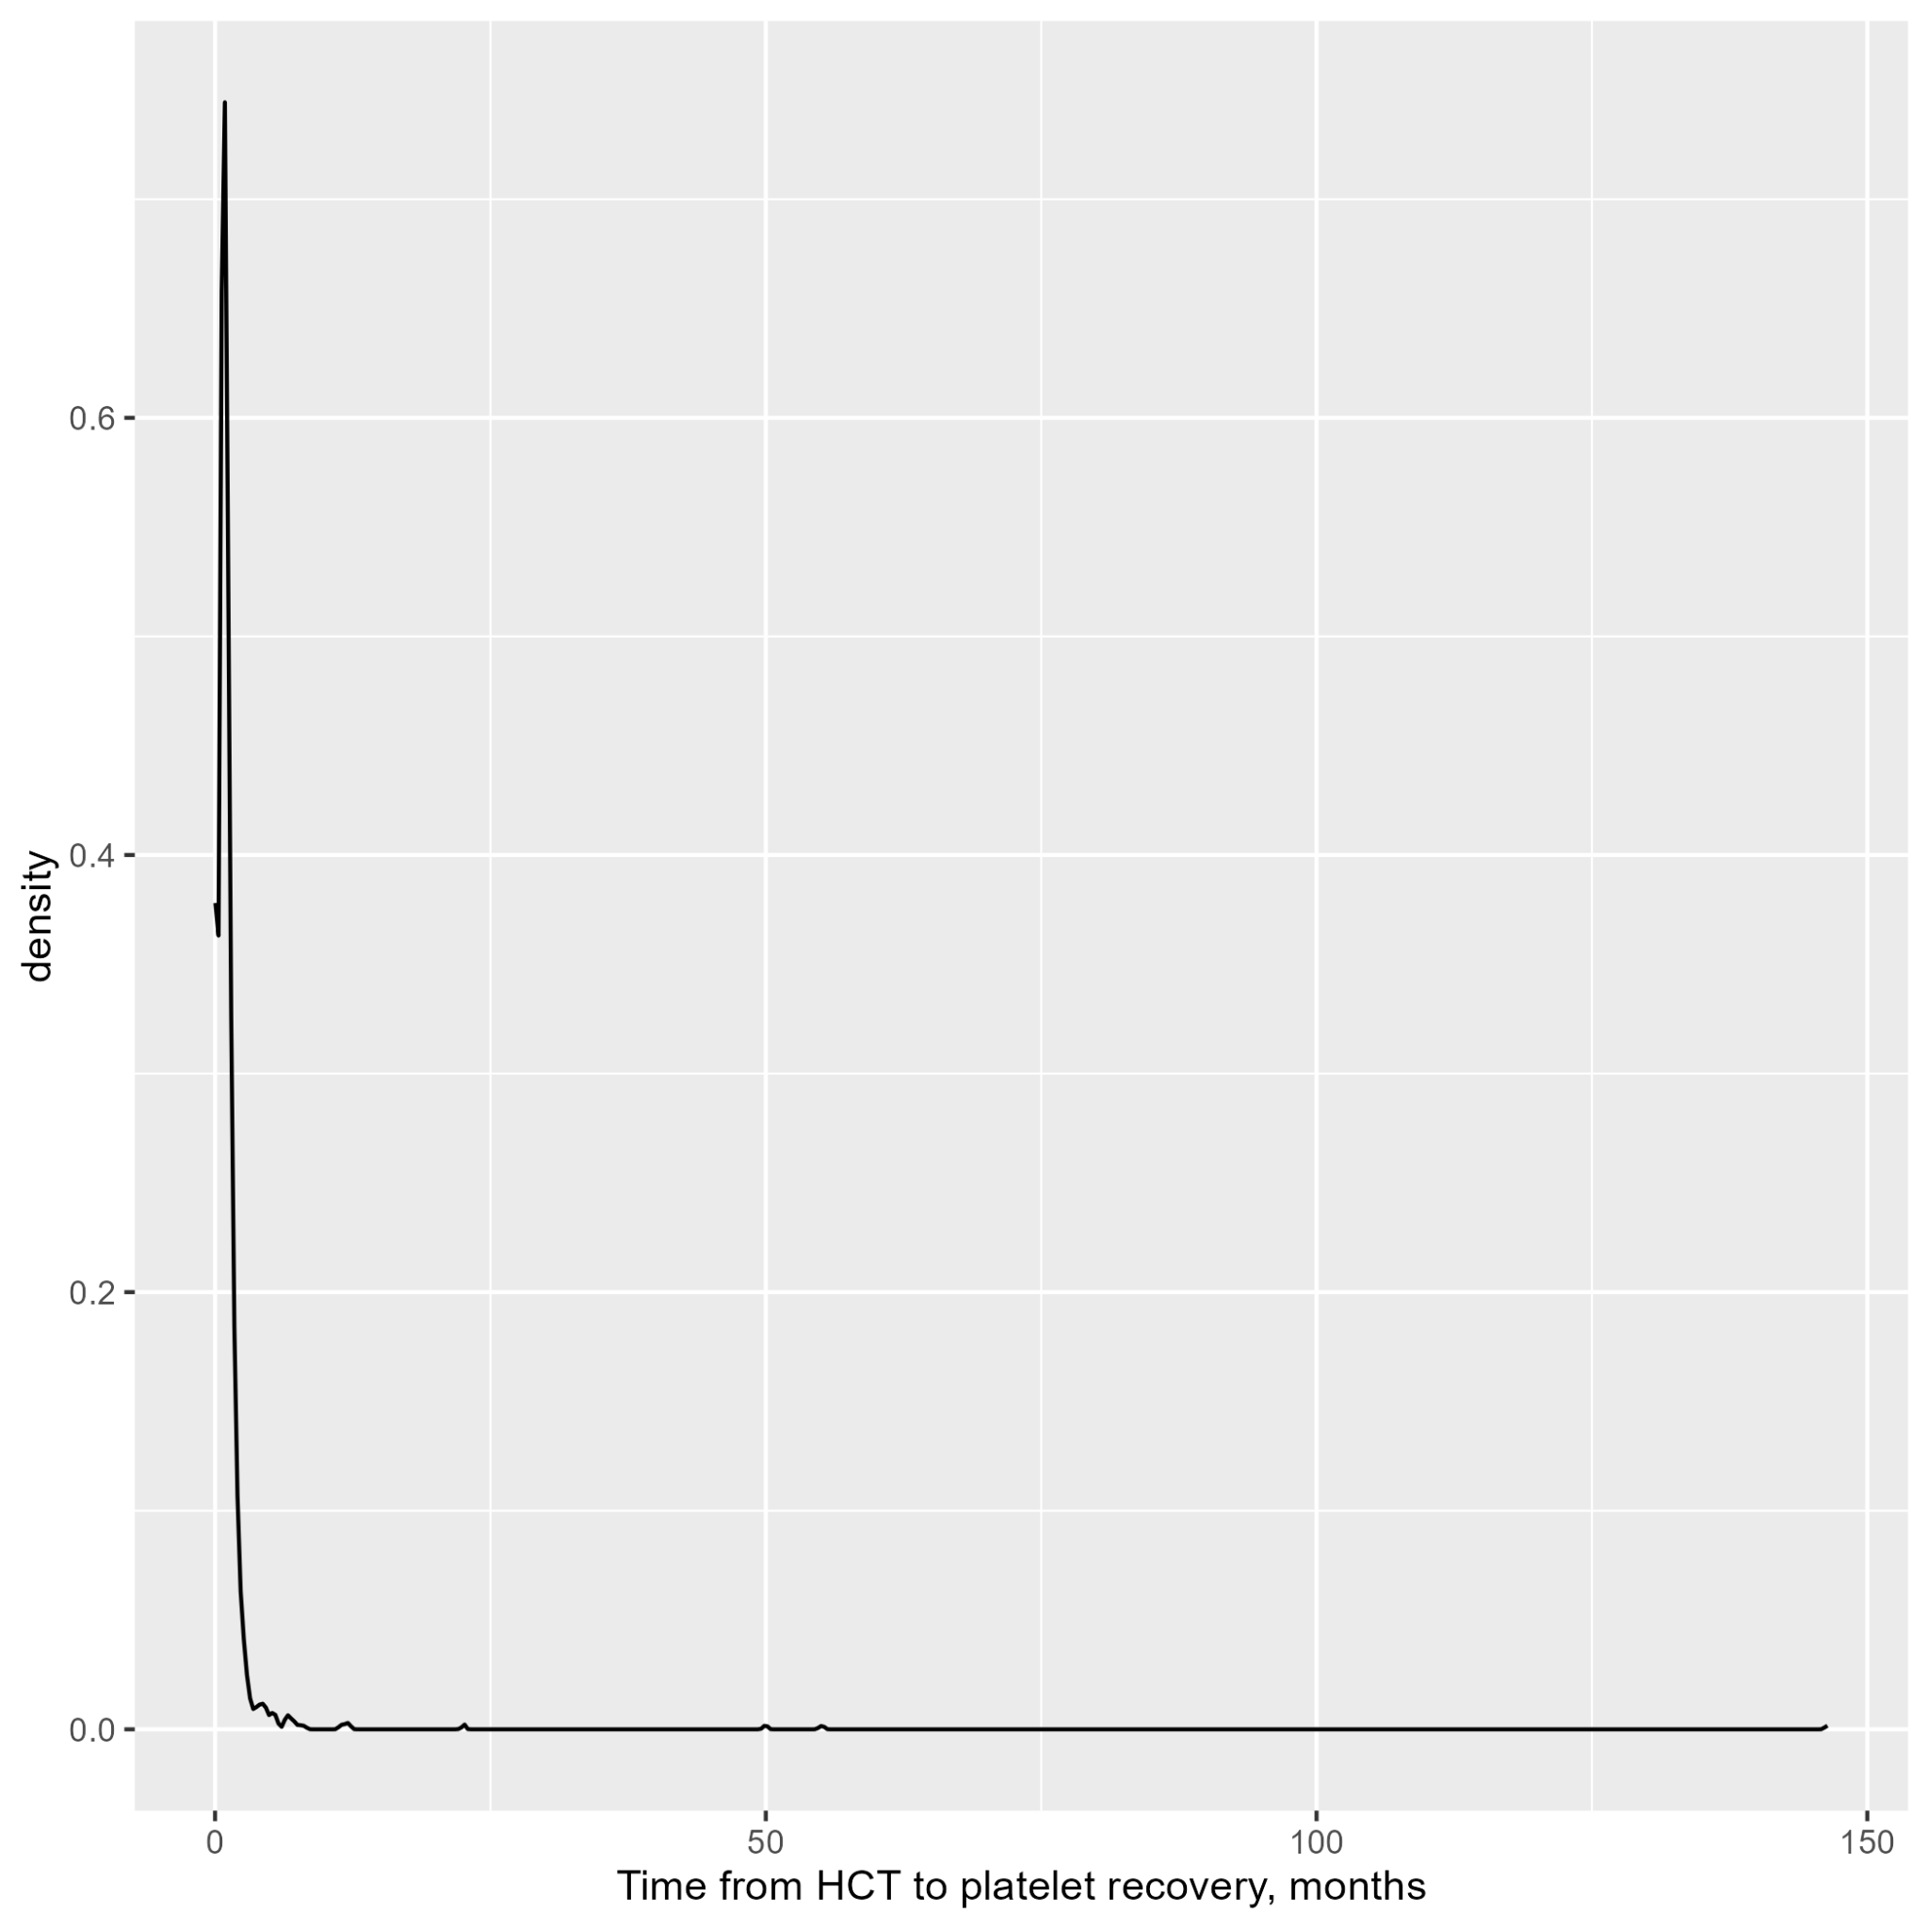

Plot 7: Distribution of Time from HCT to PTLD

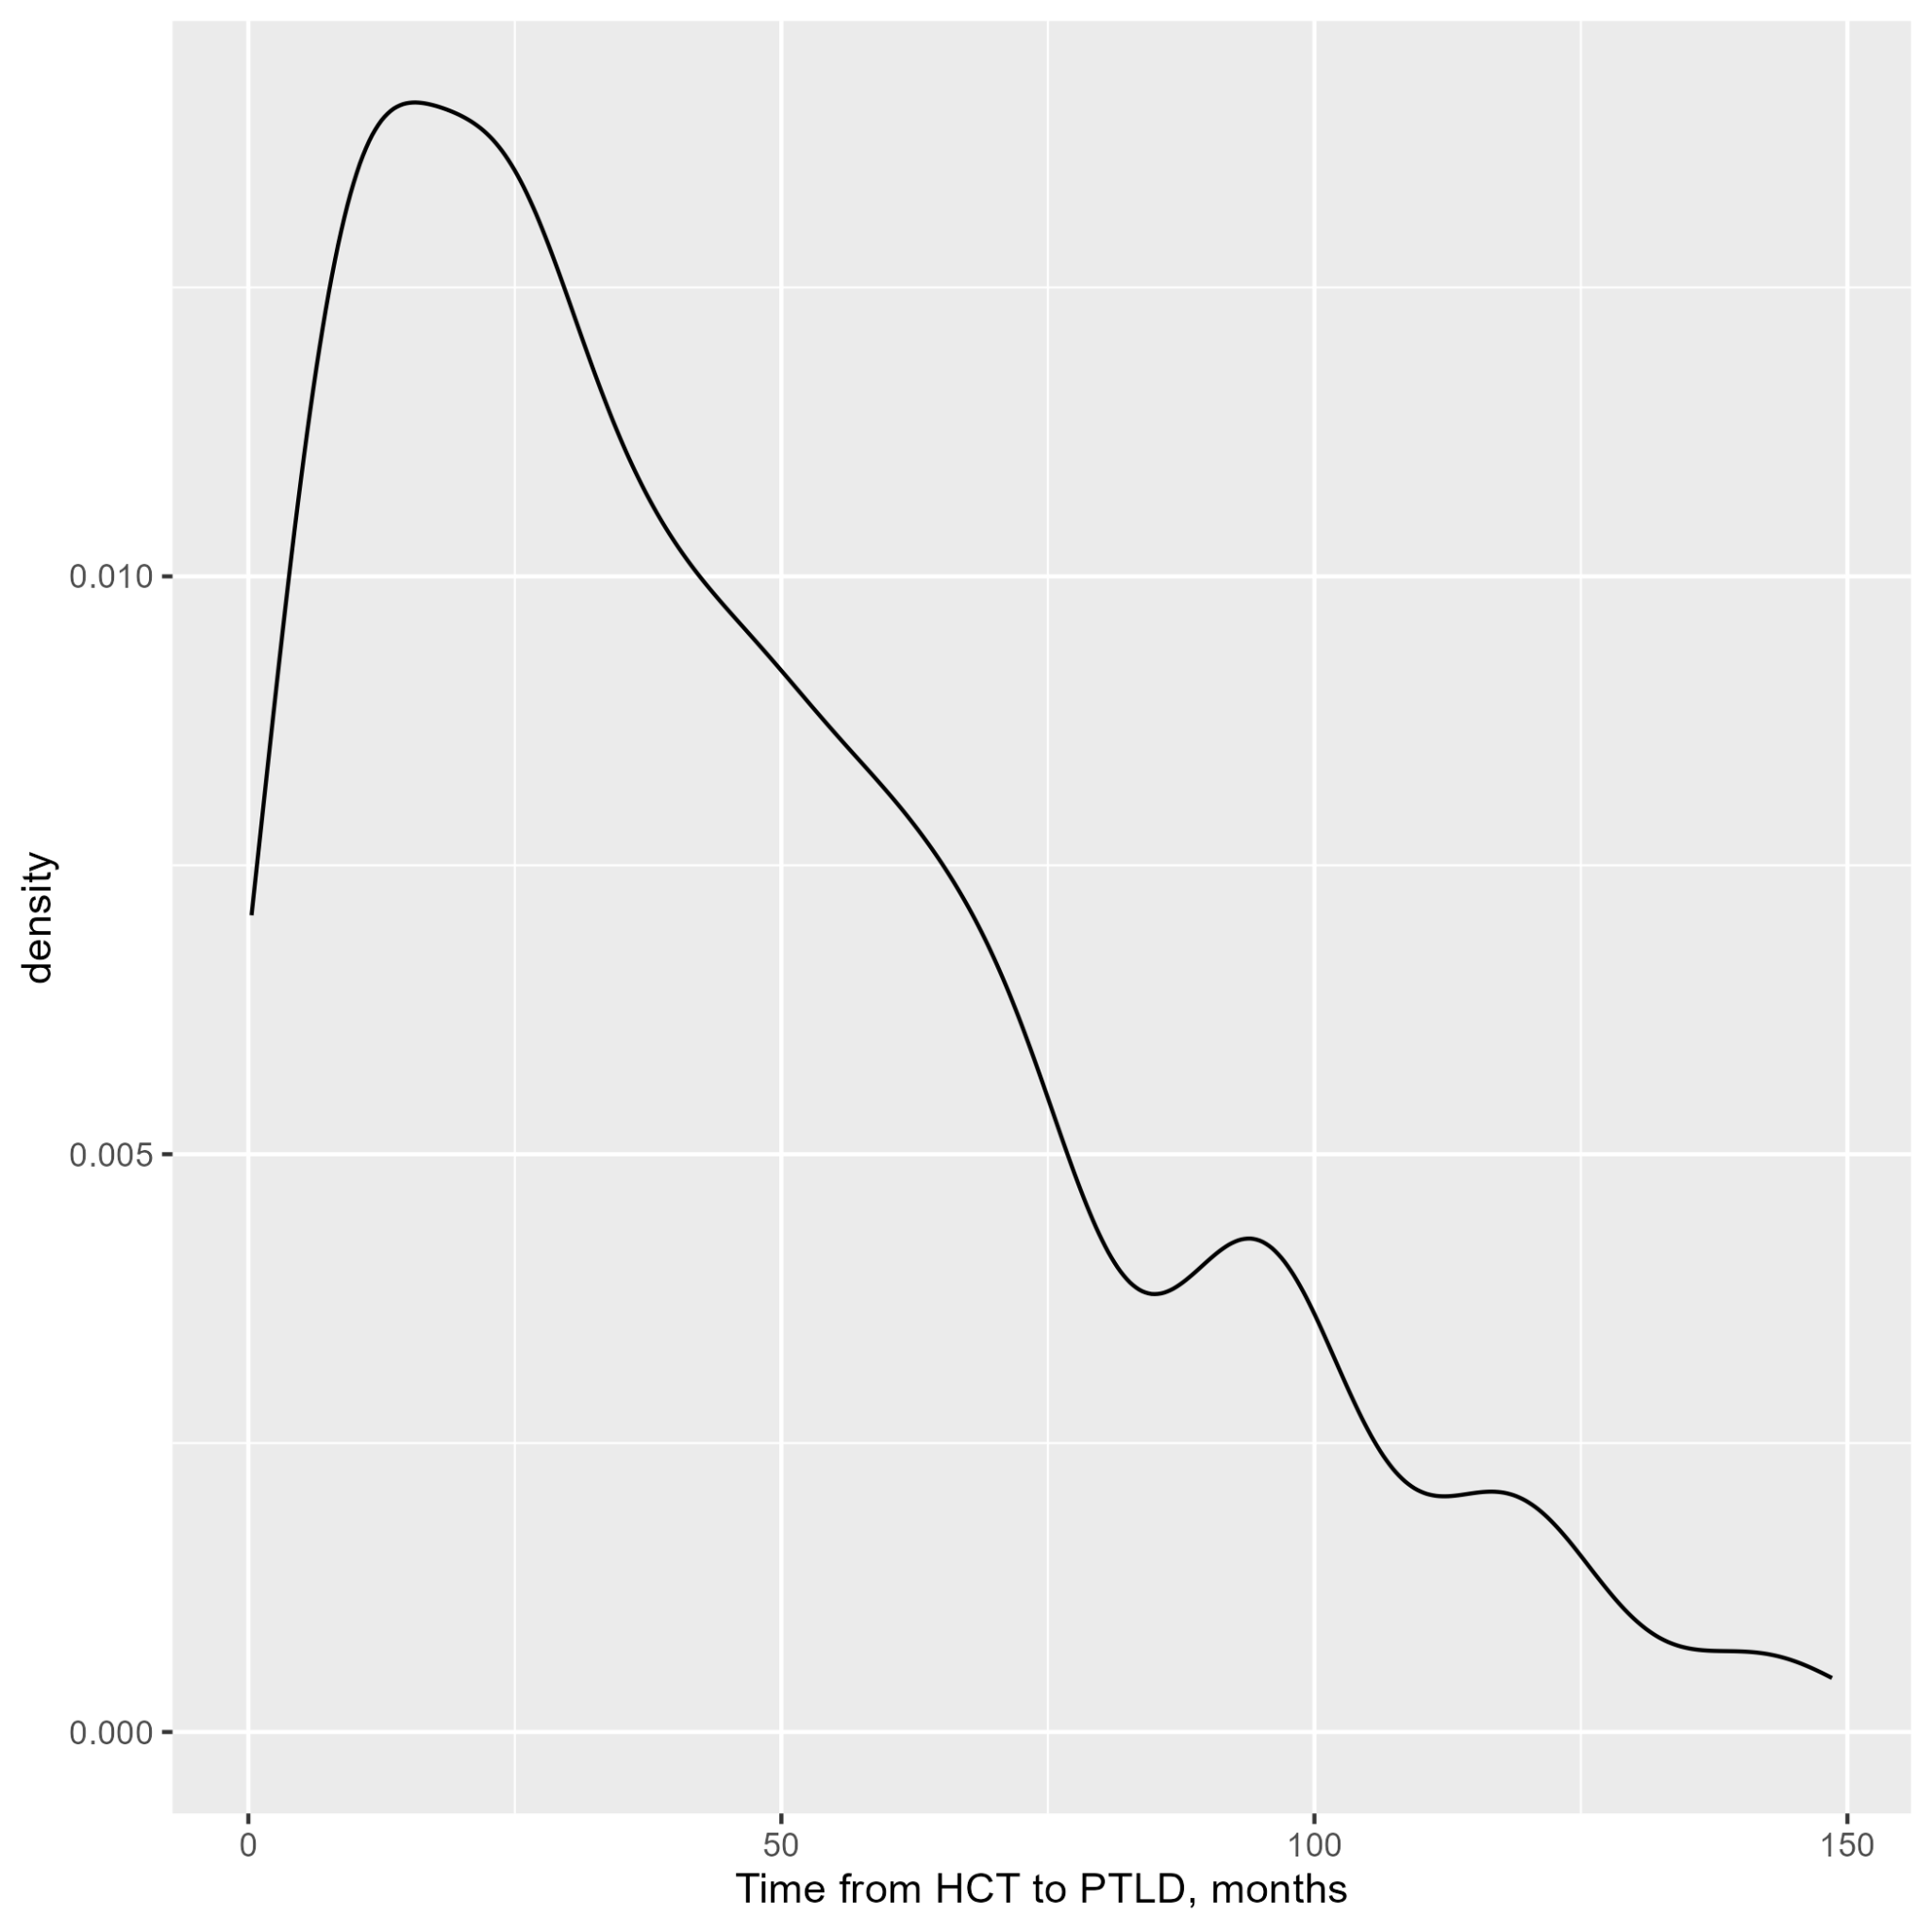

Plot 8: Distribution of Time from HCT to Second Malignancy

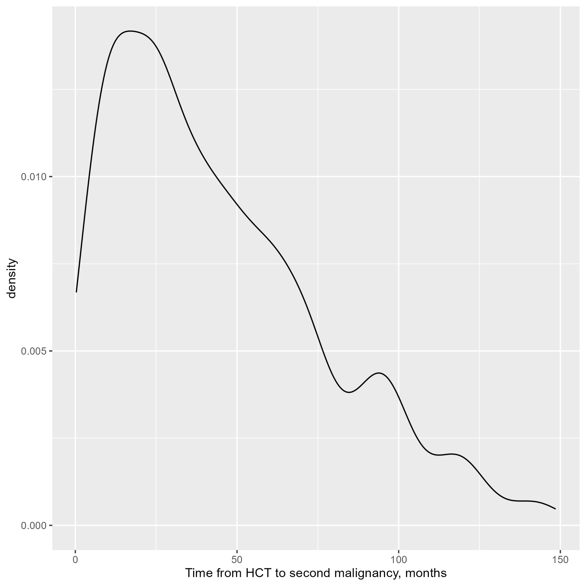

Plot 9: Distribution of Time from HCT to Date of Last Contact or Death

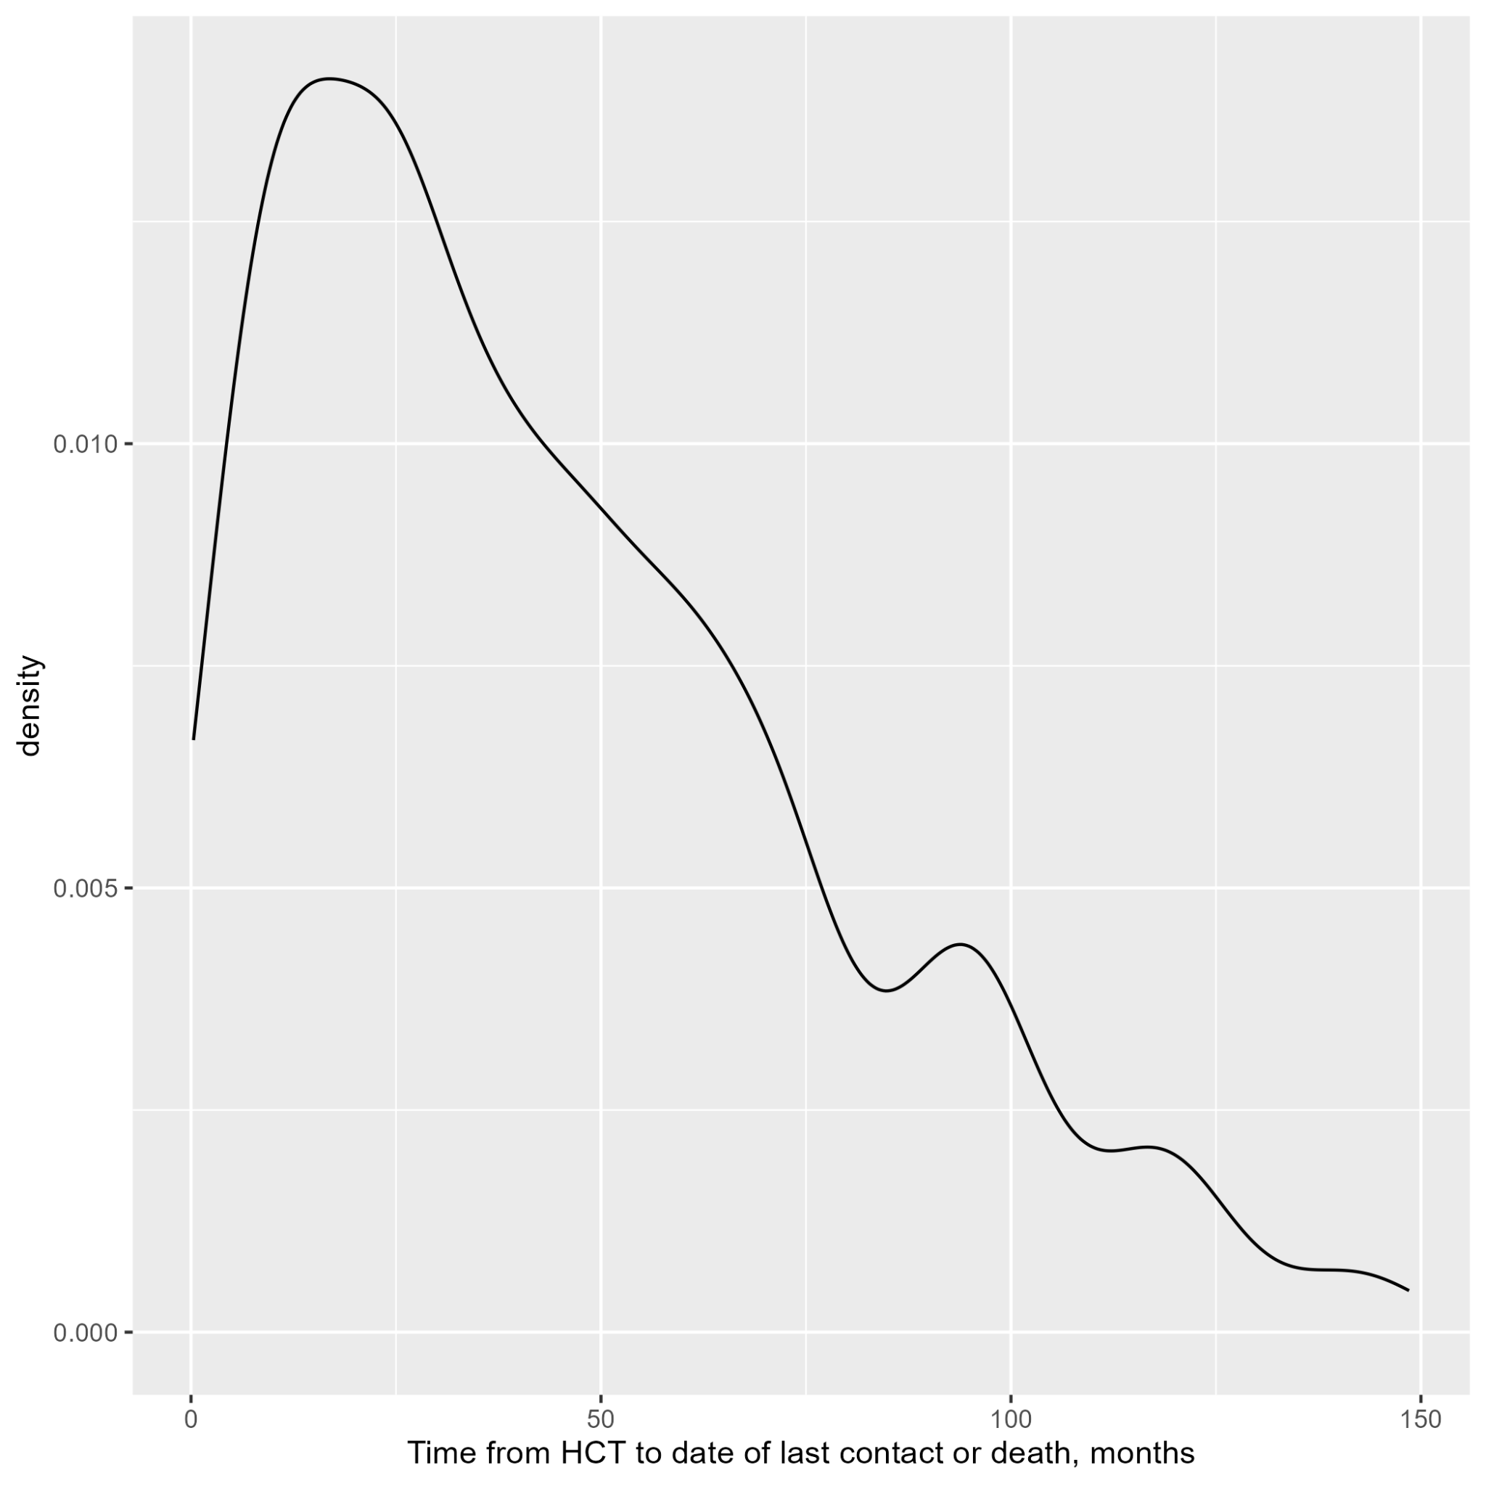

Plot 10: Distribution of Age Categories

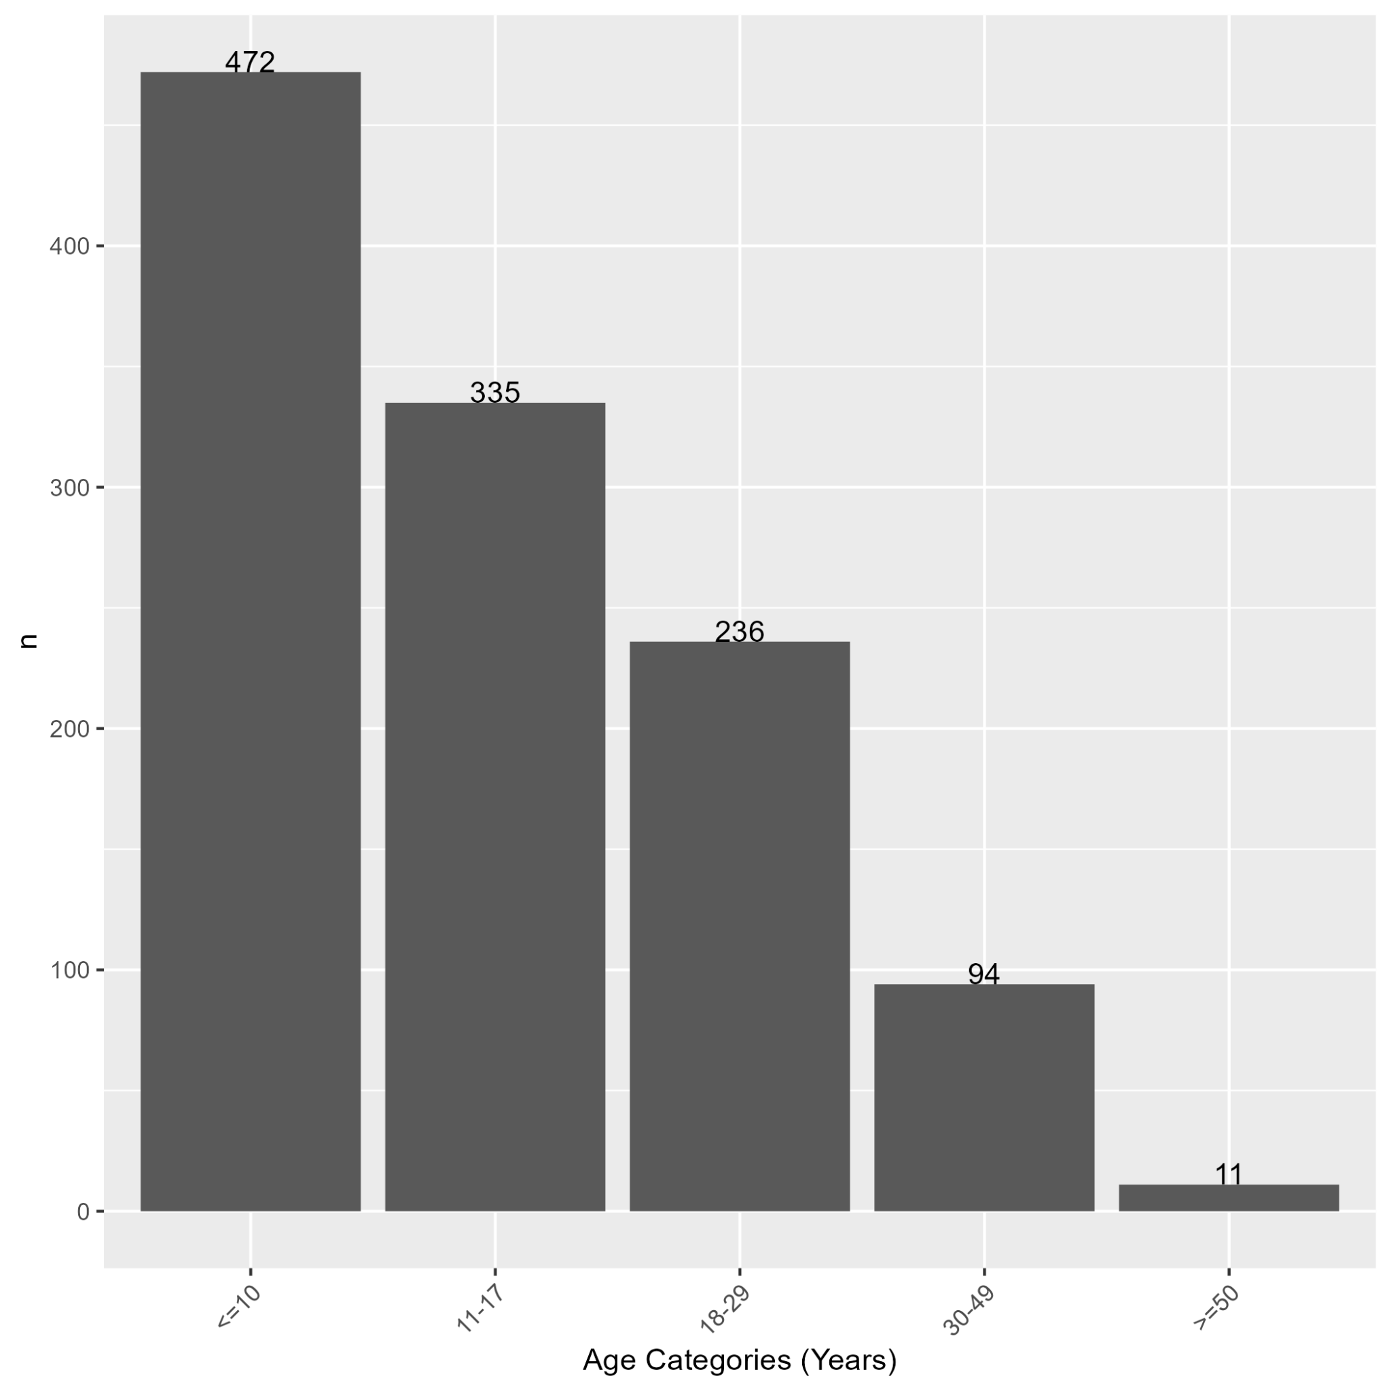

Plot 11: Distribution of Acute GVHD Event

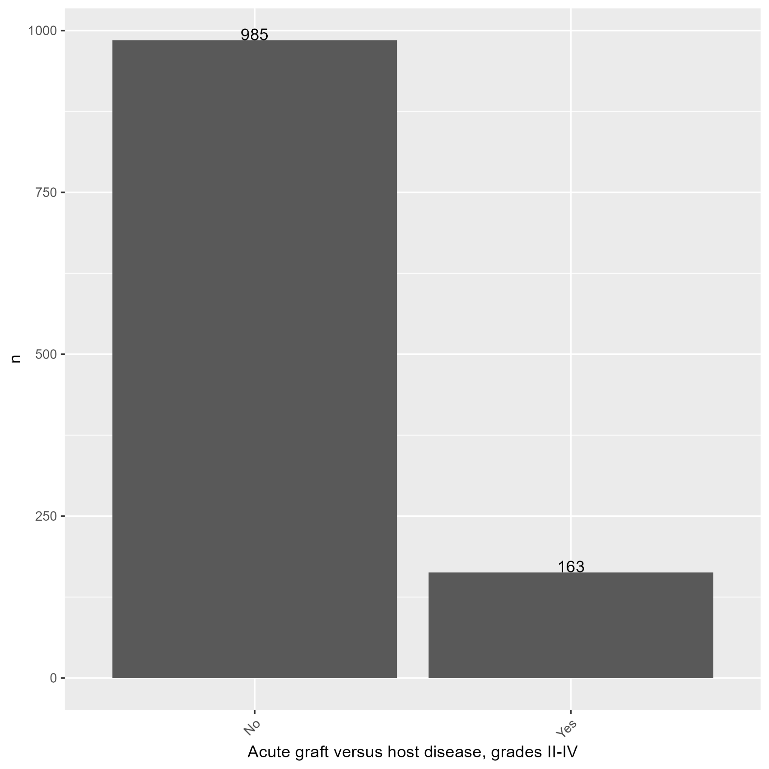

Plot 12: Distribution of Neutrophil Engraftment Event

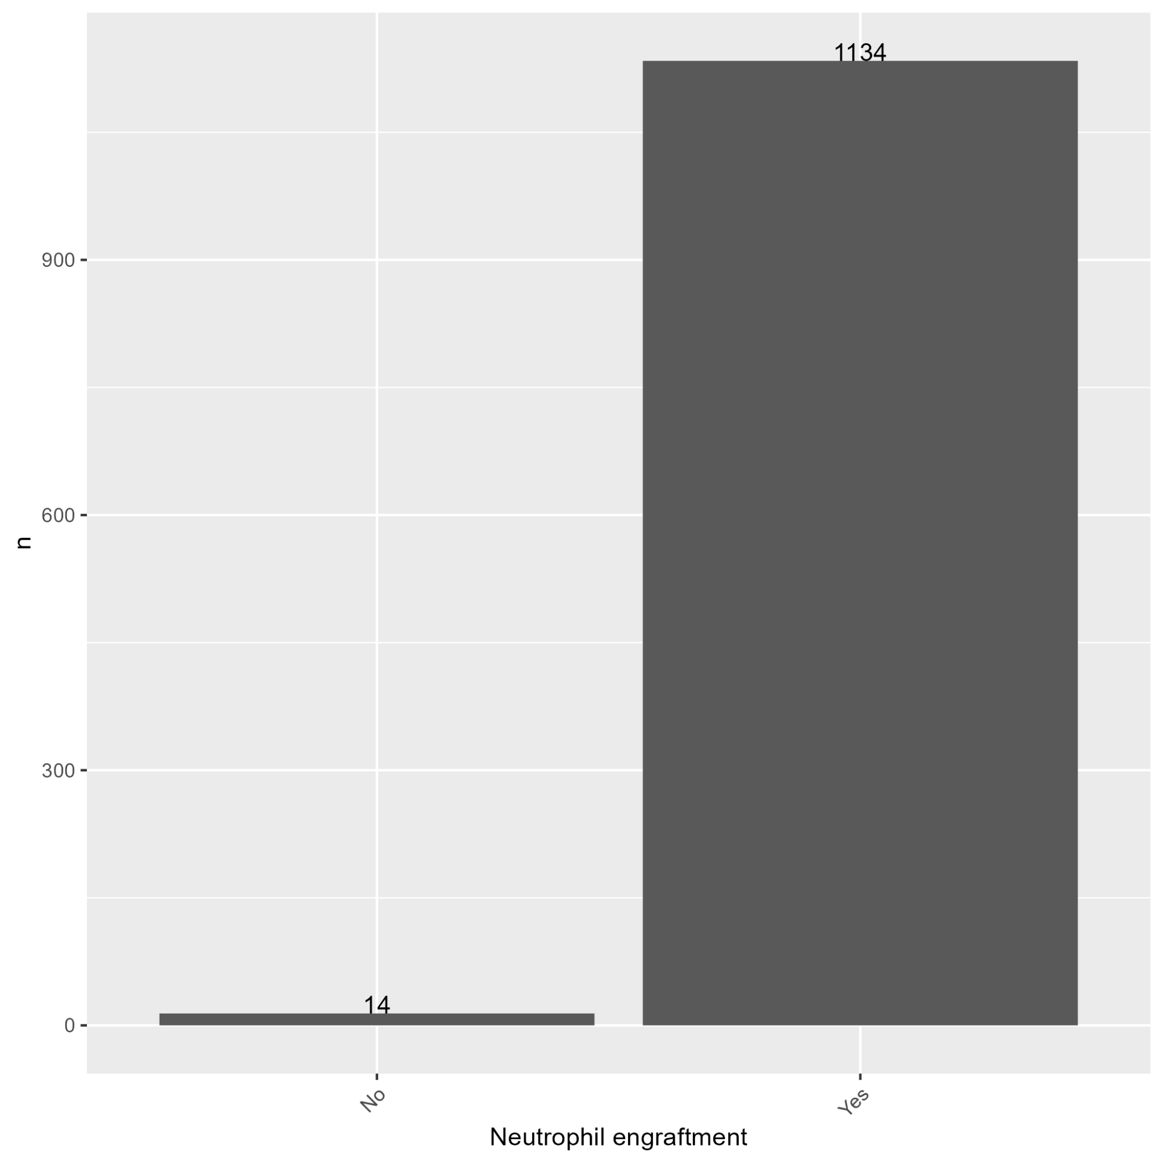

Plot 13: Distribution of ATG/Alemtuzumab Given as Conditioning Regimen/GVHD Prophylaxis

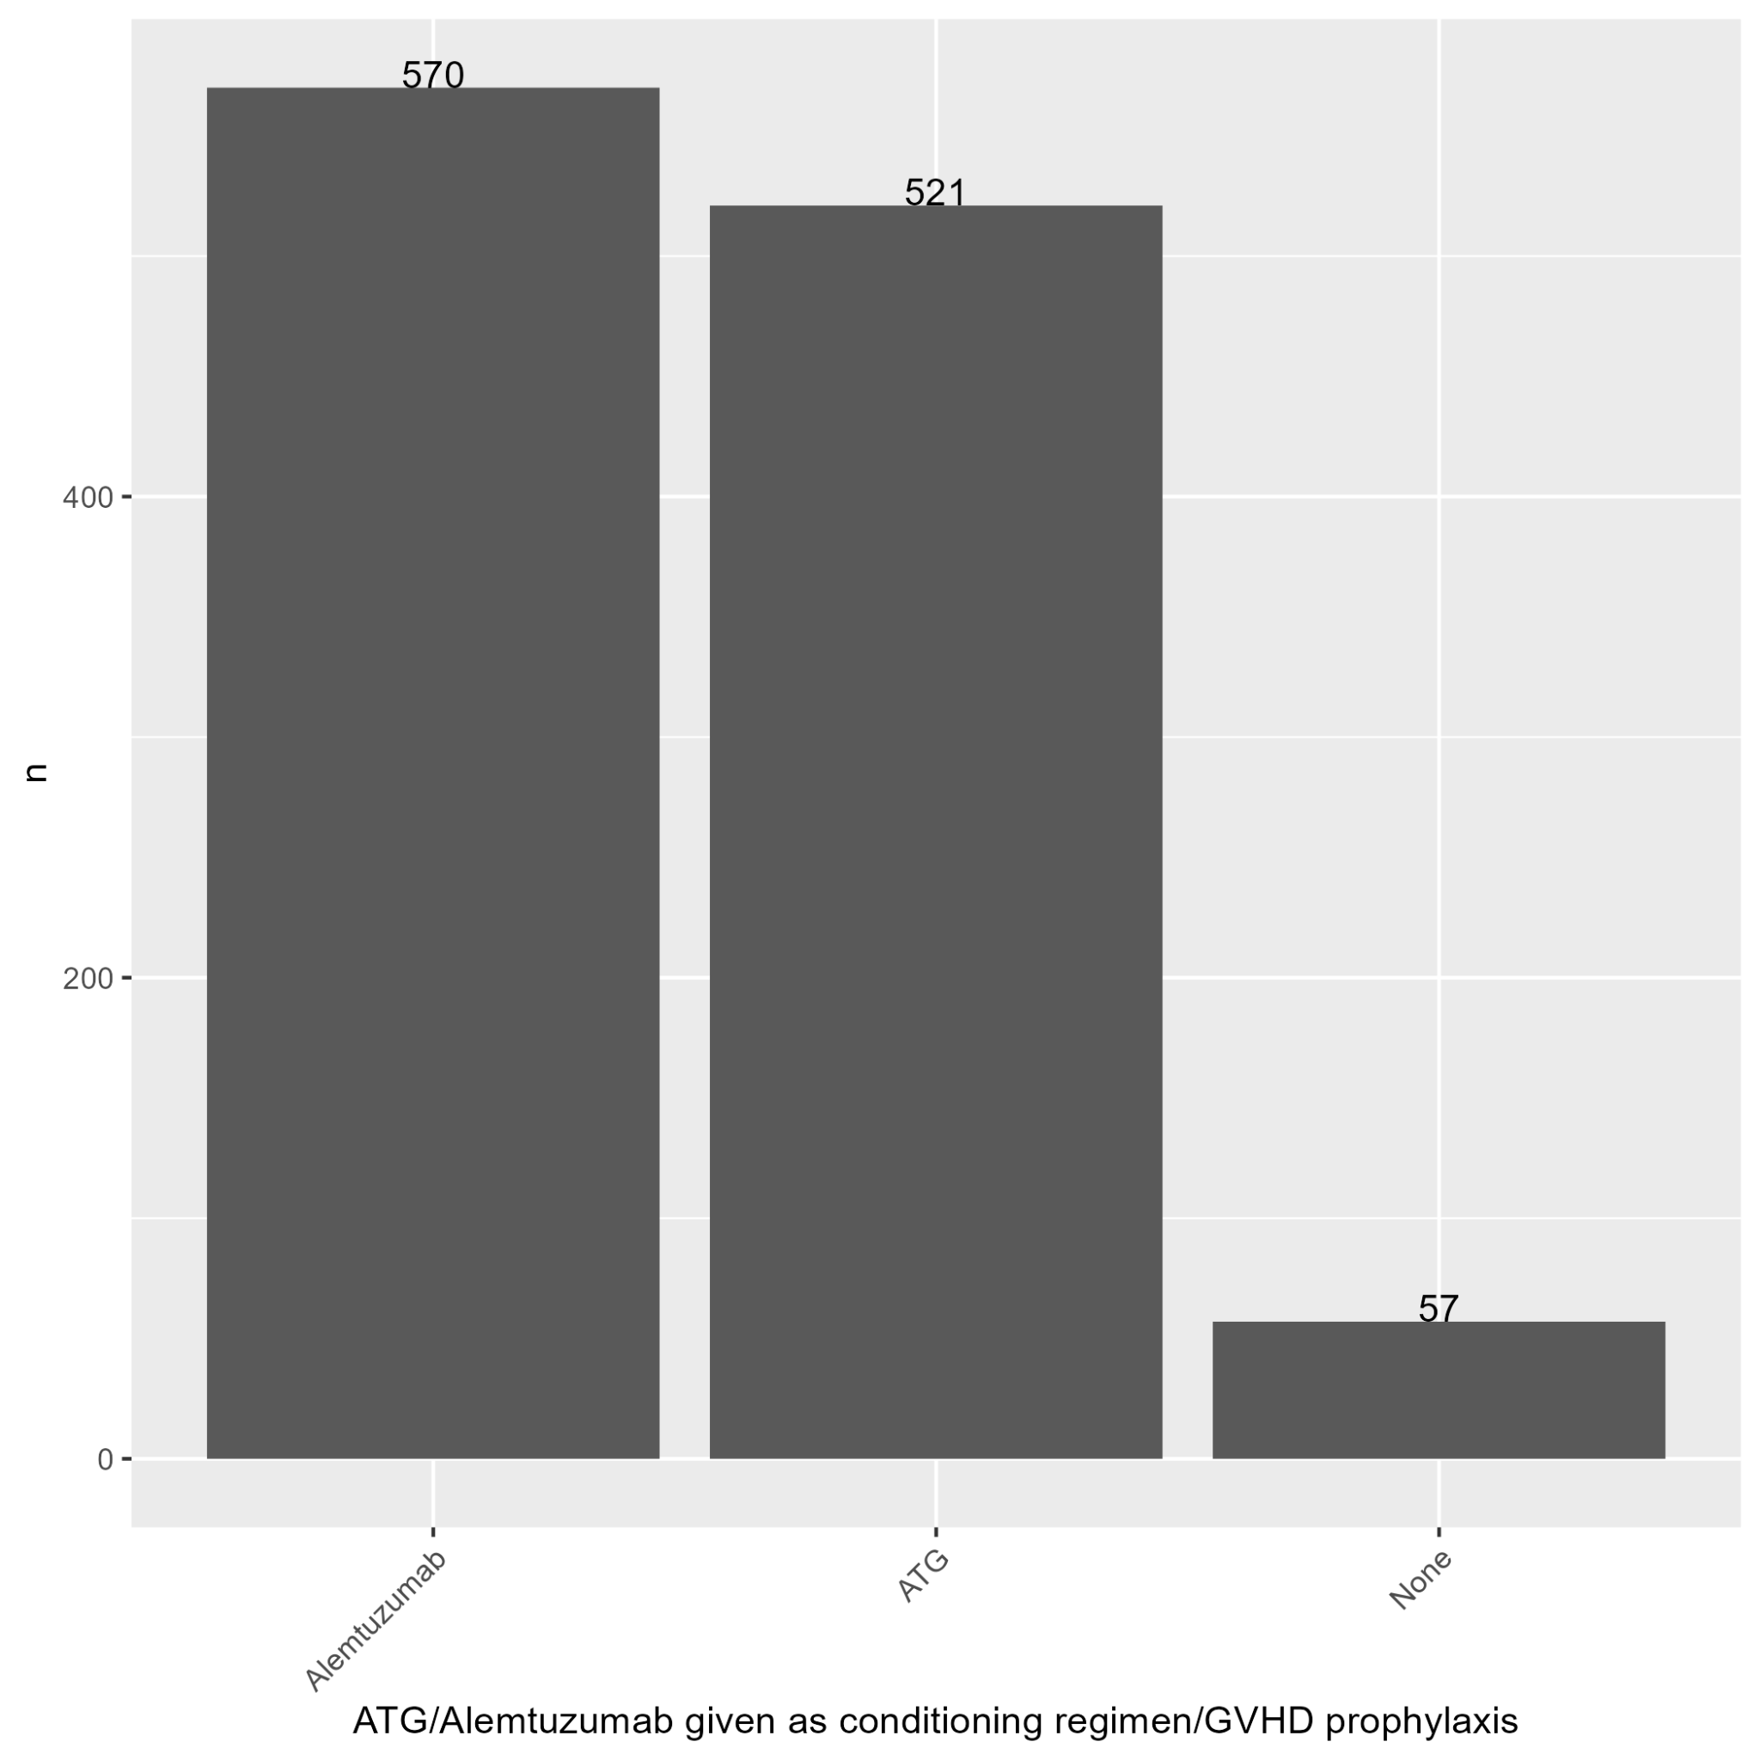

Plot 14: Distribution of Chronic GVHD Event

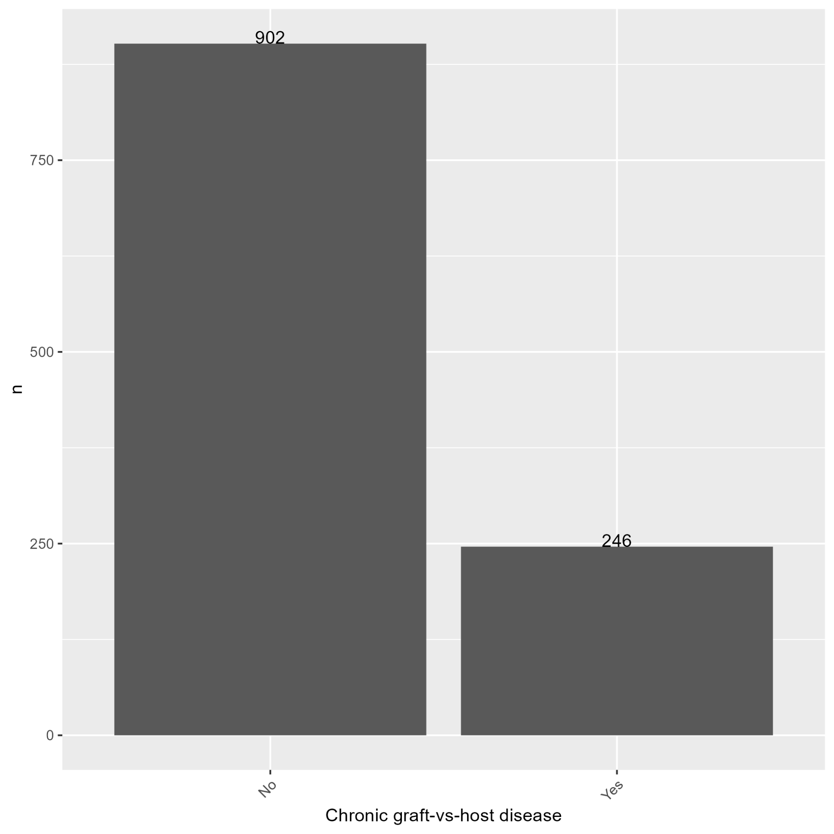

Plot 15: Distribution of Conditioning Regimen

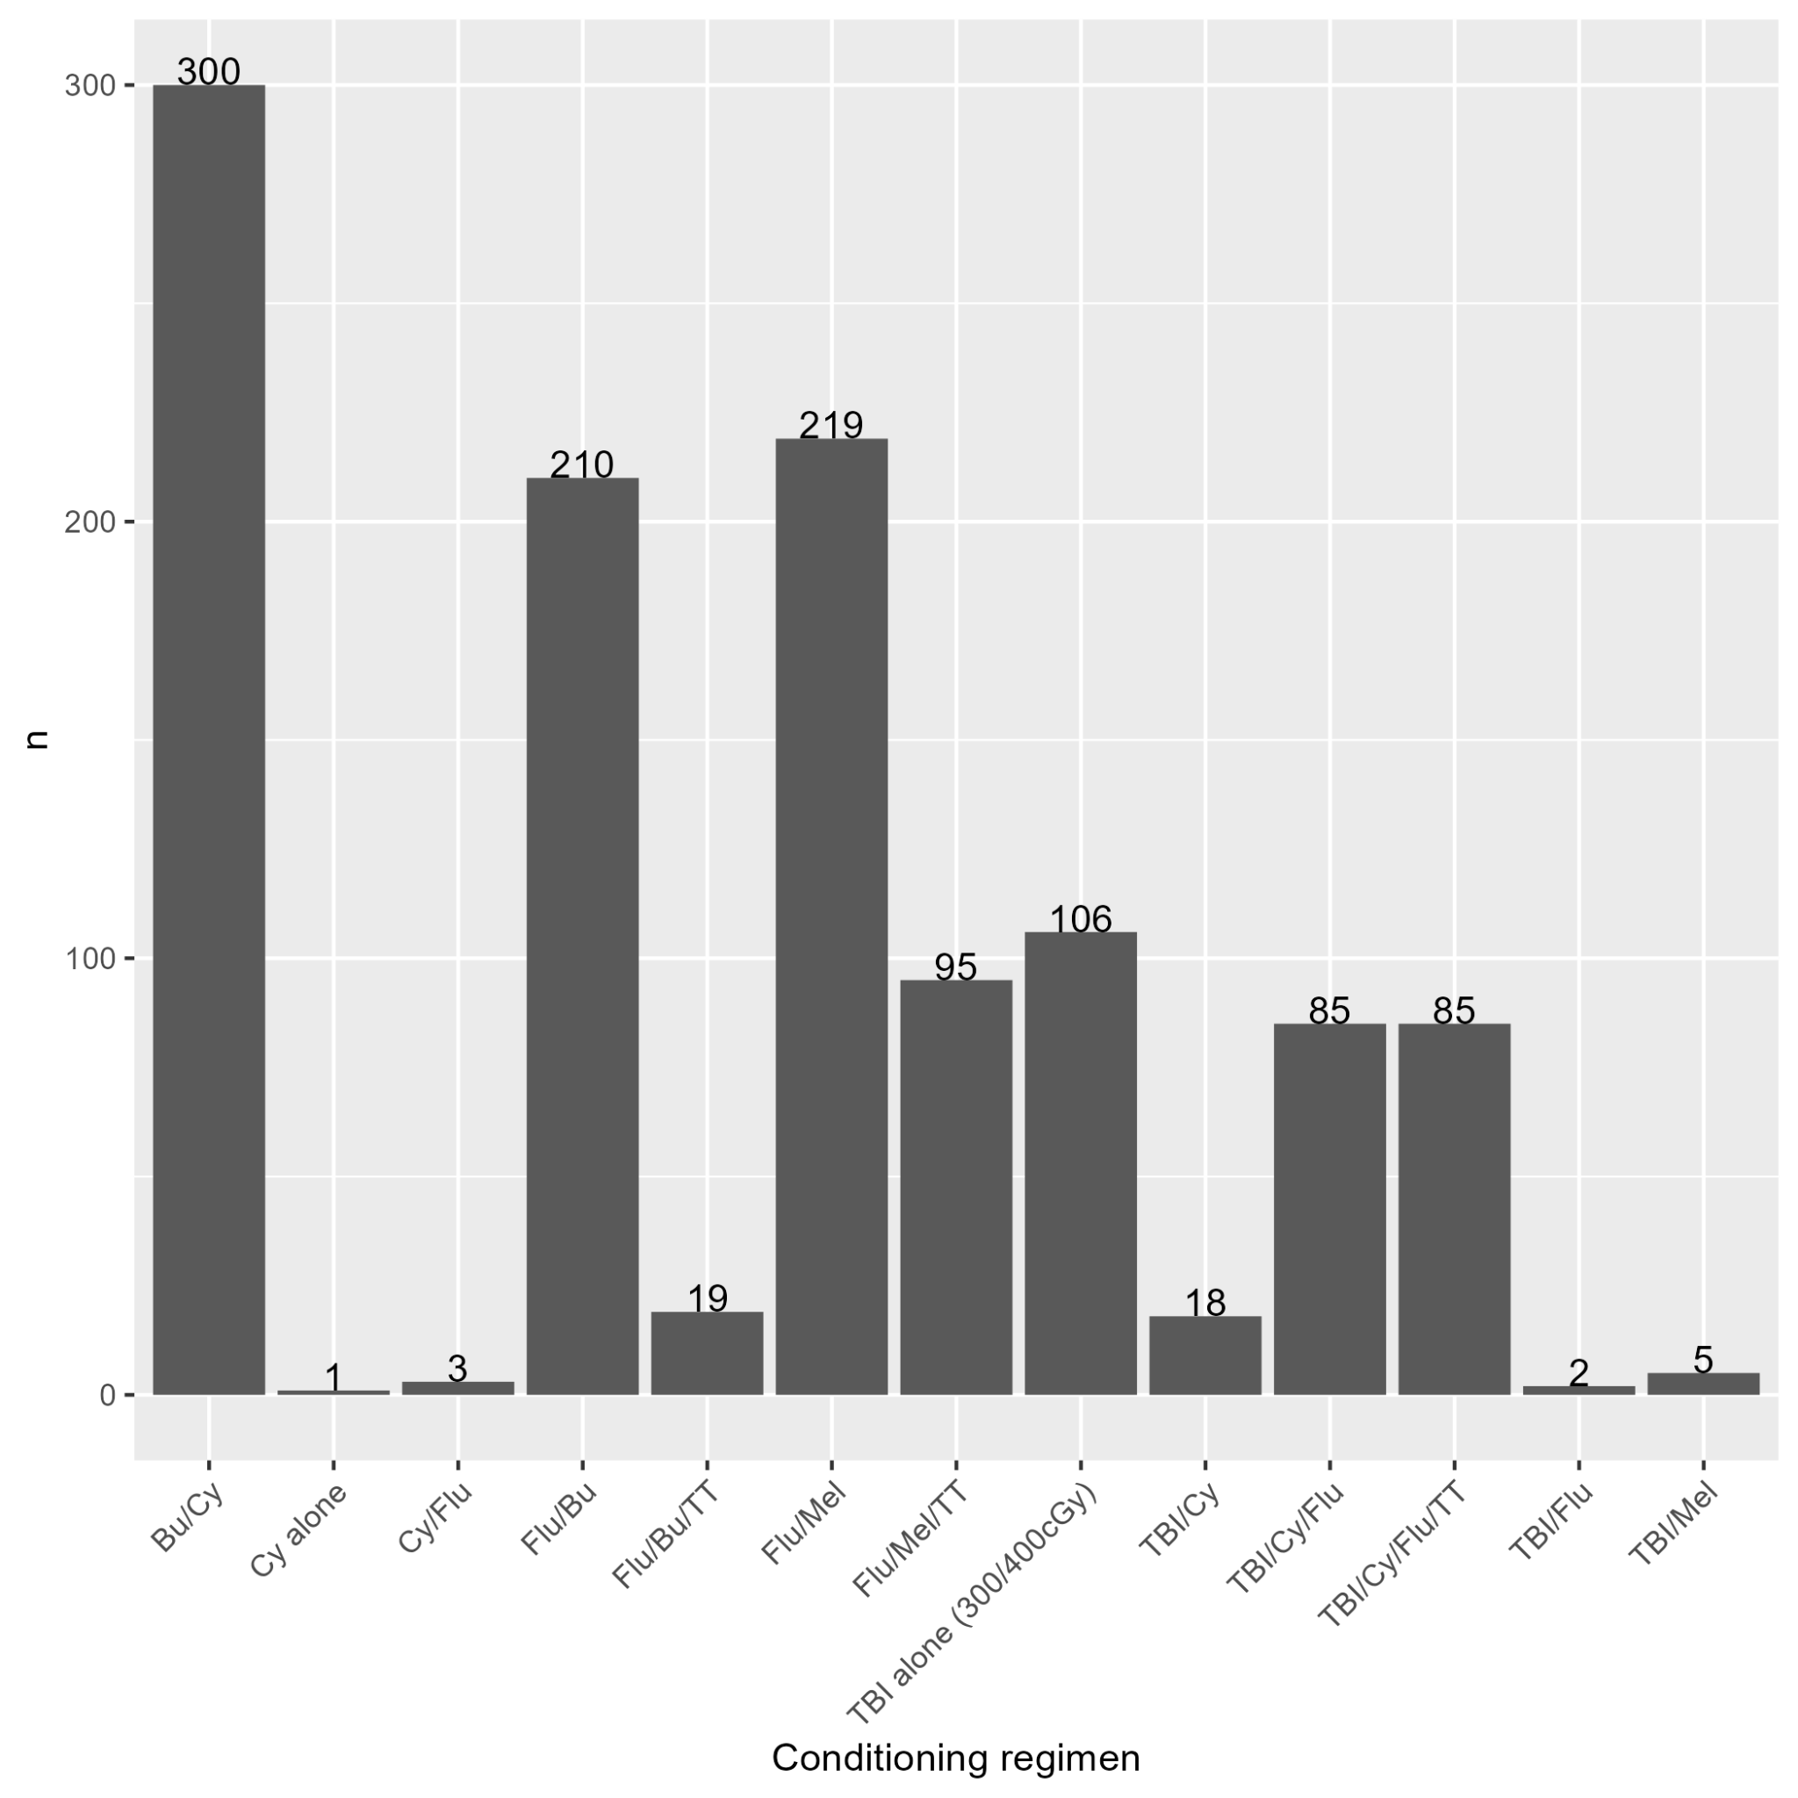

Plot 16: Distribution of Conditioning Intensity

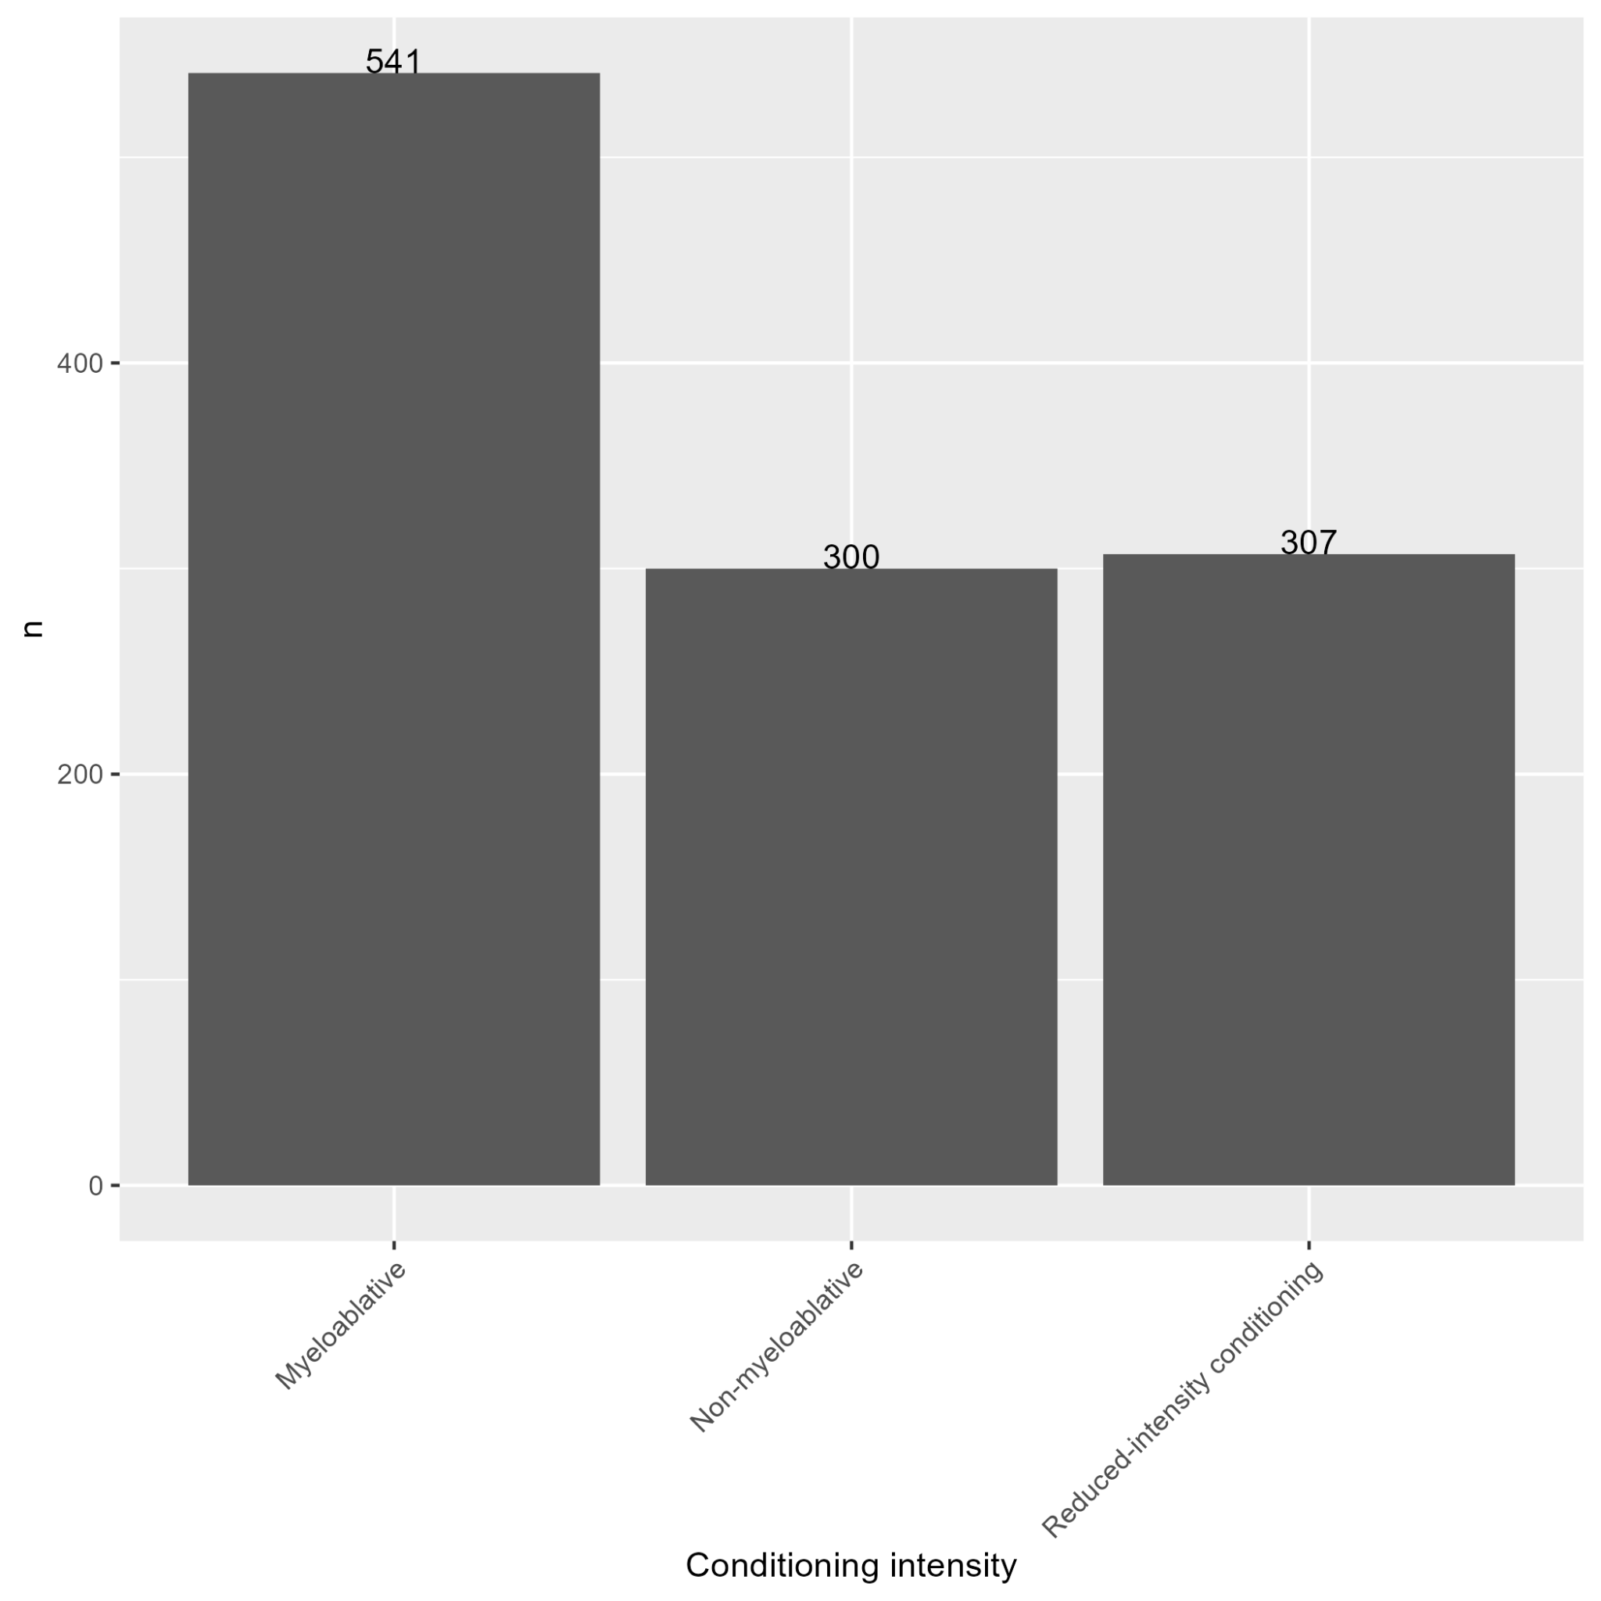

Plot 17: Distribution of Survival Status at Last Contact

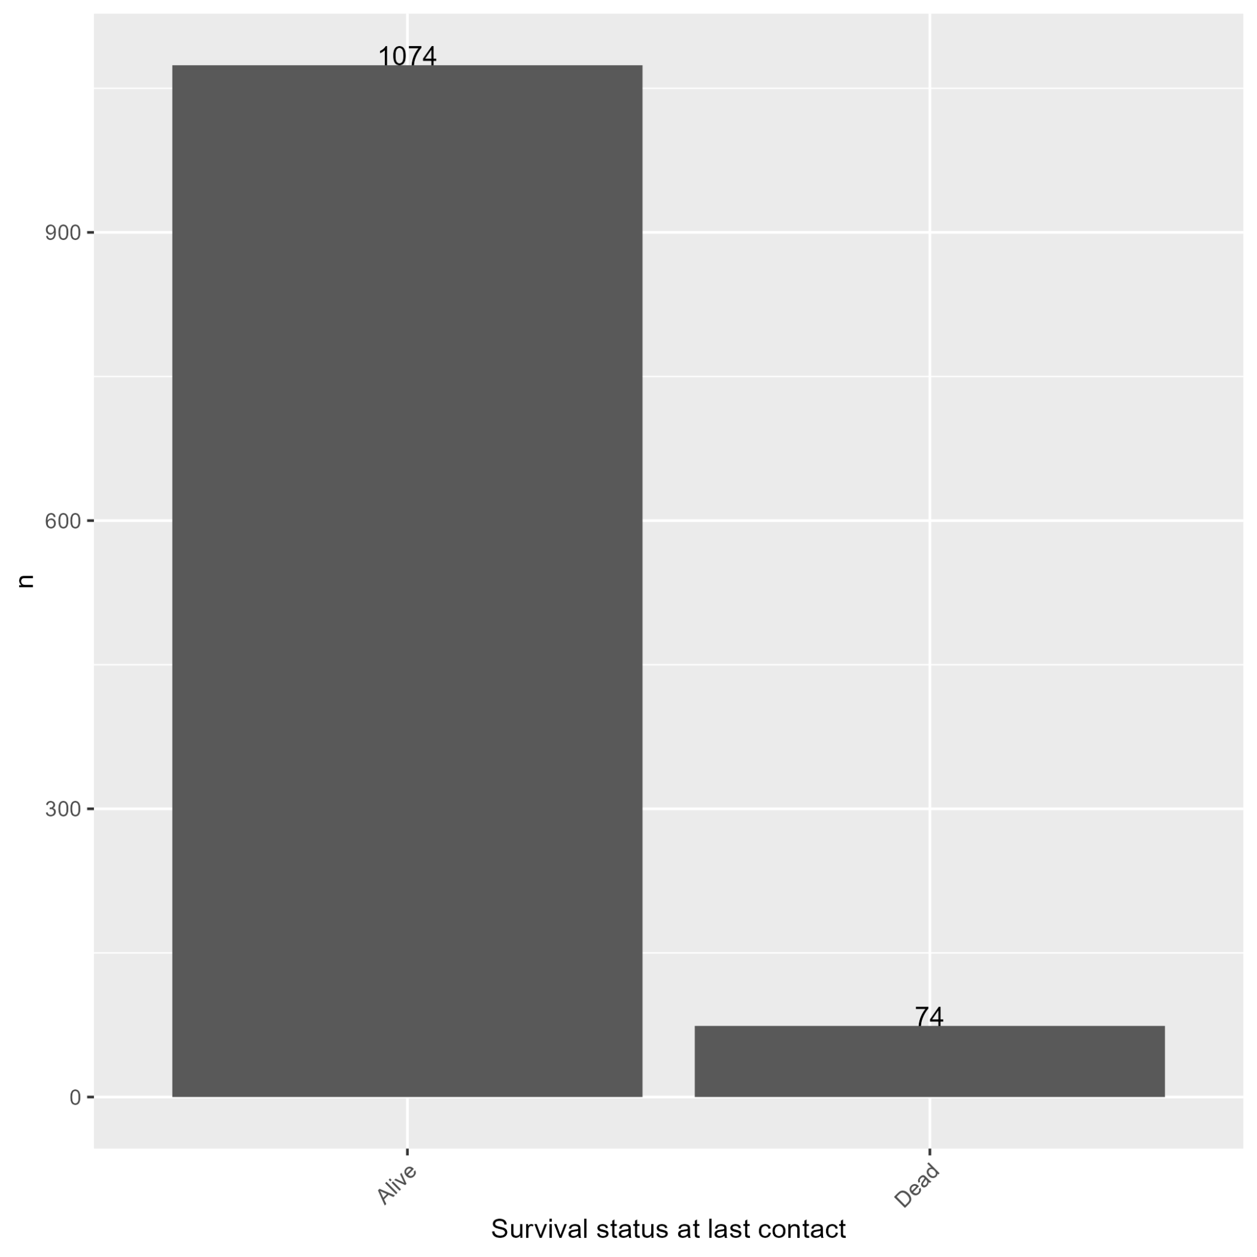

Plot 18: Distribution of Donor Type

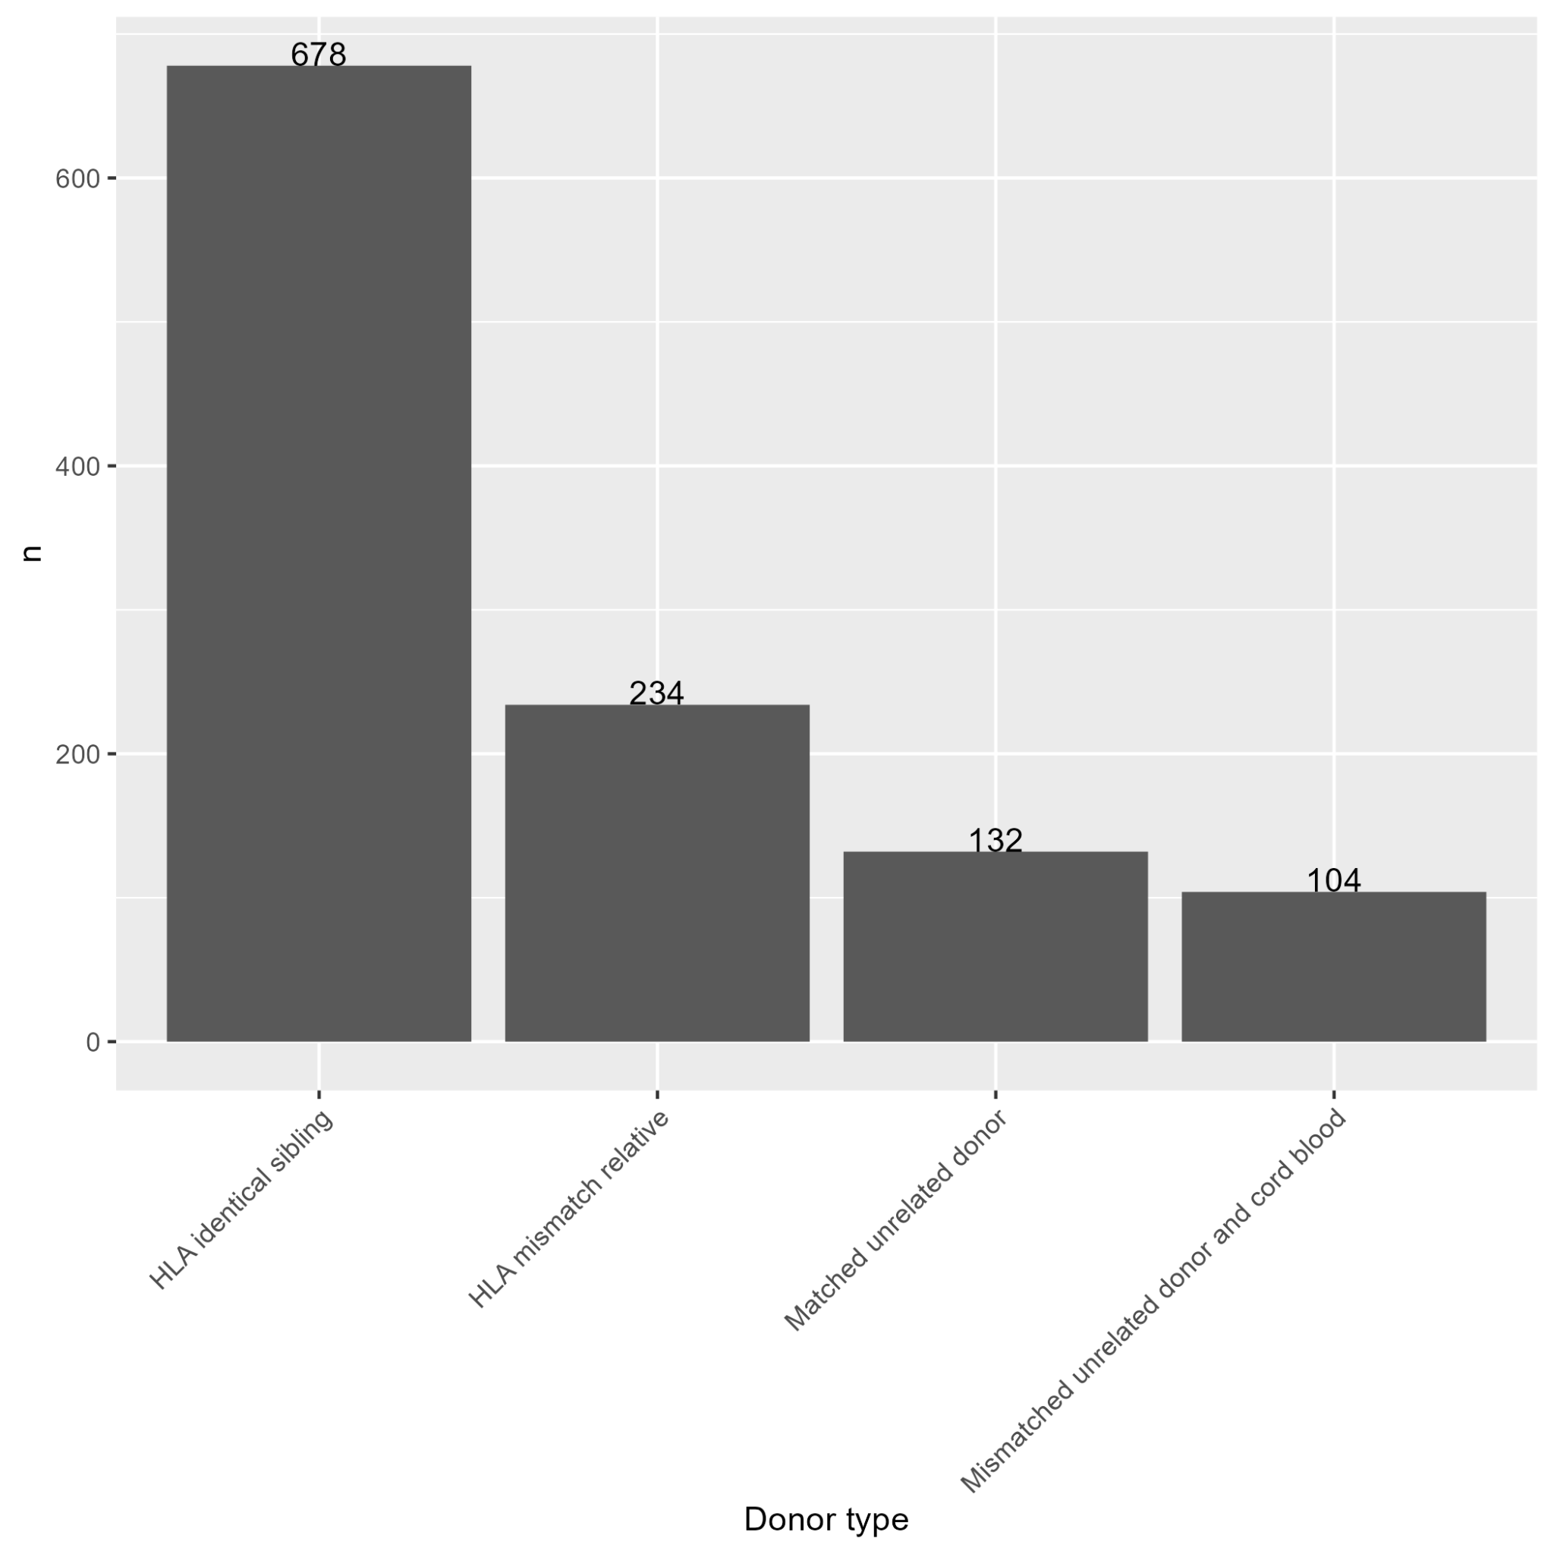

Plot 19: Distribution of Death without Acute GVHD Event

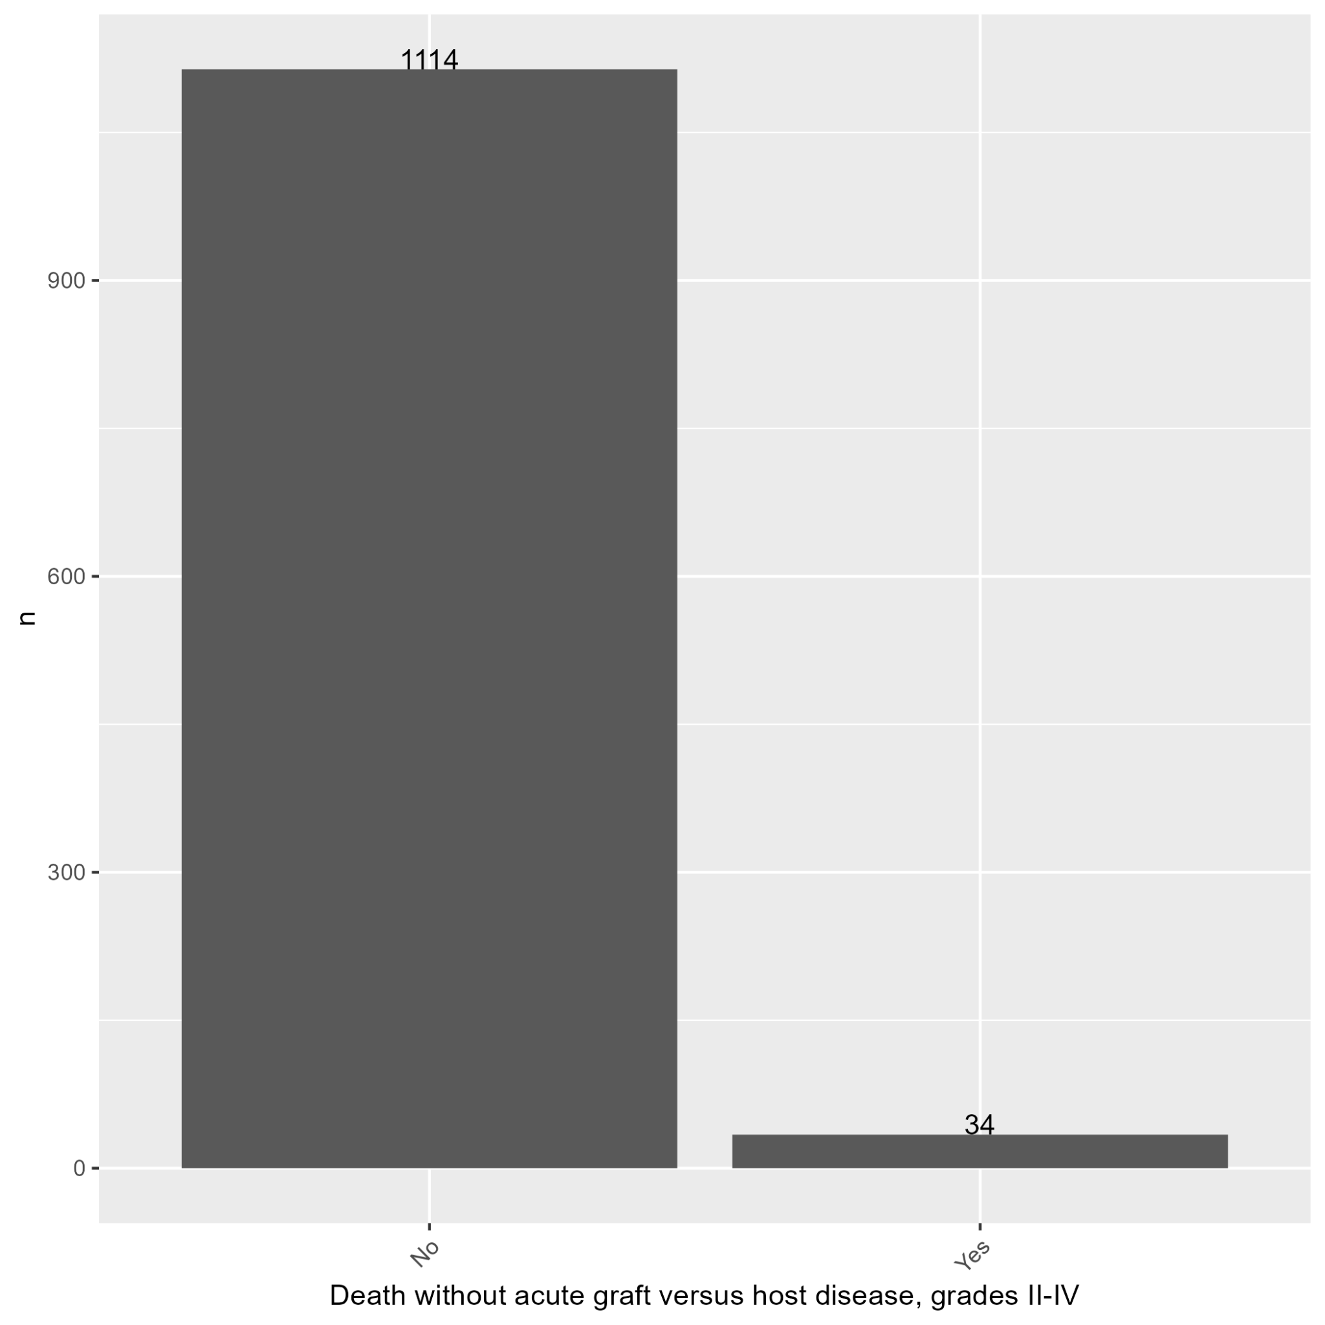

Plot 20: Distribution of Death without Neutrophil Engraftment Event

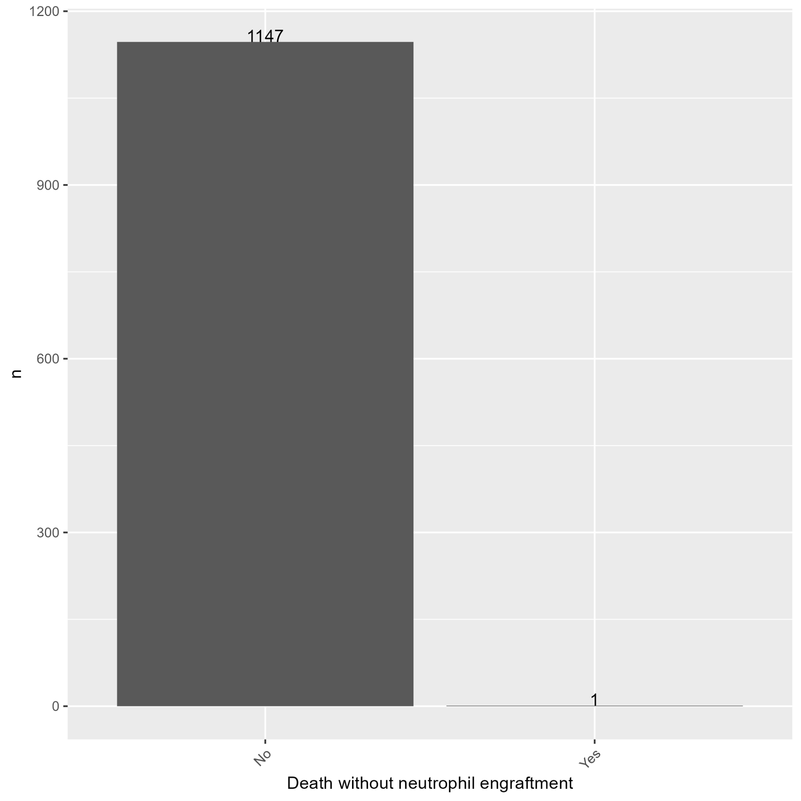

Plot 21: Distribution of Death without Chronic GVHD Event

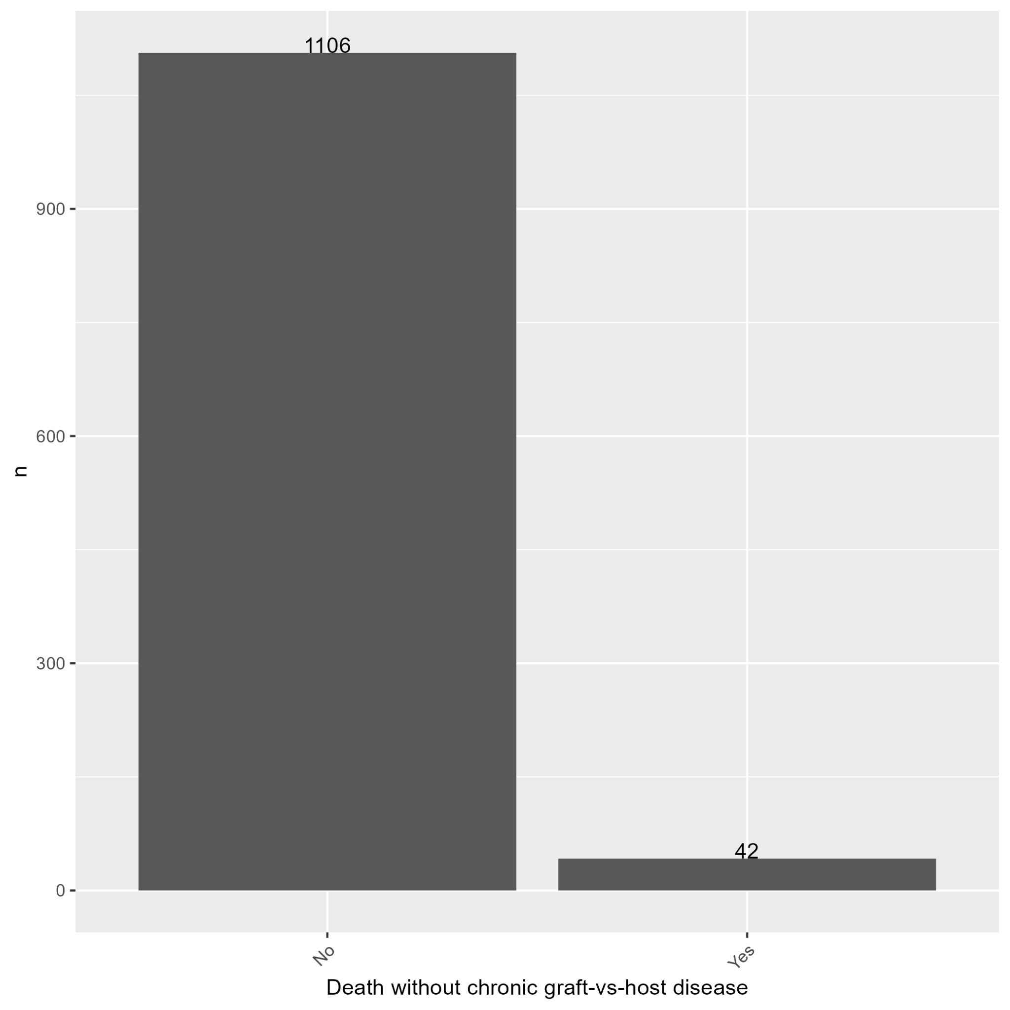

Plot 22: Distribution of Death without Graft Failure Event

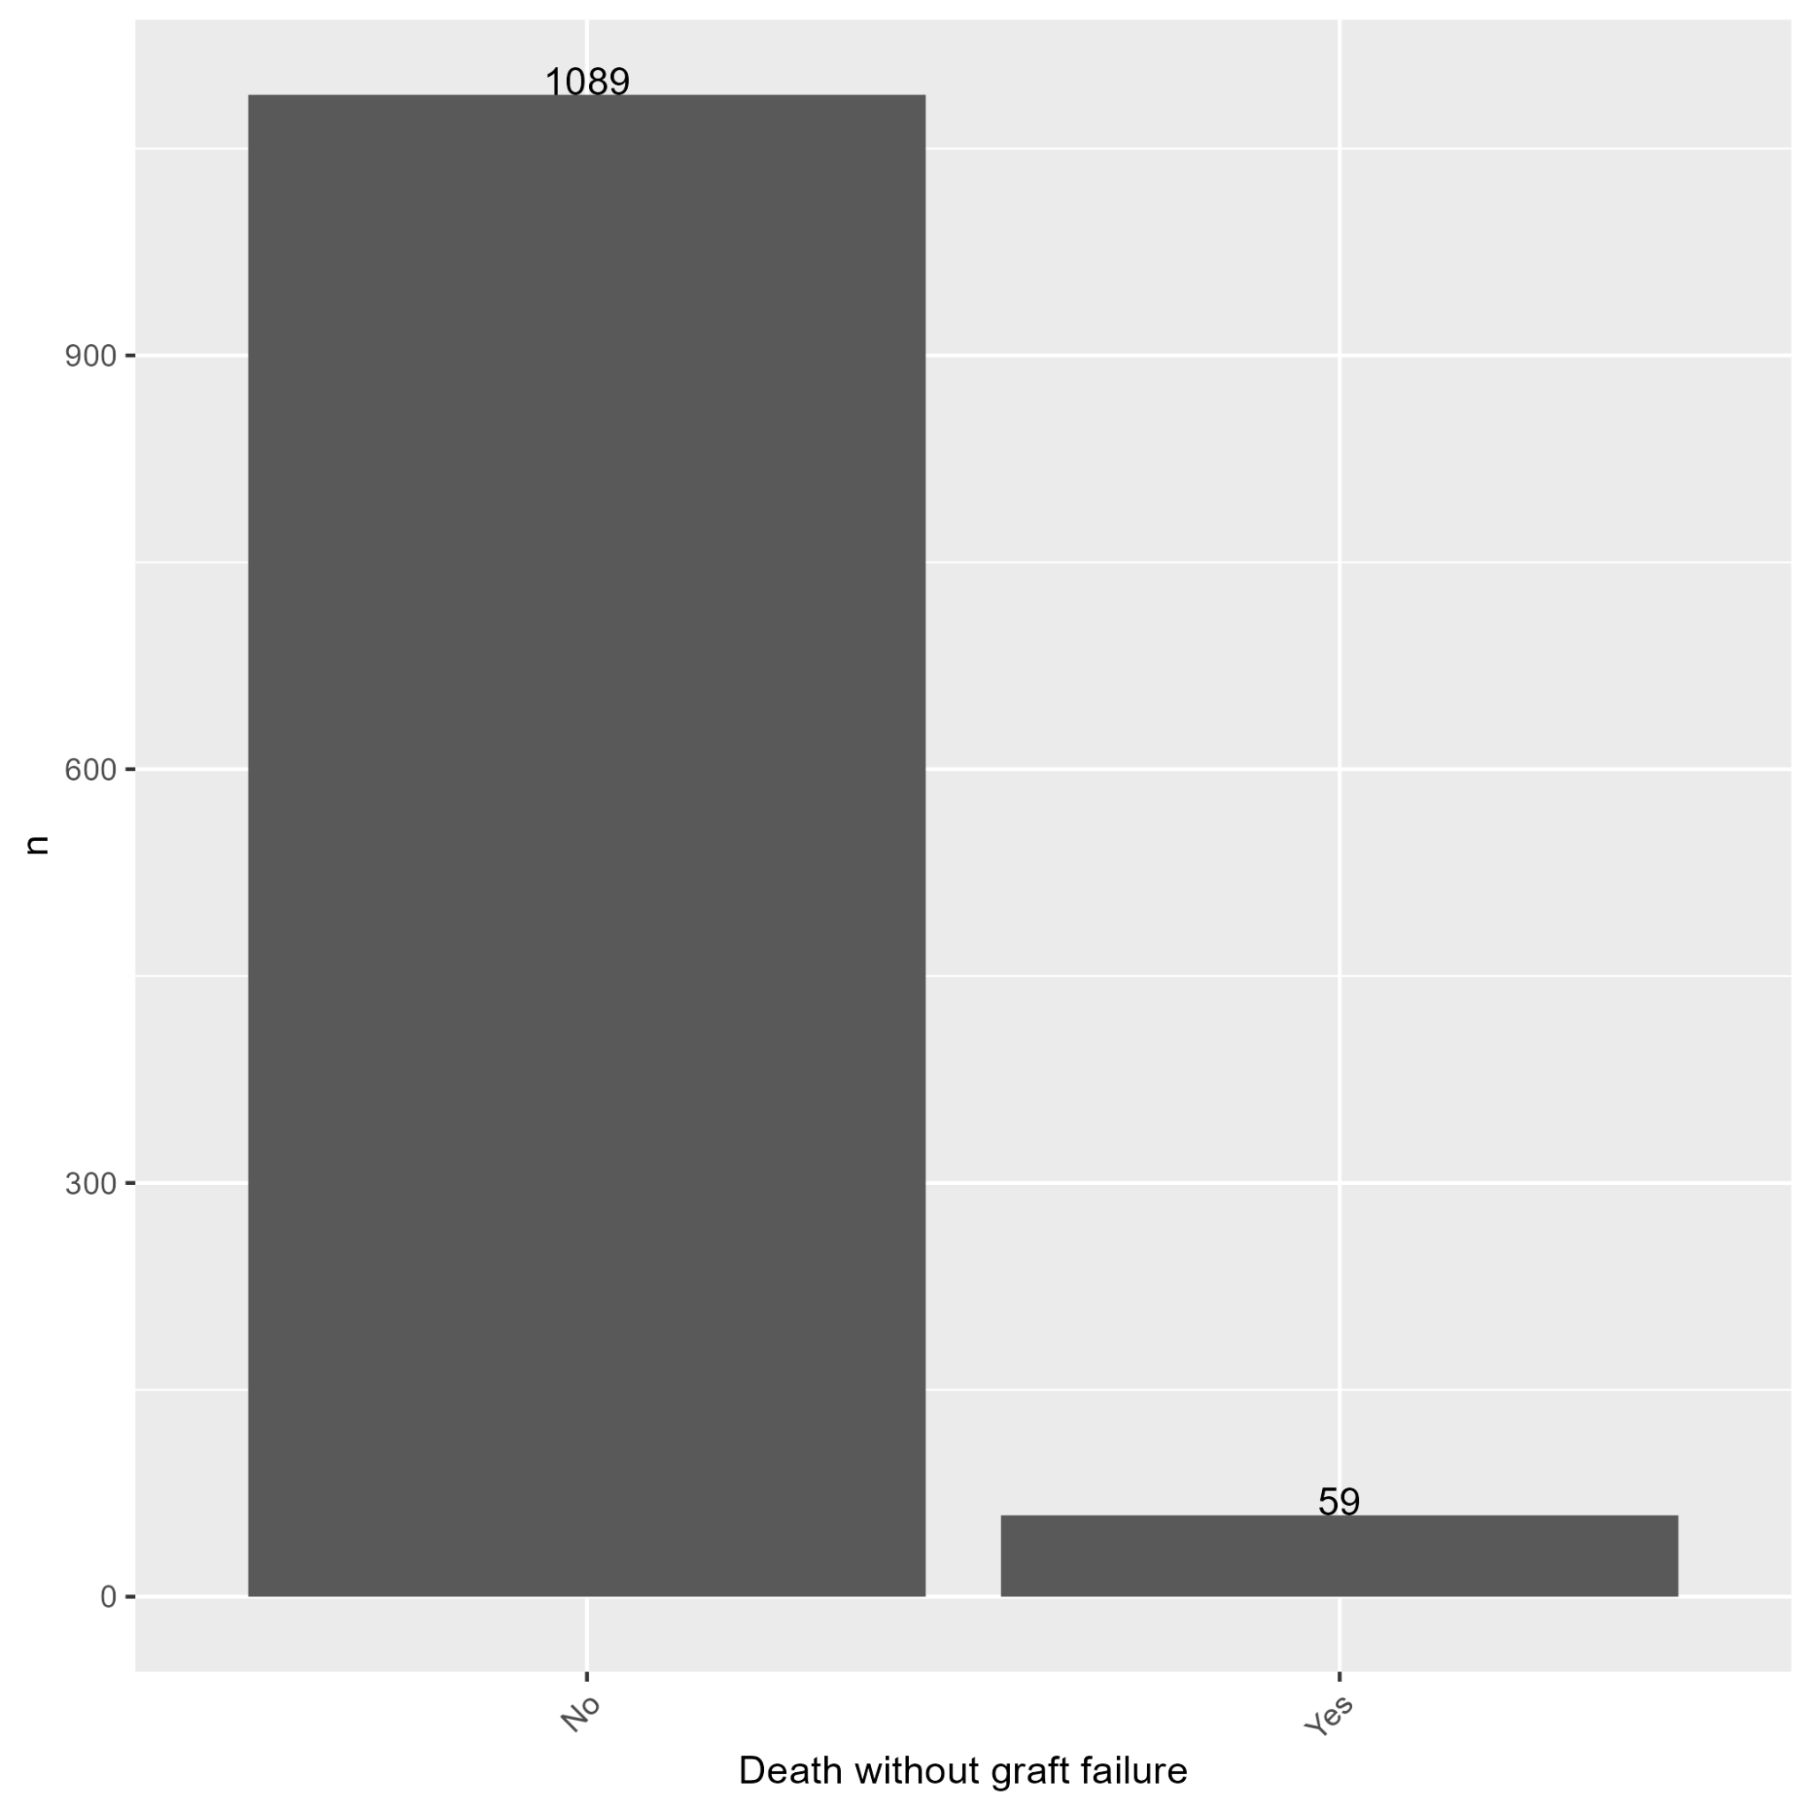

Plot 23: Distribution of Death without Platelet Recovery Event

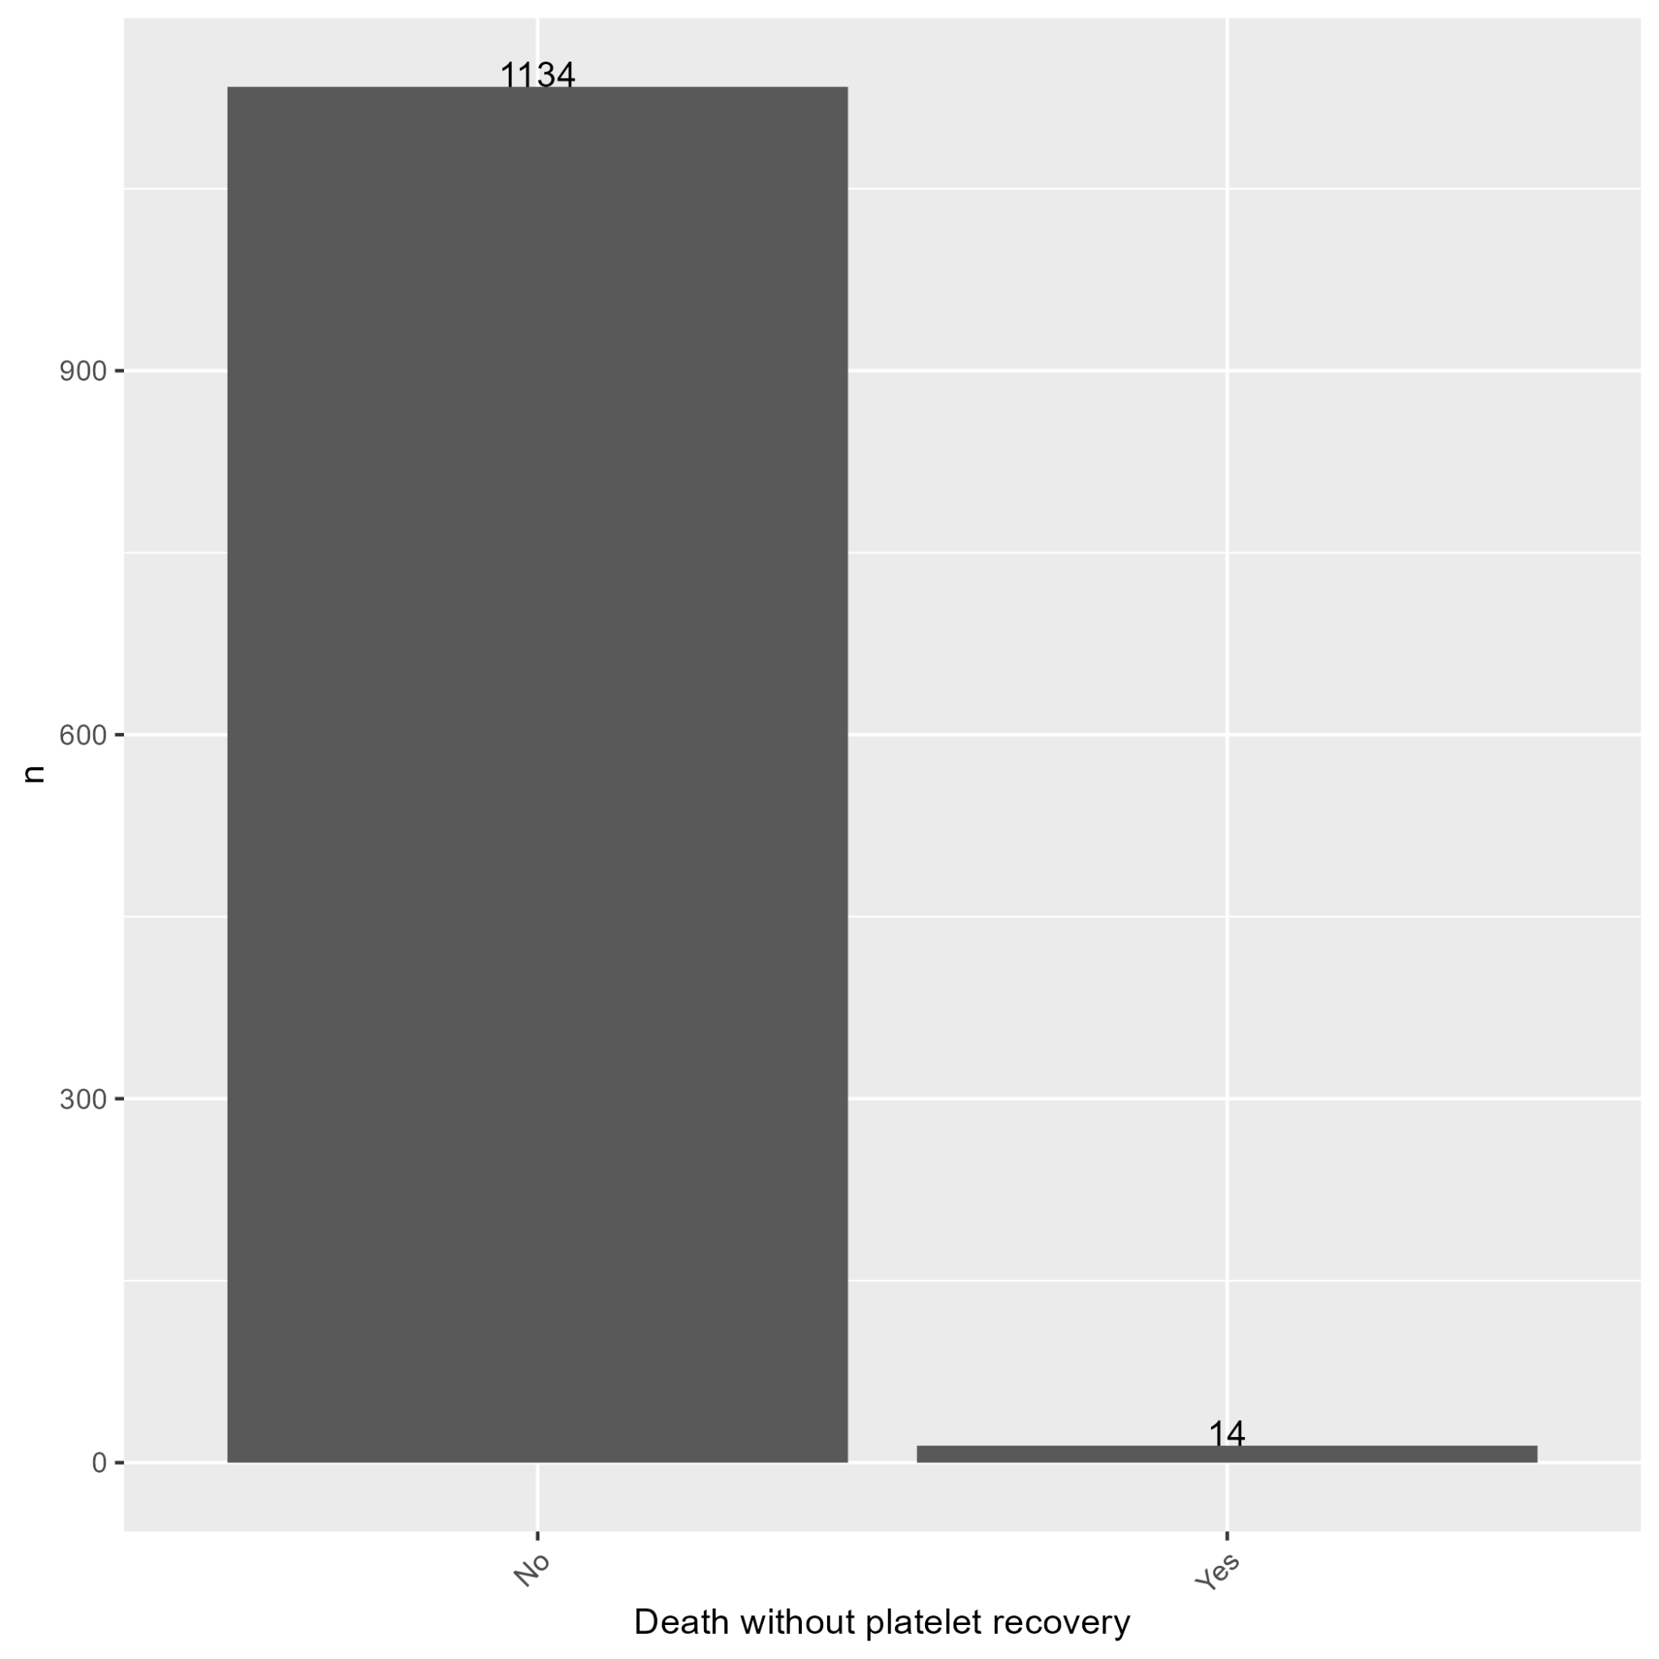

Plot 24: Distribution of Event-Free Survival (Graft Failure or Death are the Events)

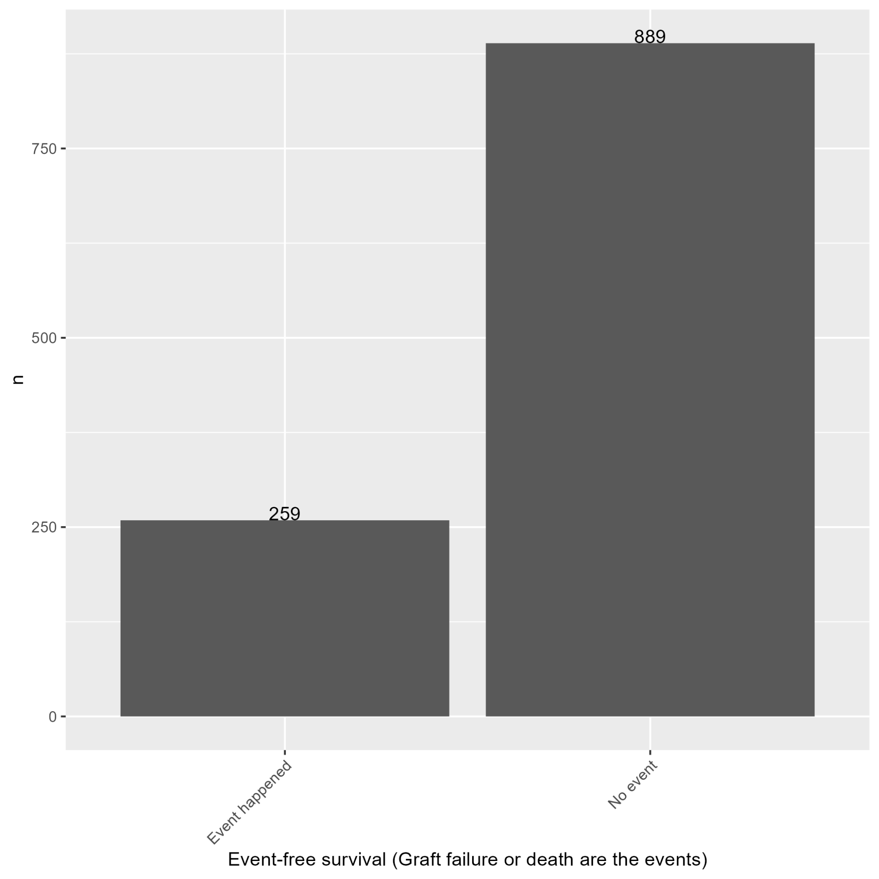

Plot 25: Distribution of Ethnicity

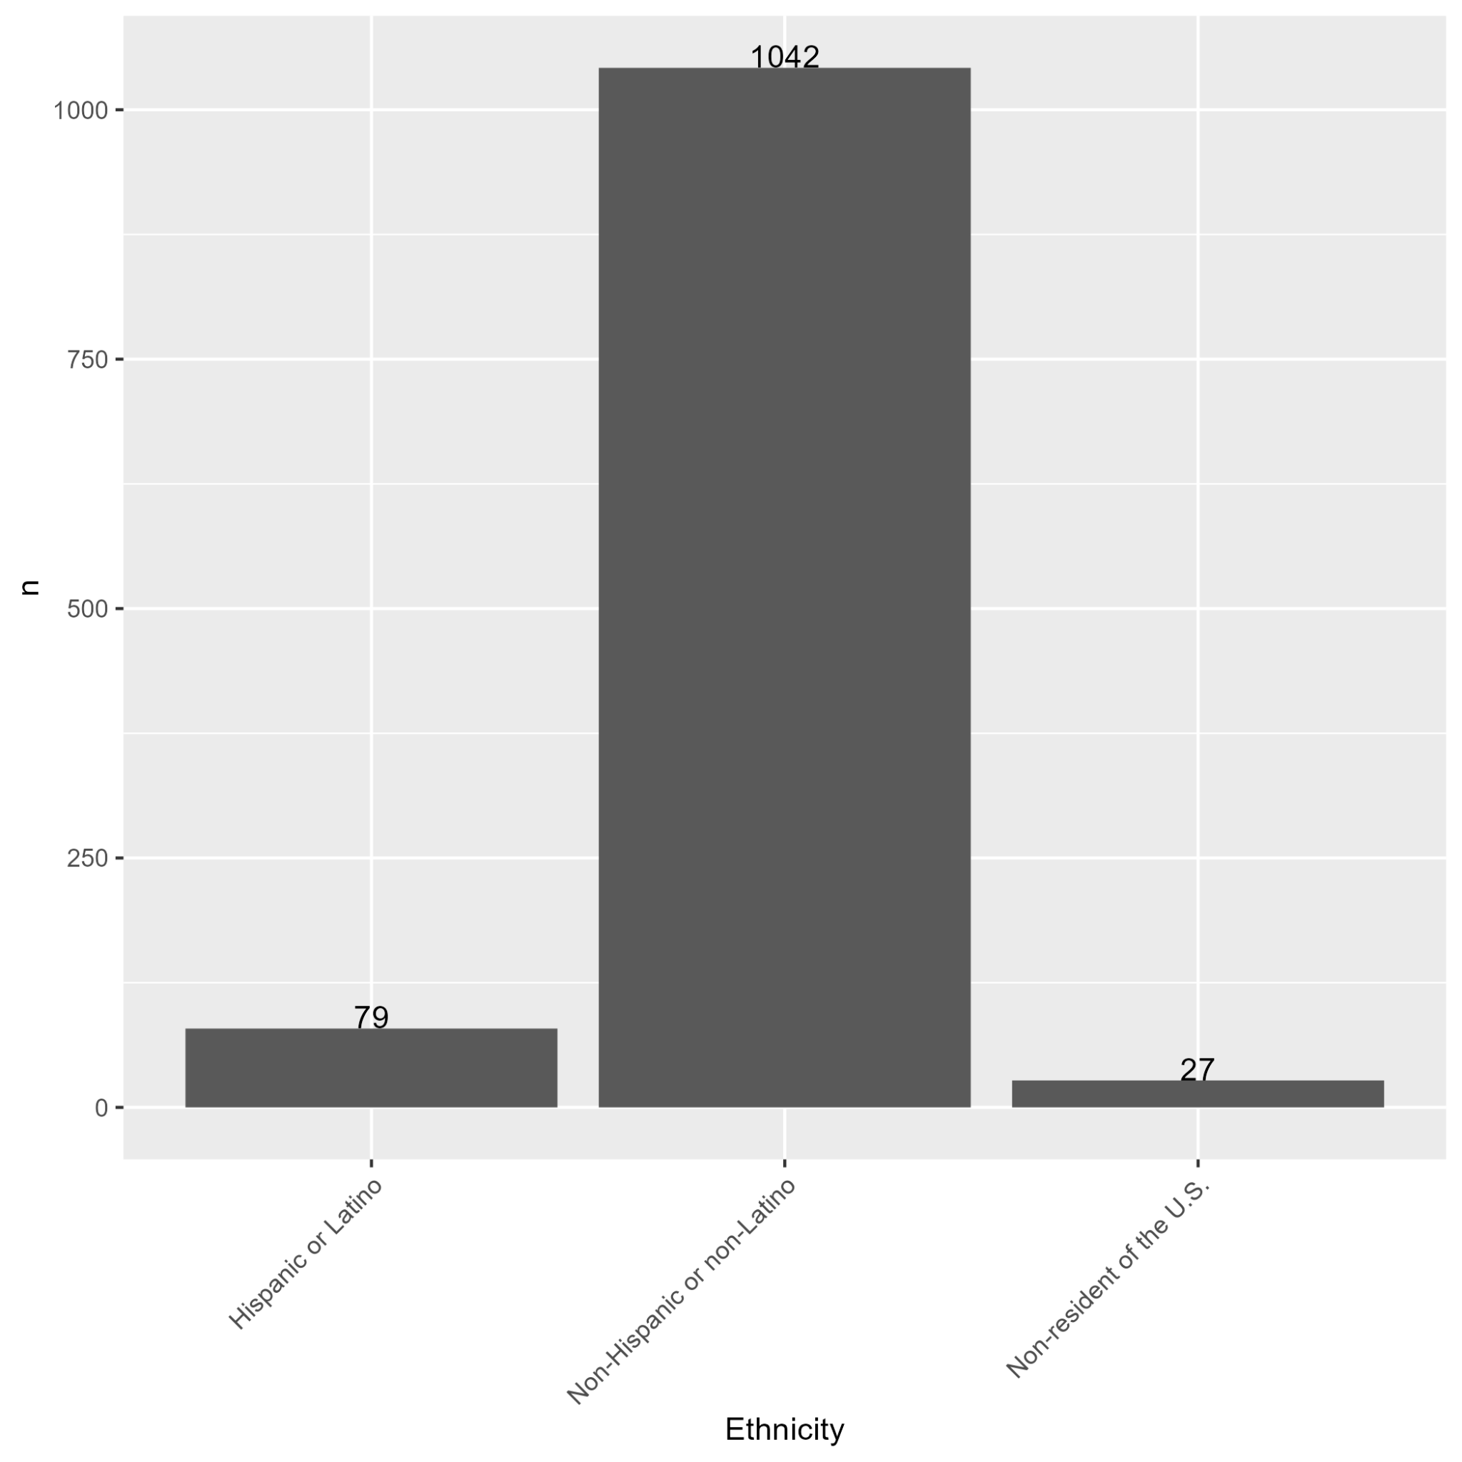

Plot 26: Distribution of Cases from BMT CTN 0601

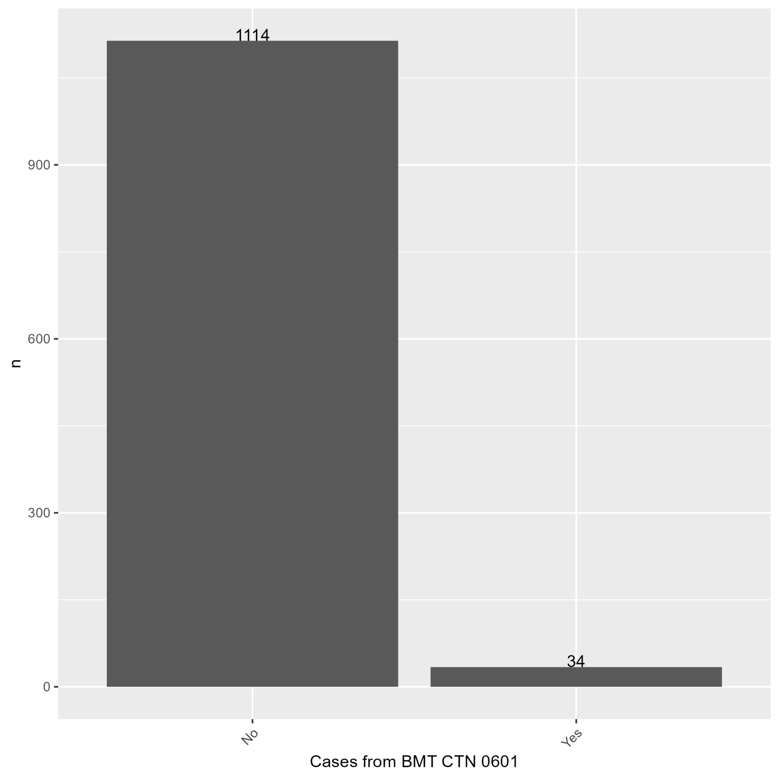

Plot 27: Distribution of Cases from 2016 Blood Publication

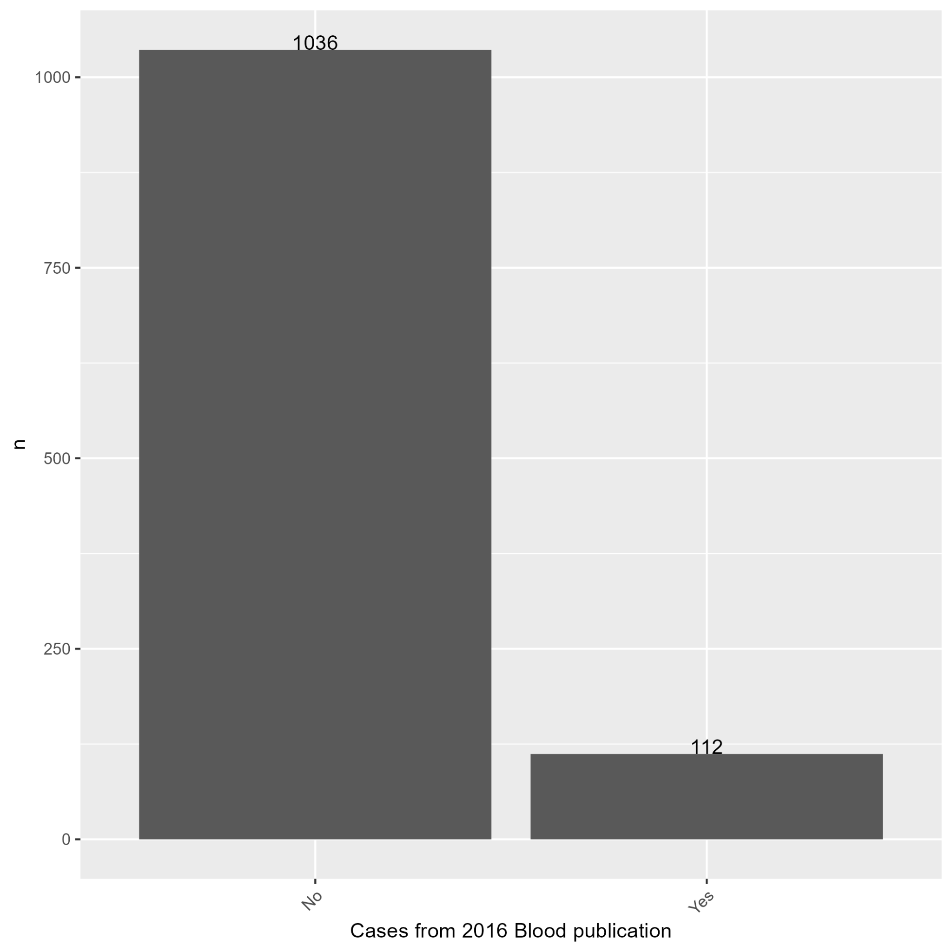

Plot 28: Distribution of Cases from 2019 Lancet Hematology Publication

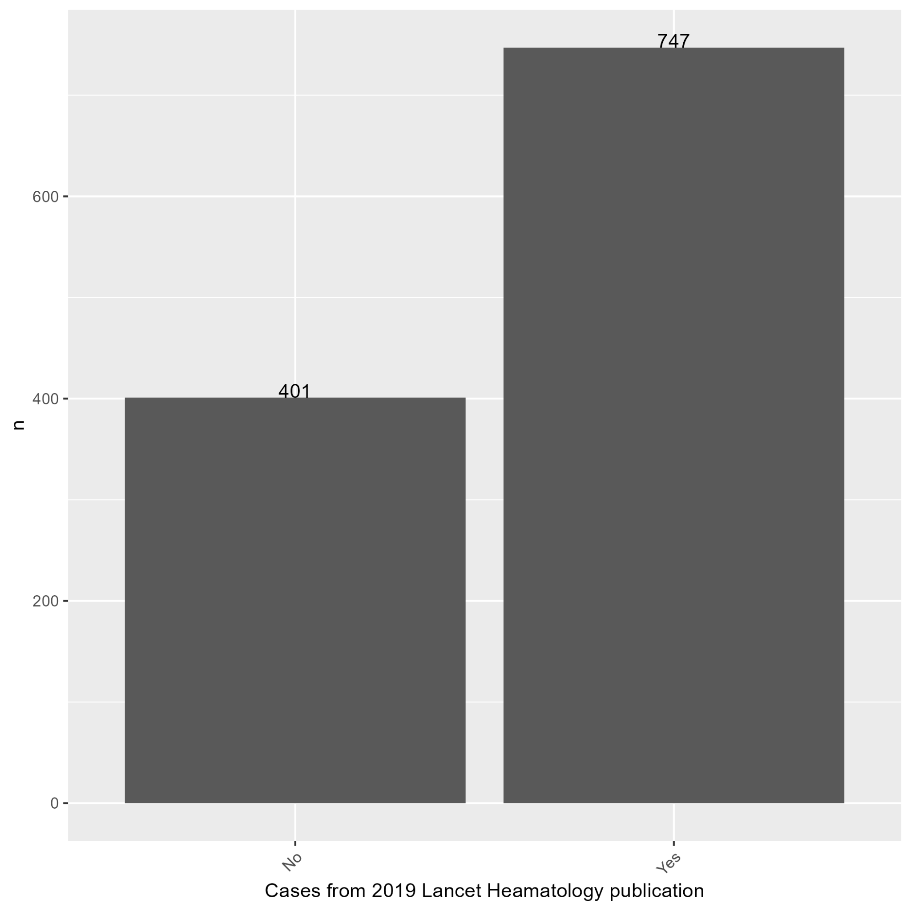

Plot 29: Distribution of Graft Failure Event

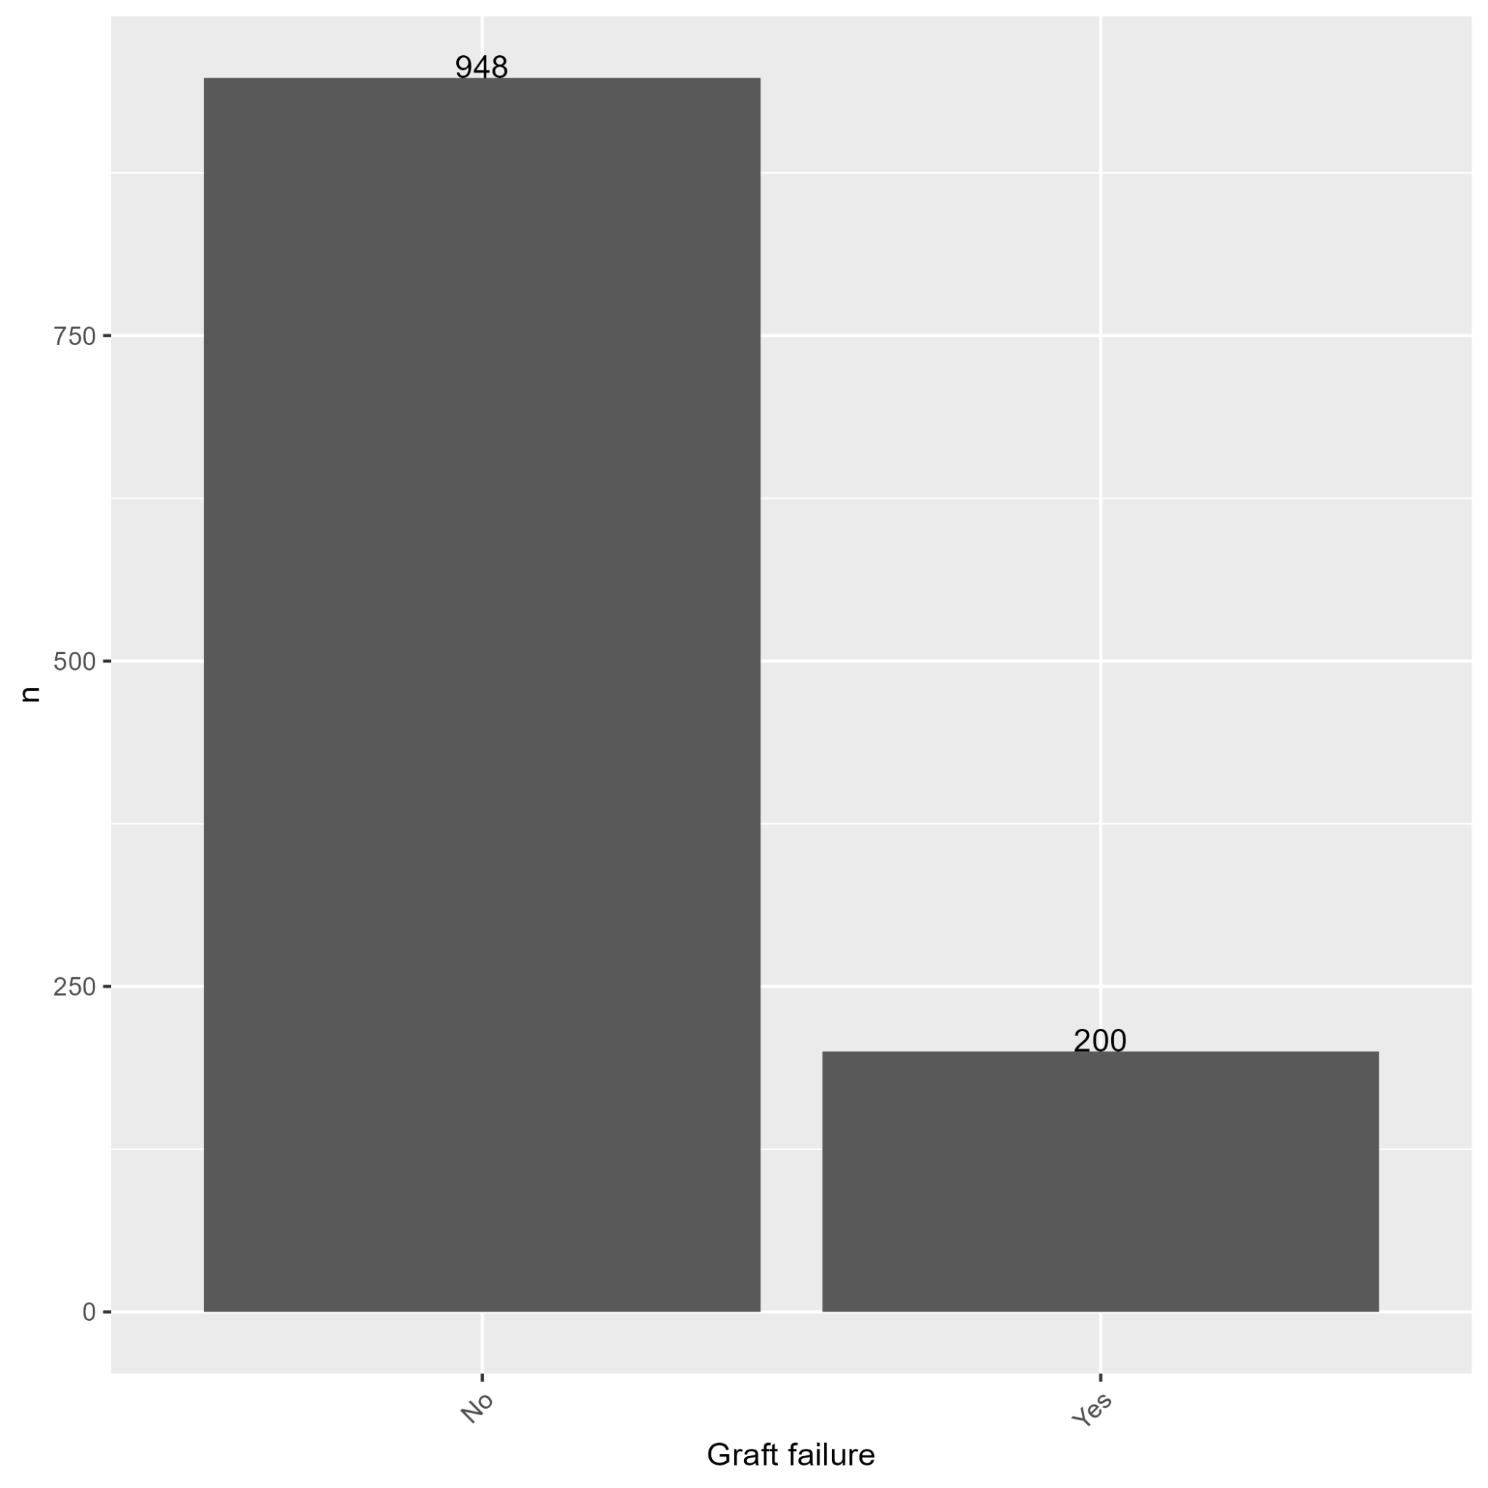

Plot 30: Distribution of Graft Type

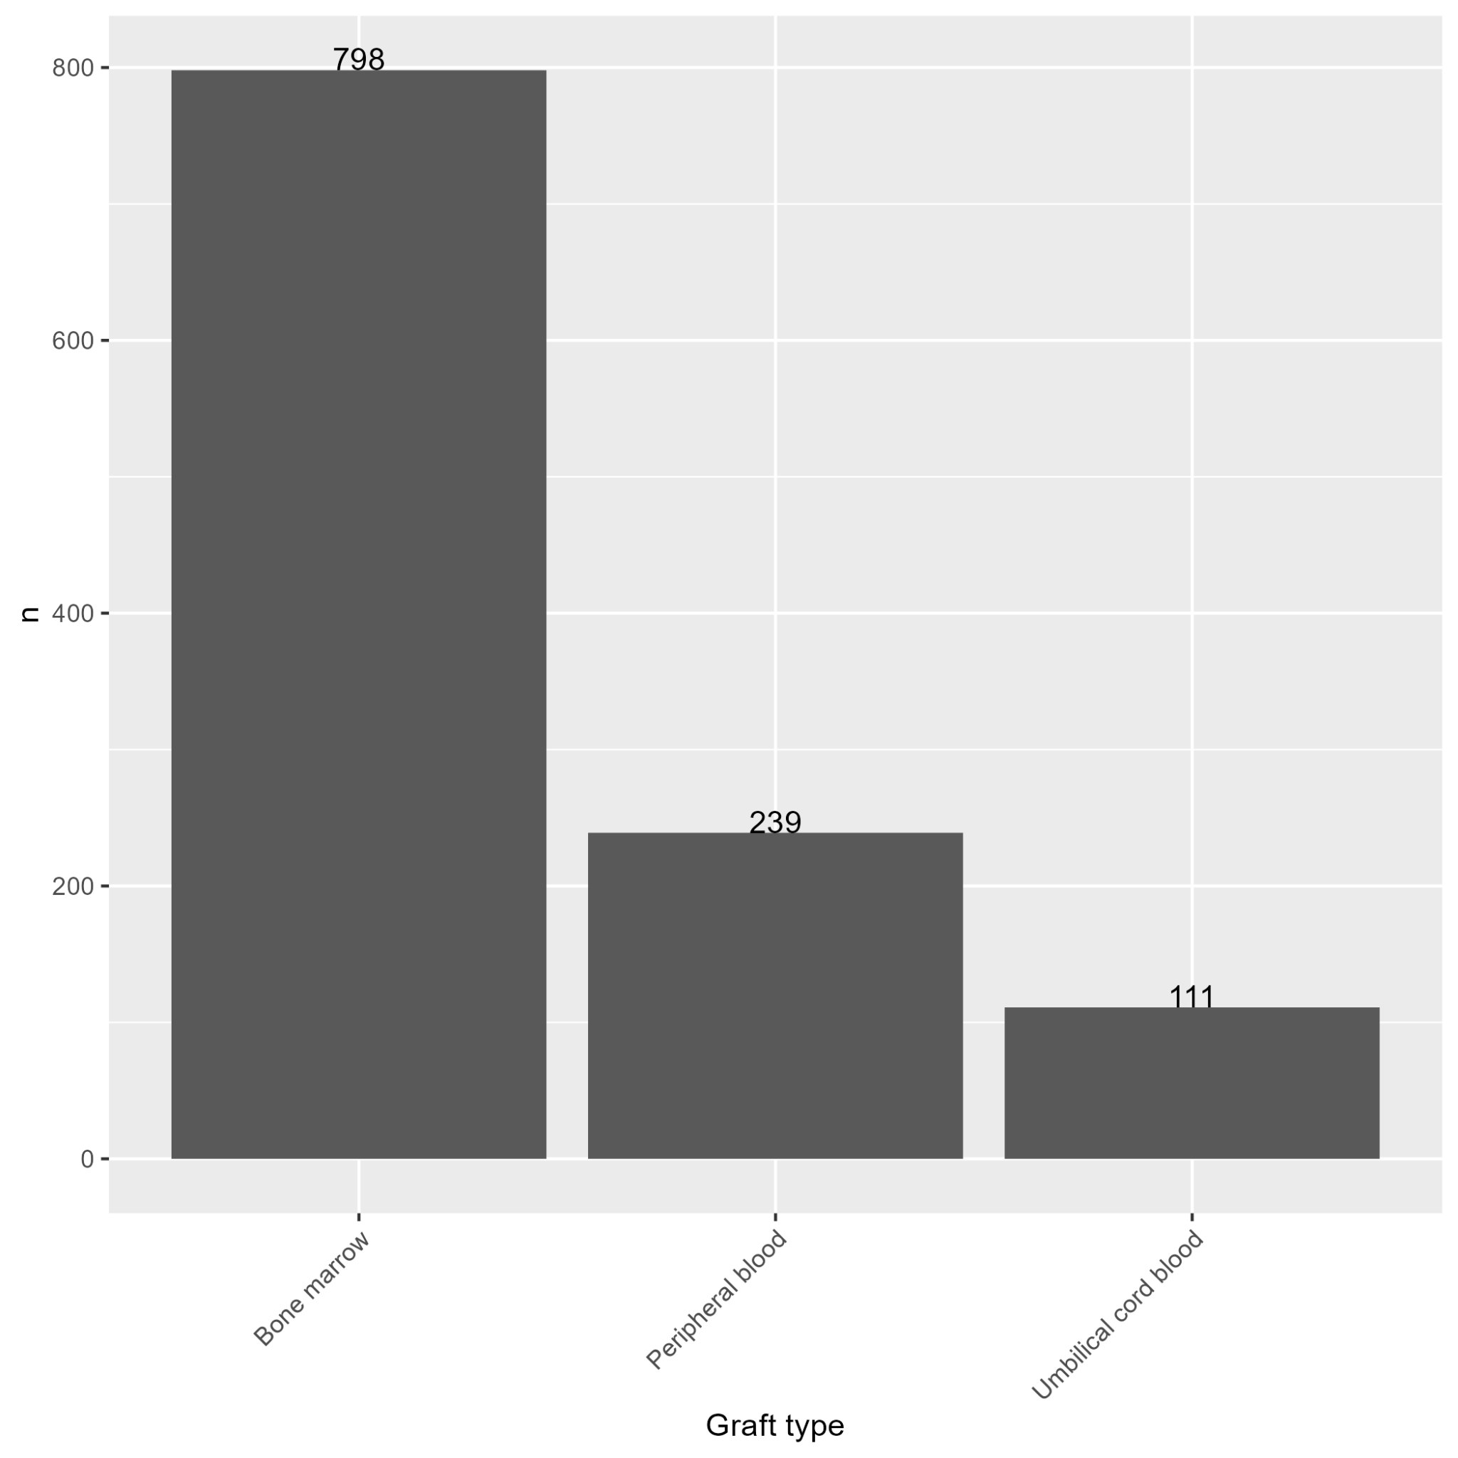

Plot 31: Distribution of GVHD Prophylaxis

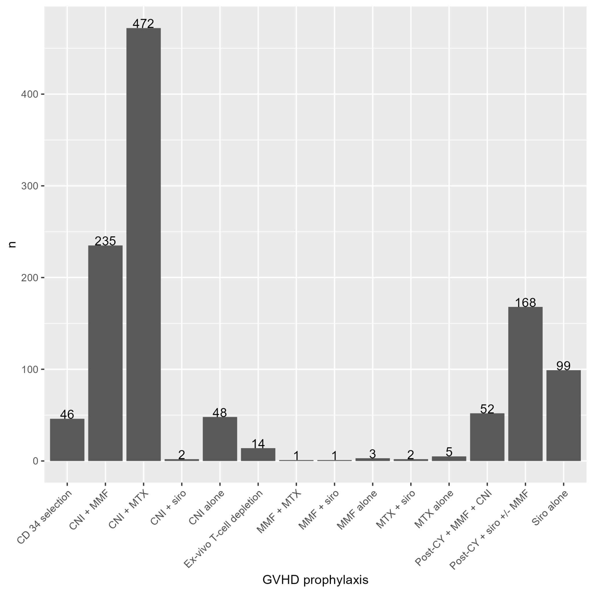

Plot 32: Distribution of HCT-Comorbidity Index

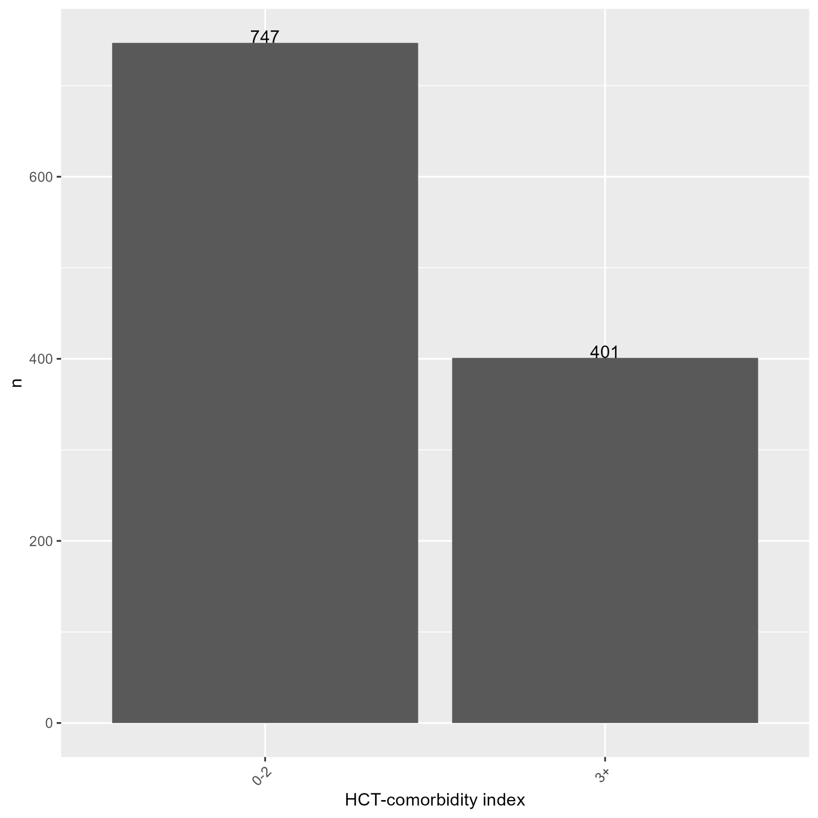

Plot 33: Distribution of Donor-Recipient HLA Matching

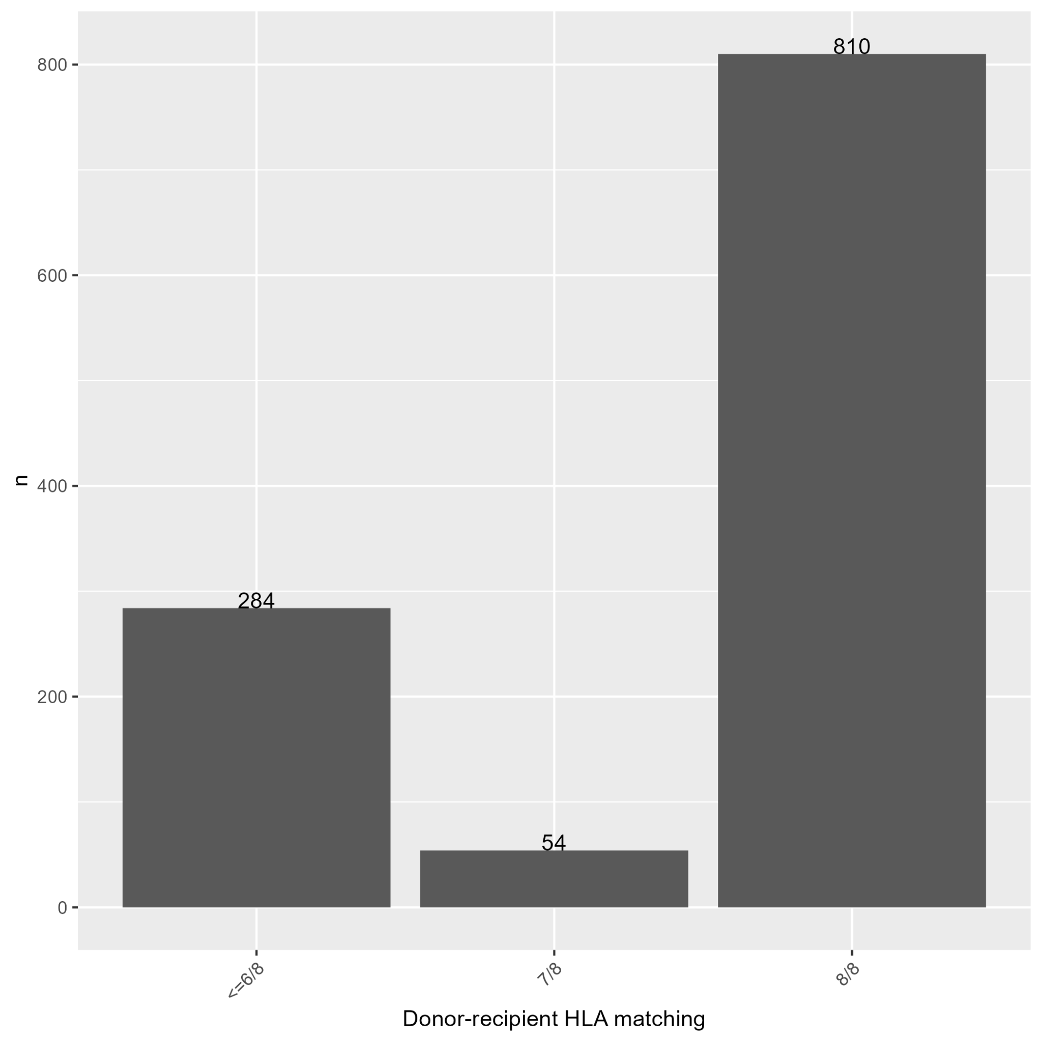

Plot 34: Distribution of Karnofsky/Lansky Score at HCT

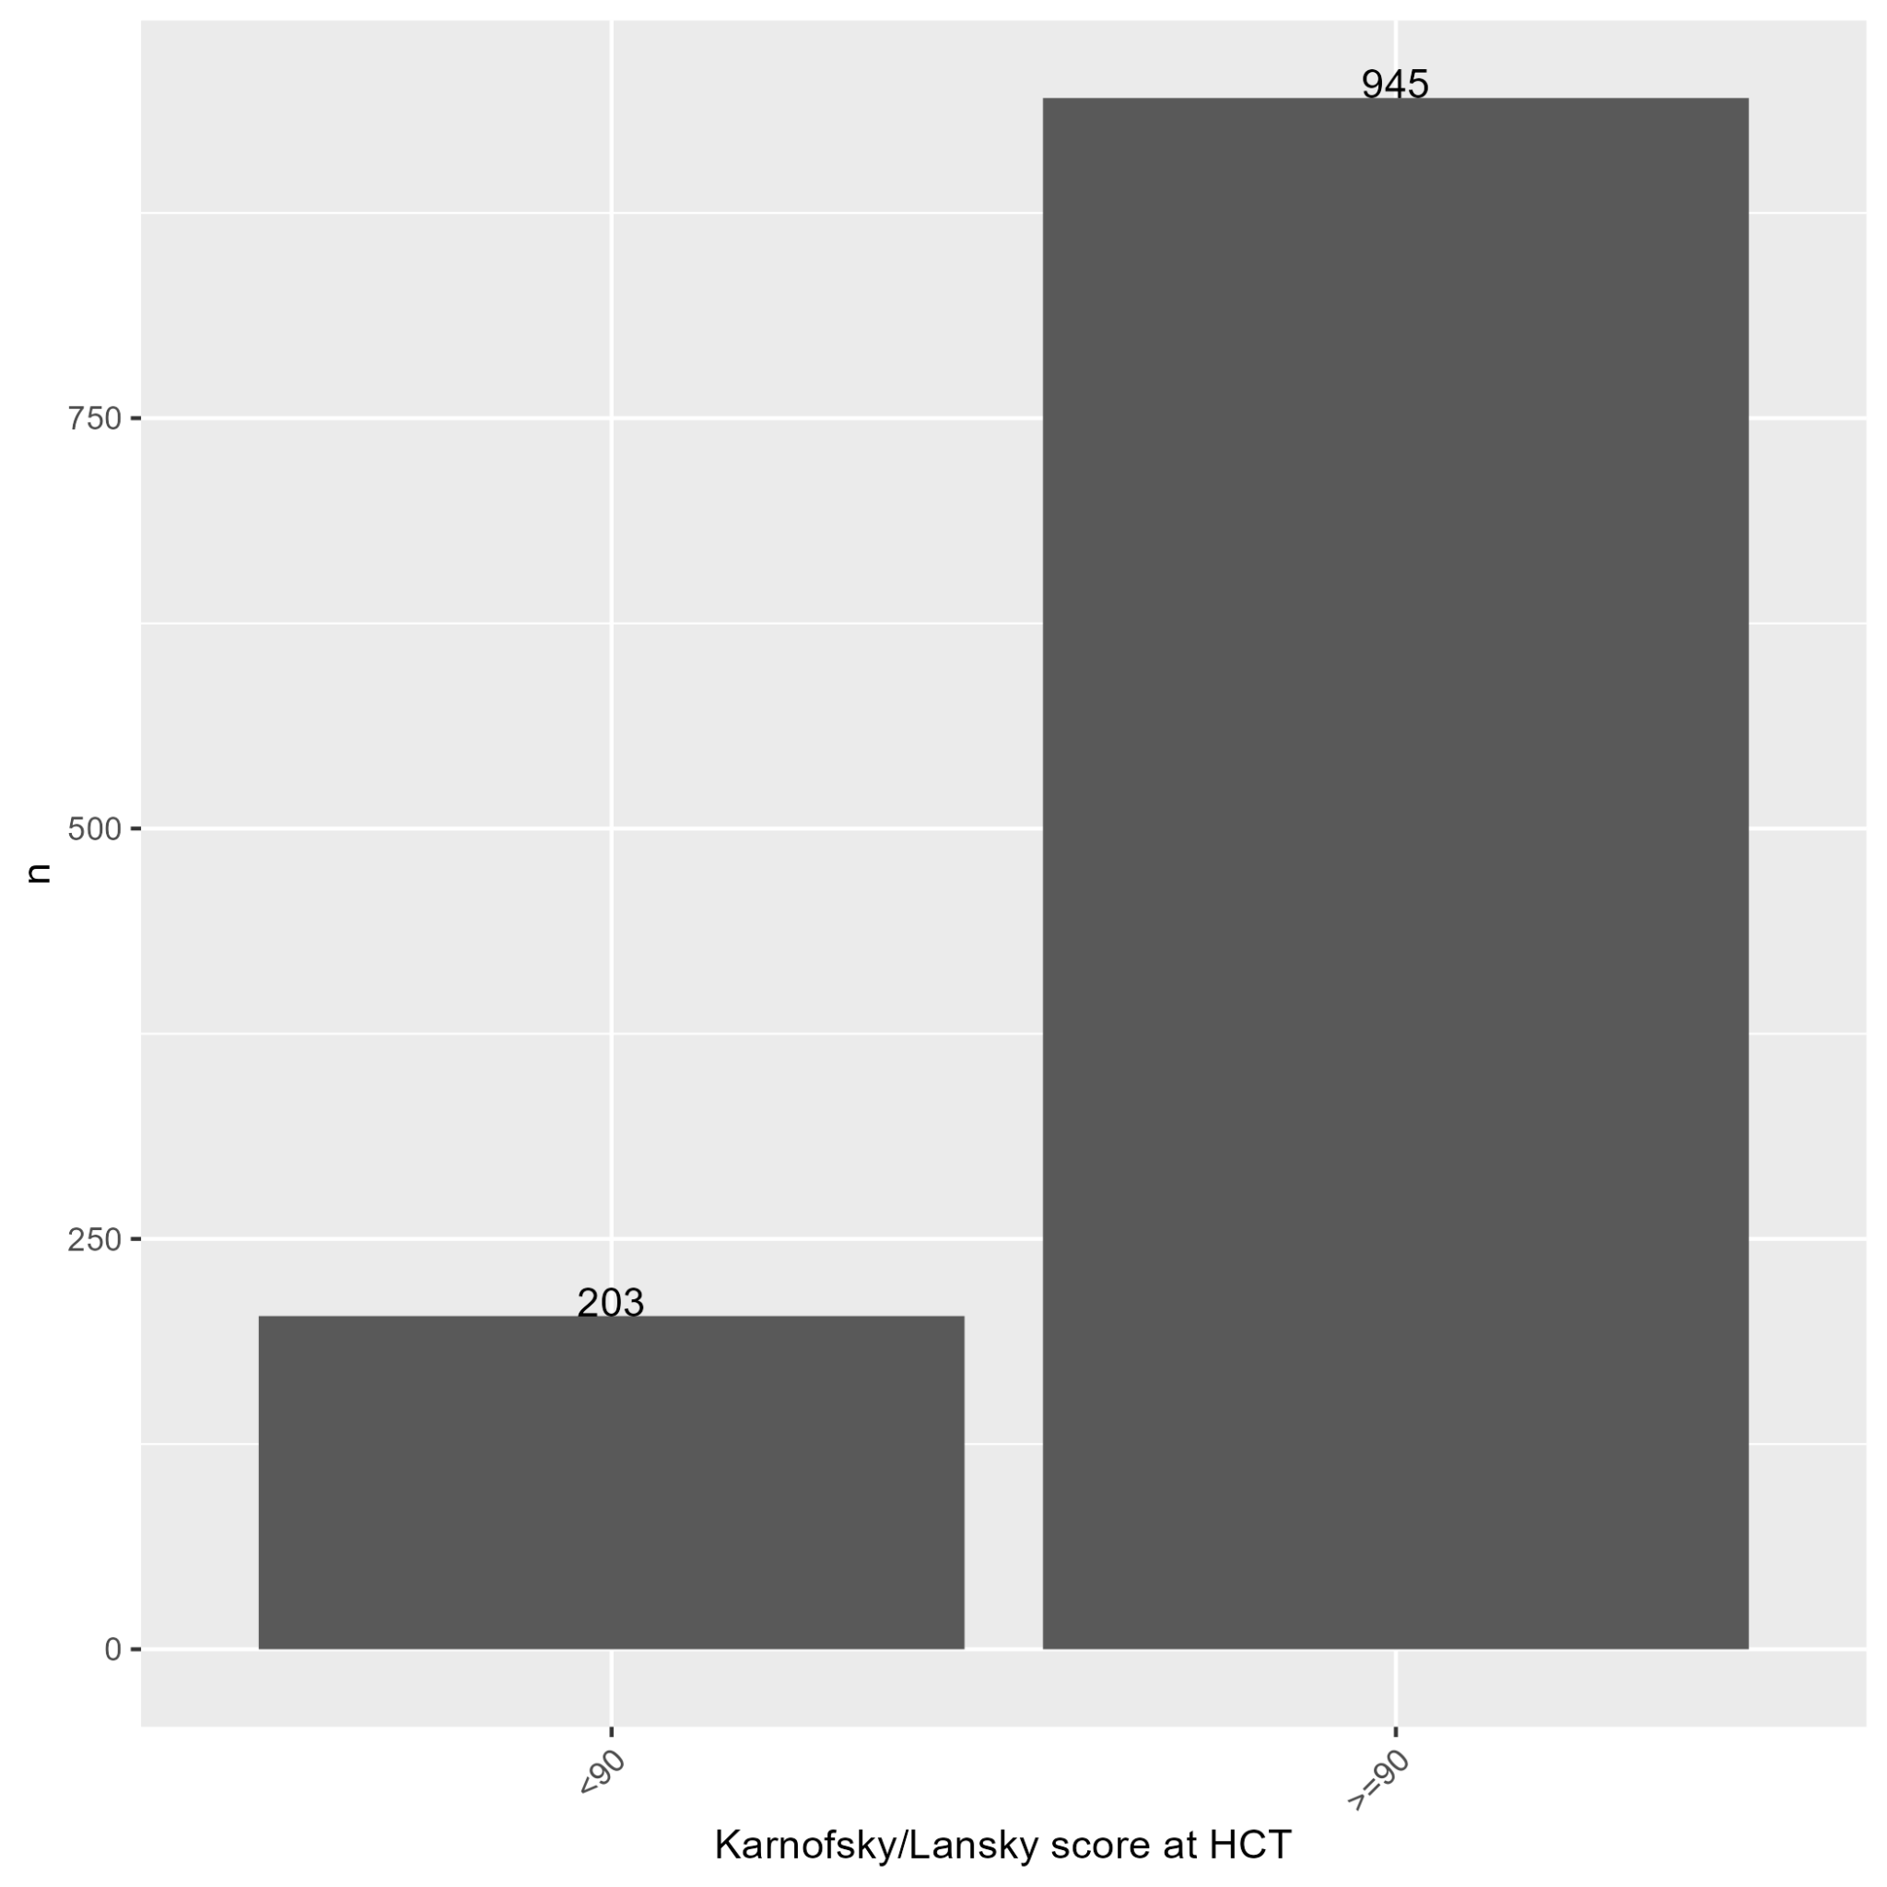

Plot 35: Distribution of Platelet Recovery Event

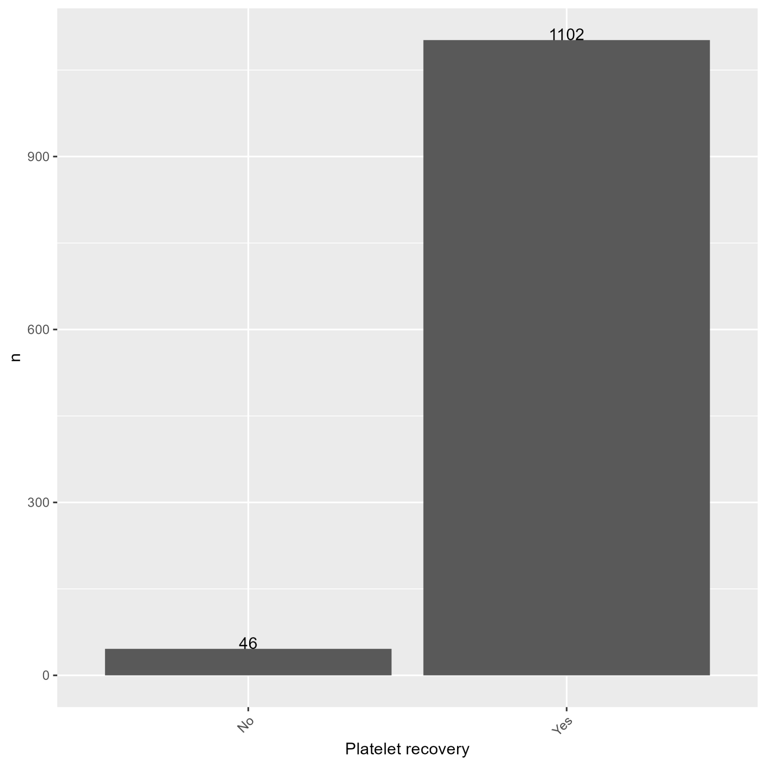

Plot 36: Distribution of PTLD Event

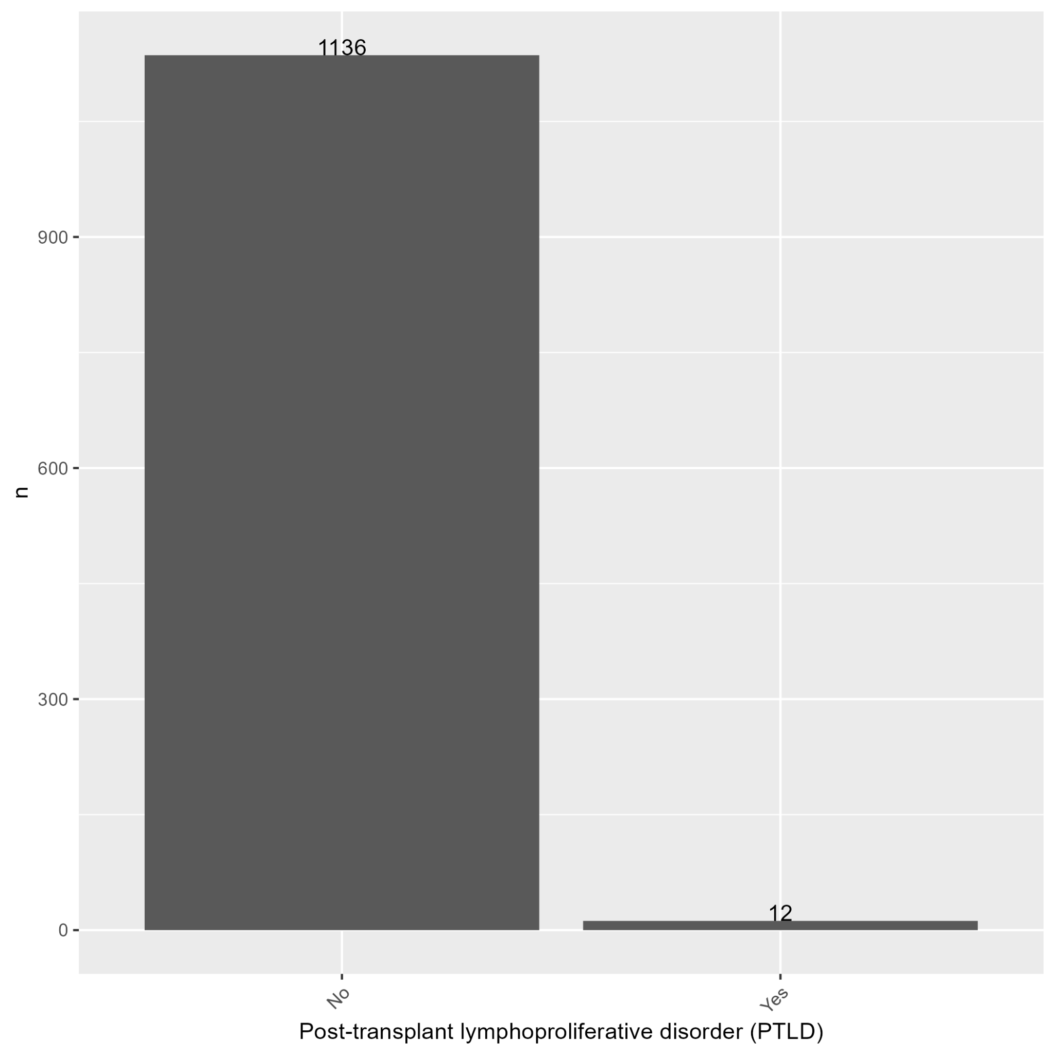

Plot 37: Distribution of Race

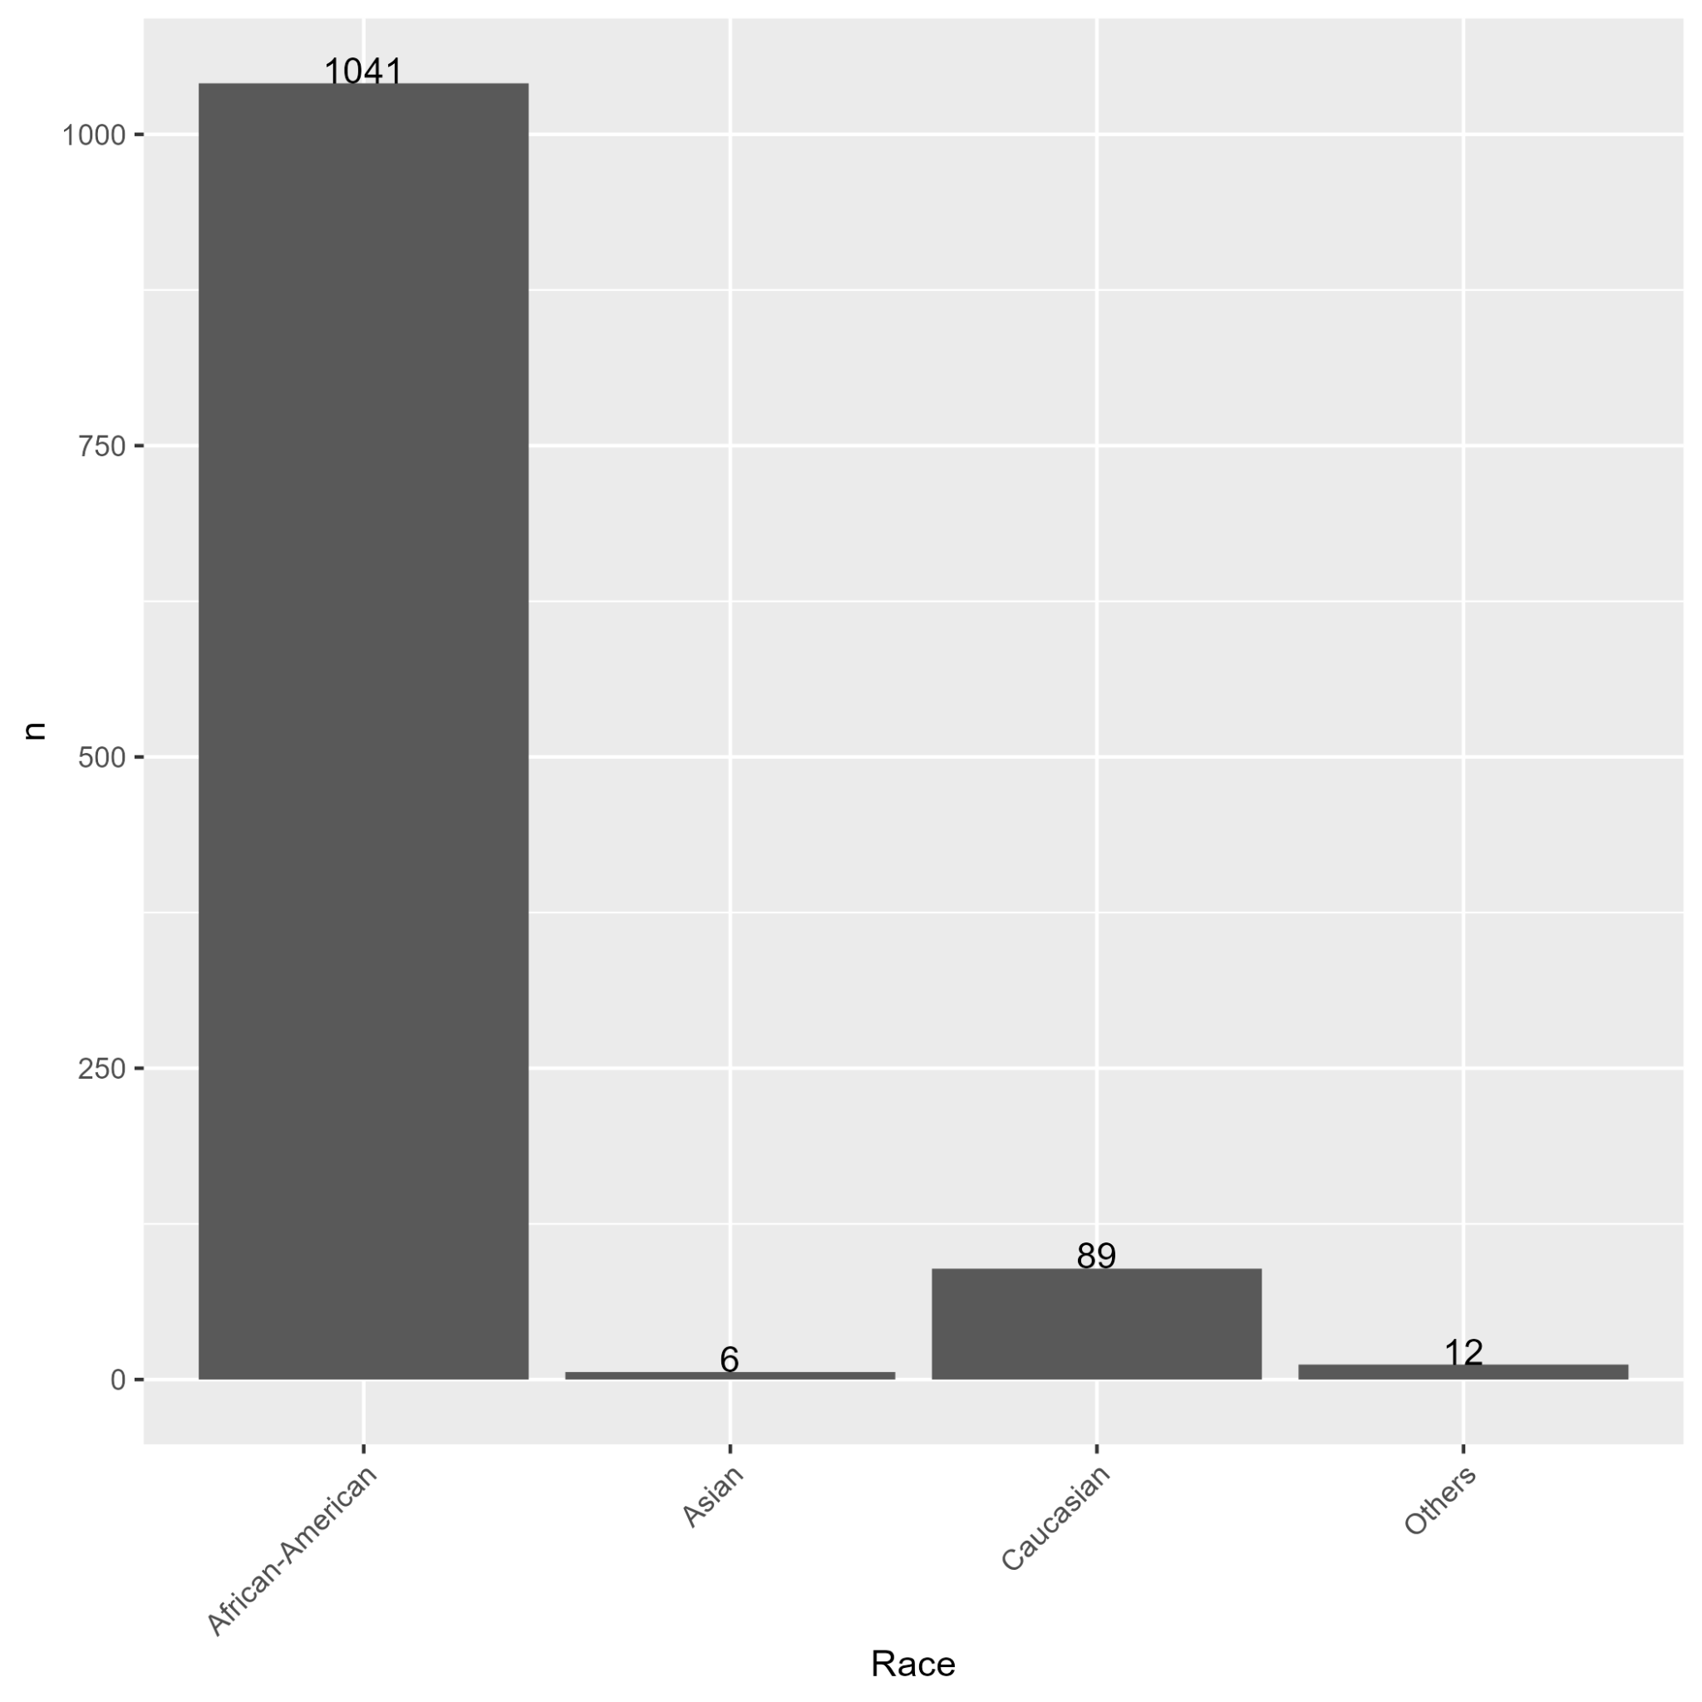

Plot 38: Distribution of Recipient CMV Serostatus

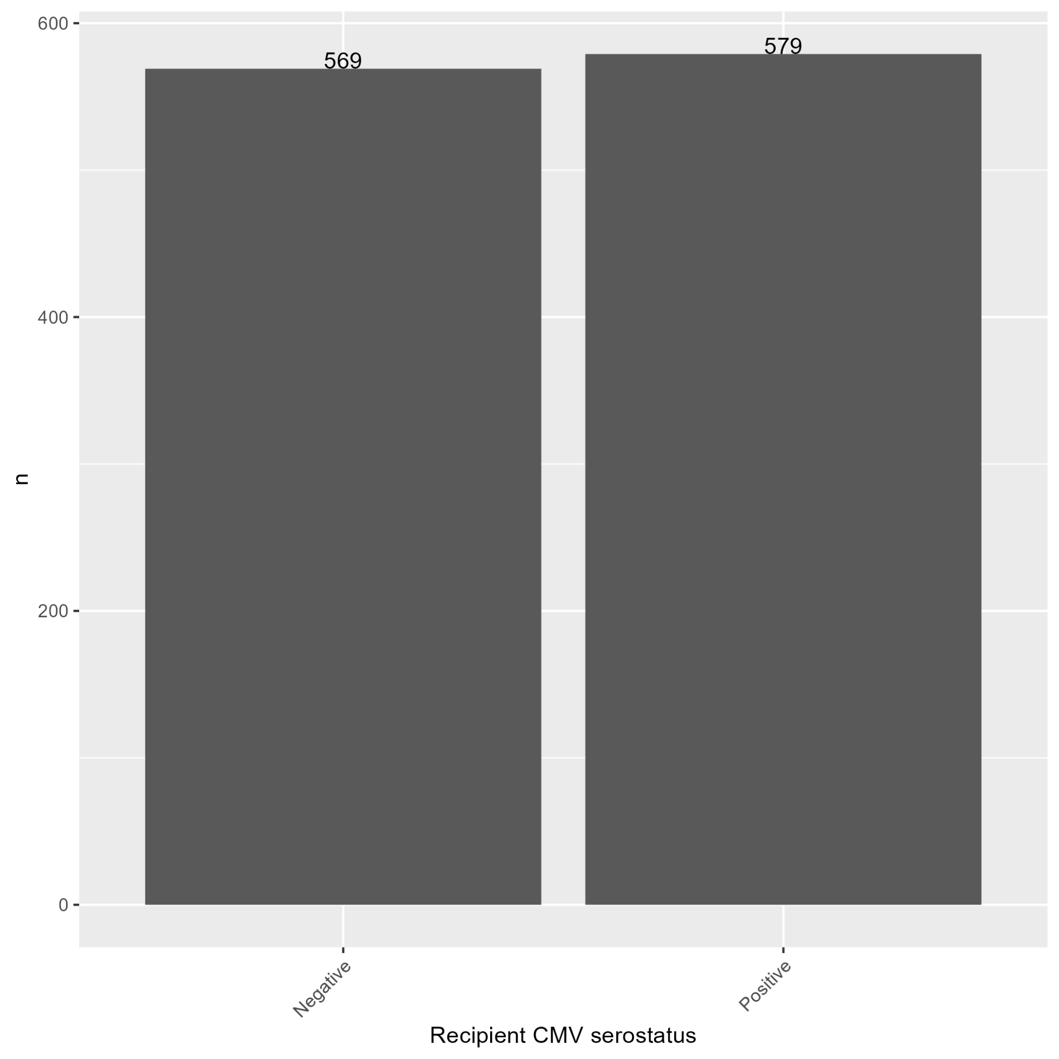

Plot 39: Distribution of Second Malignancy Event

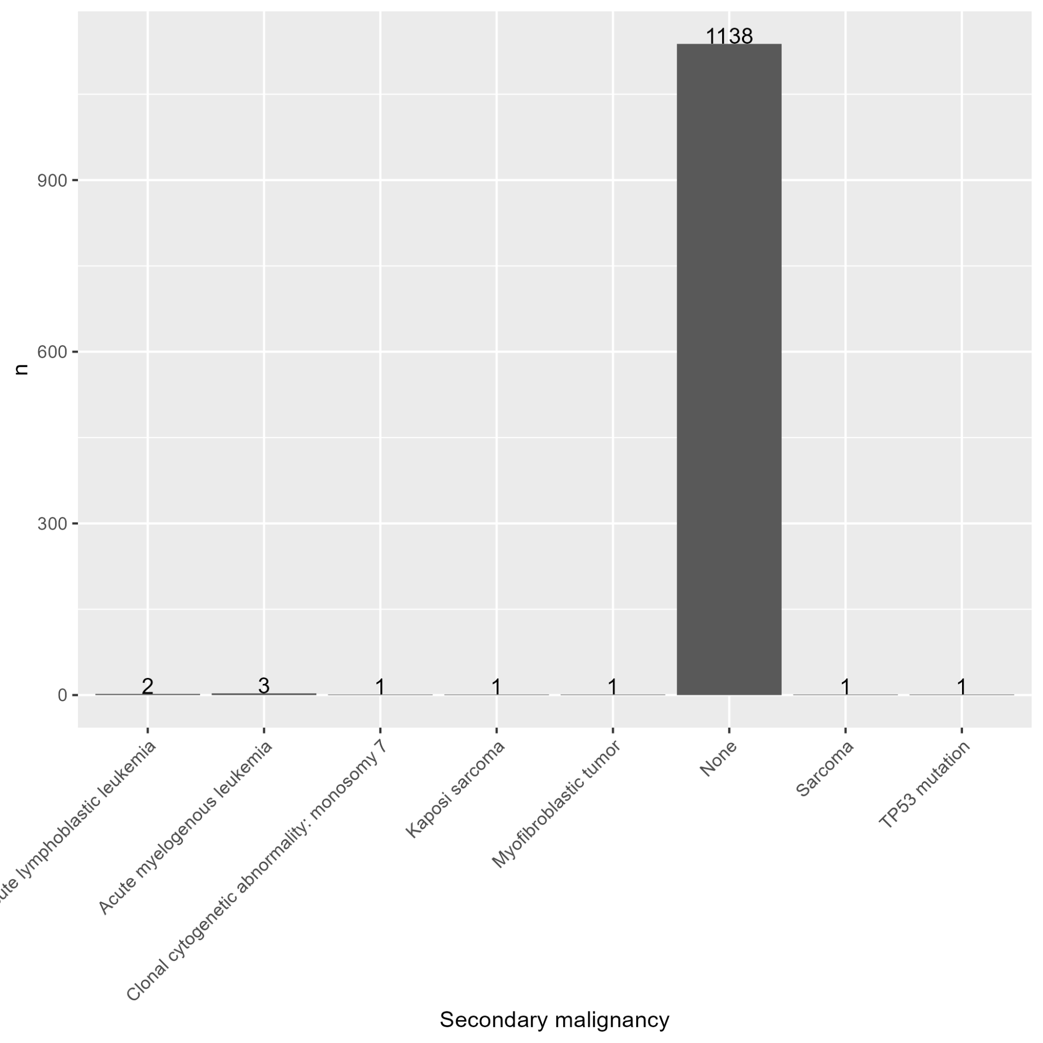

Plot 40: Distribution of Sex

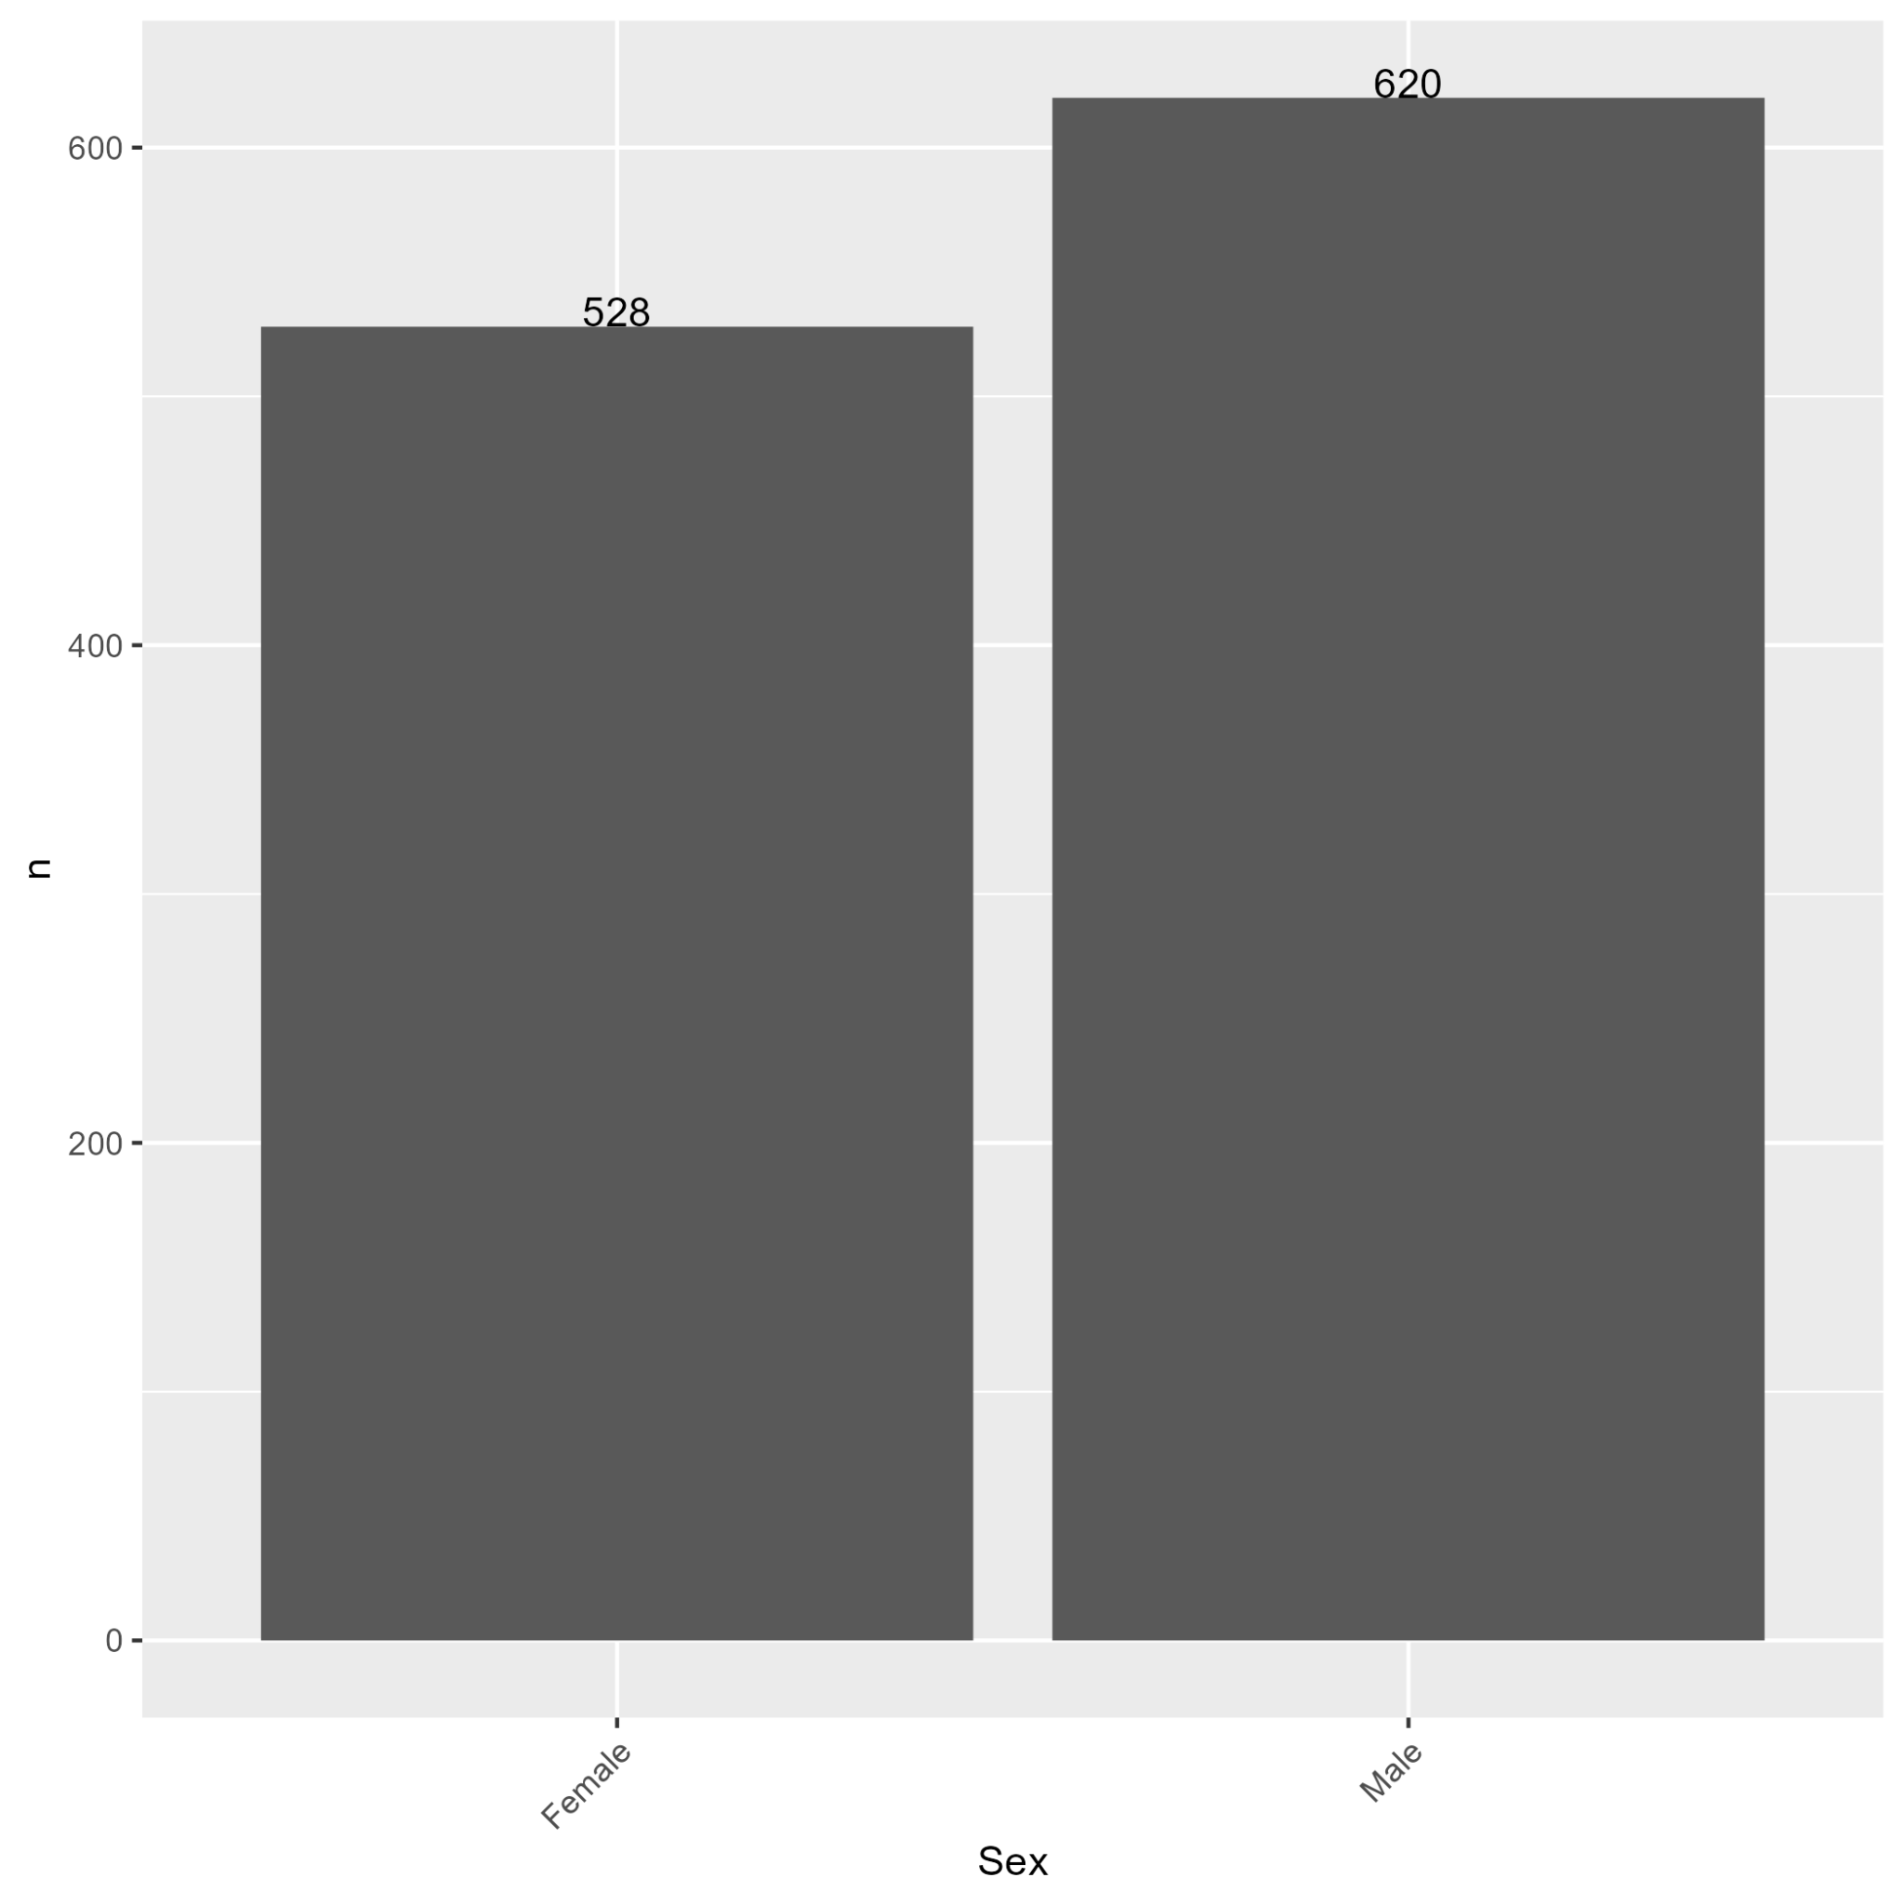

Plot 41: Distribution of Disease Genotype

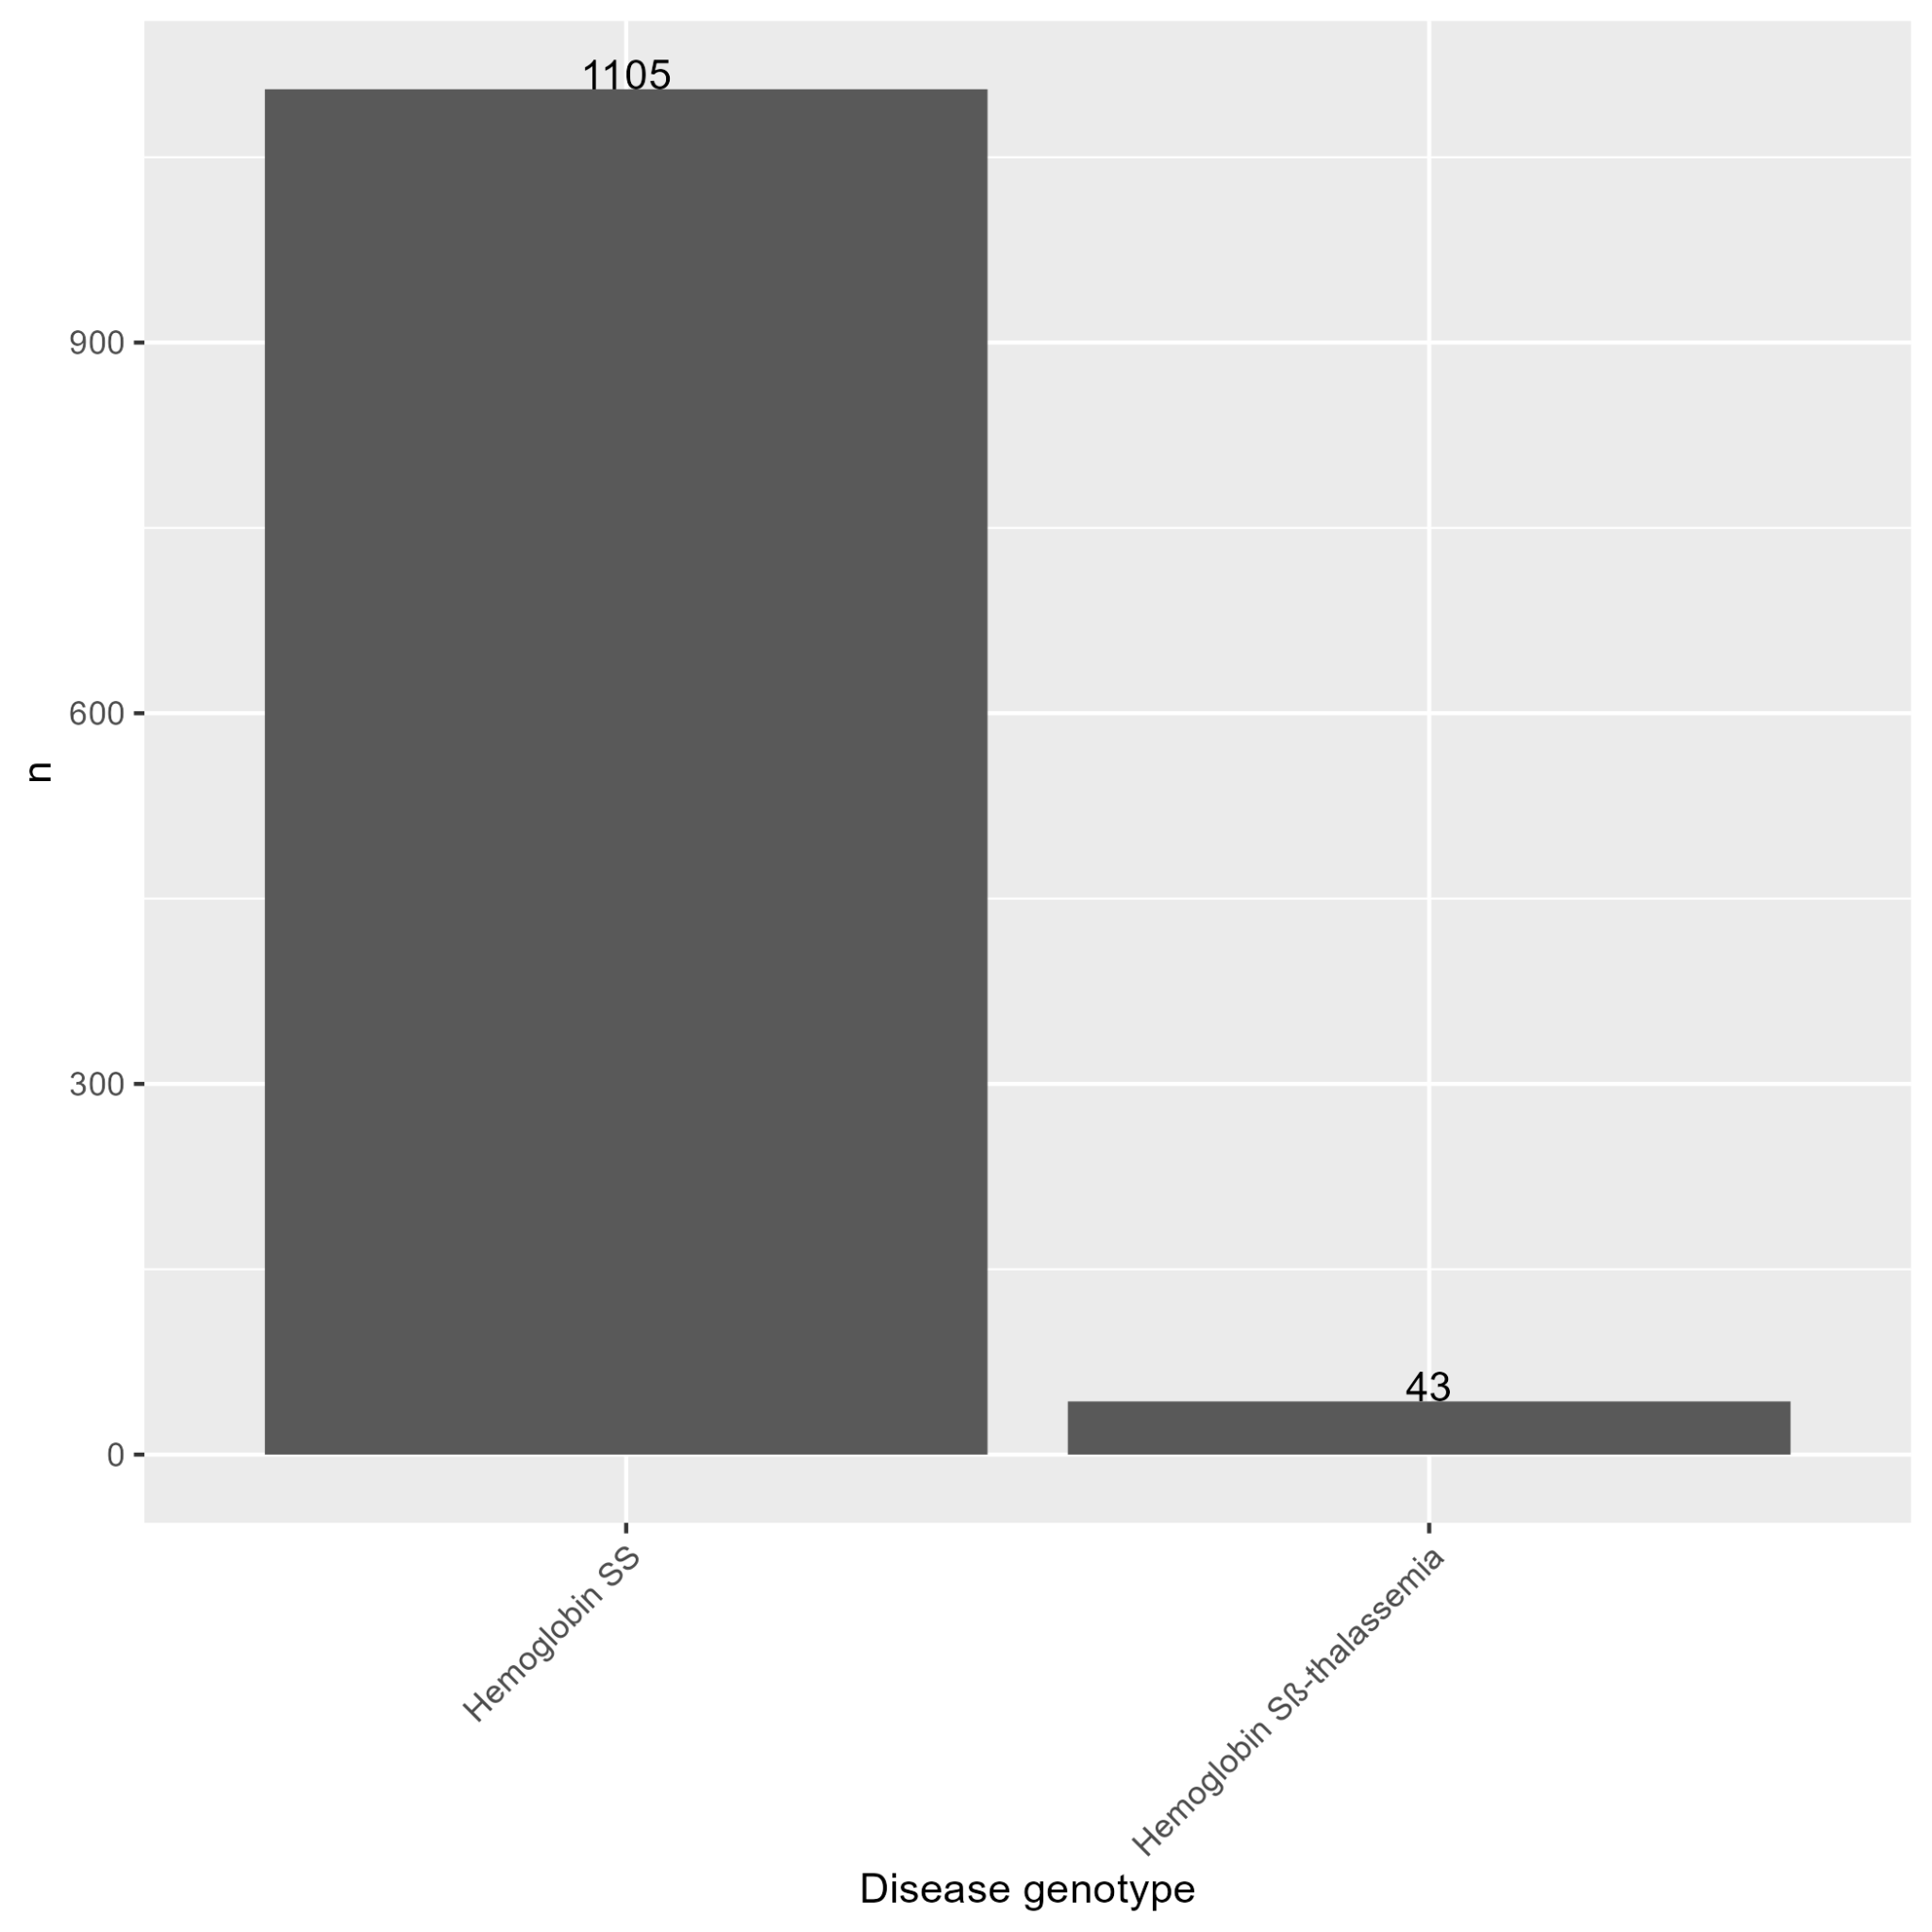

Plot 42: Distribution of Year of Transplant Categories

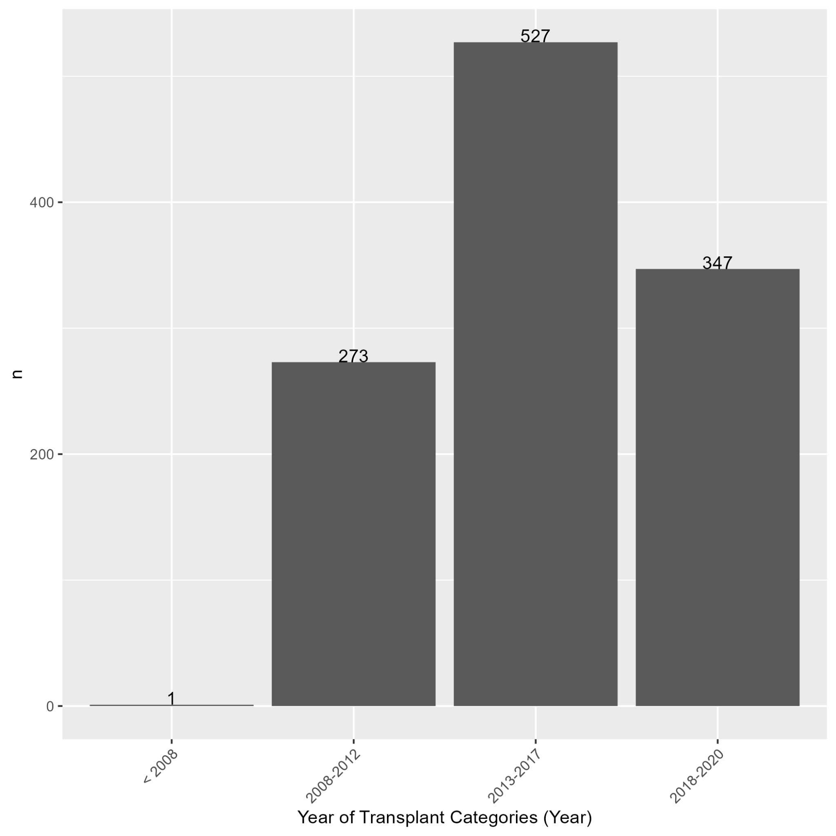

Plot 43: Distribution of Year of Transplant

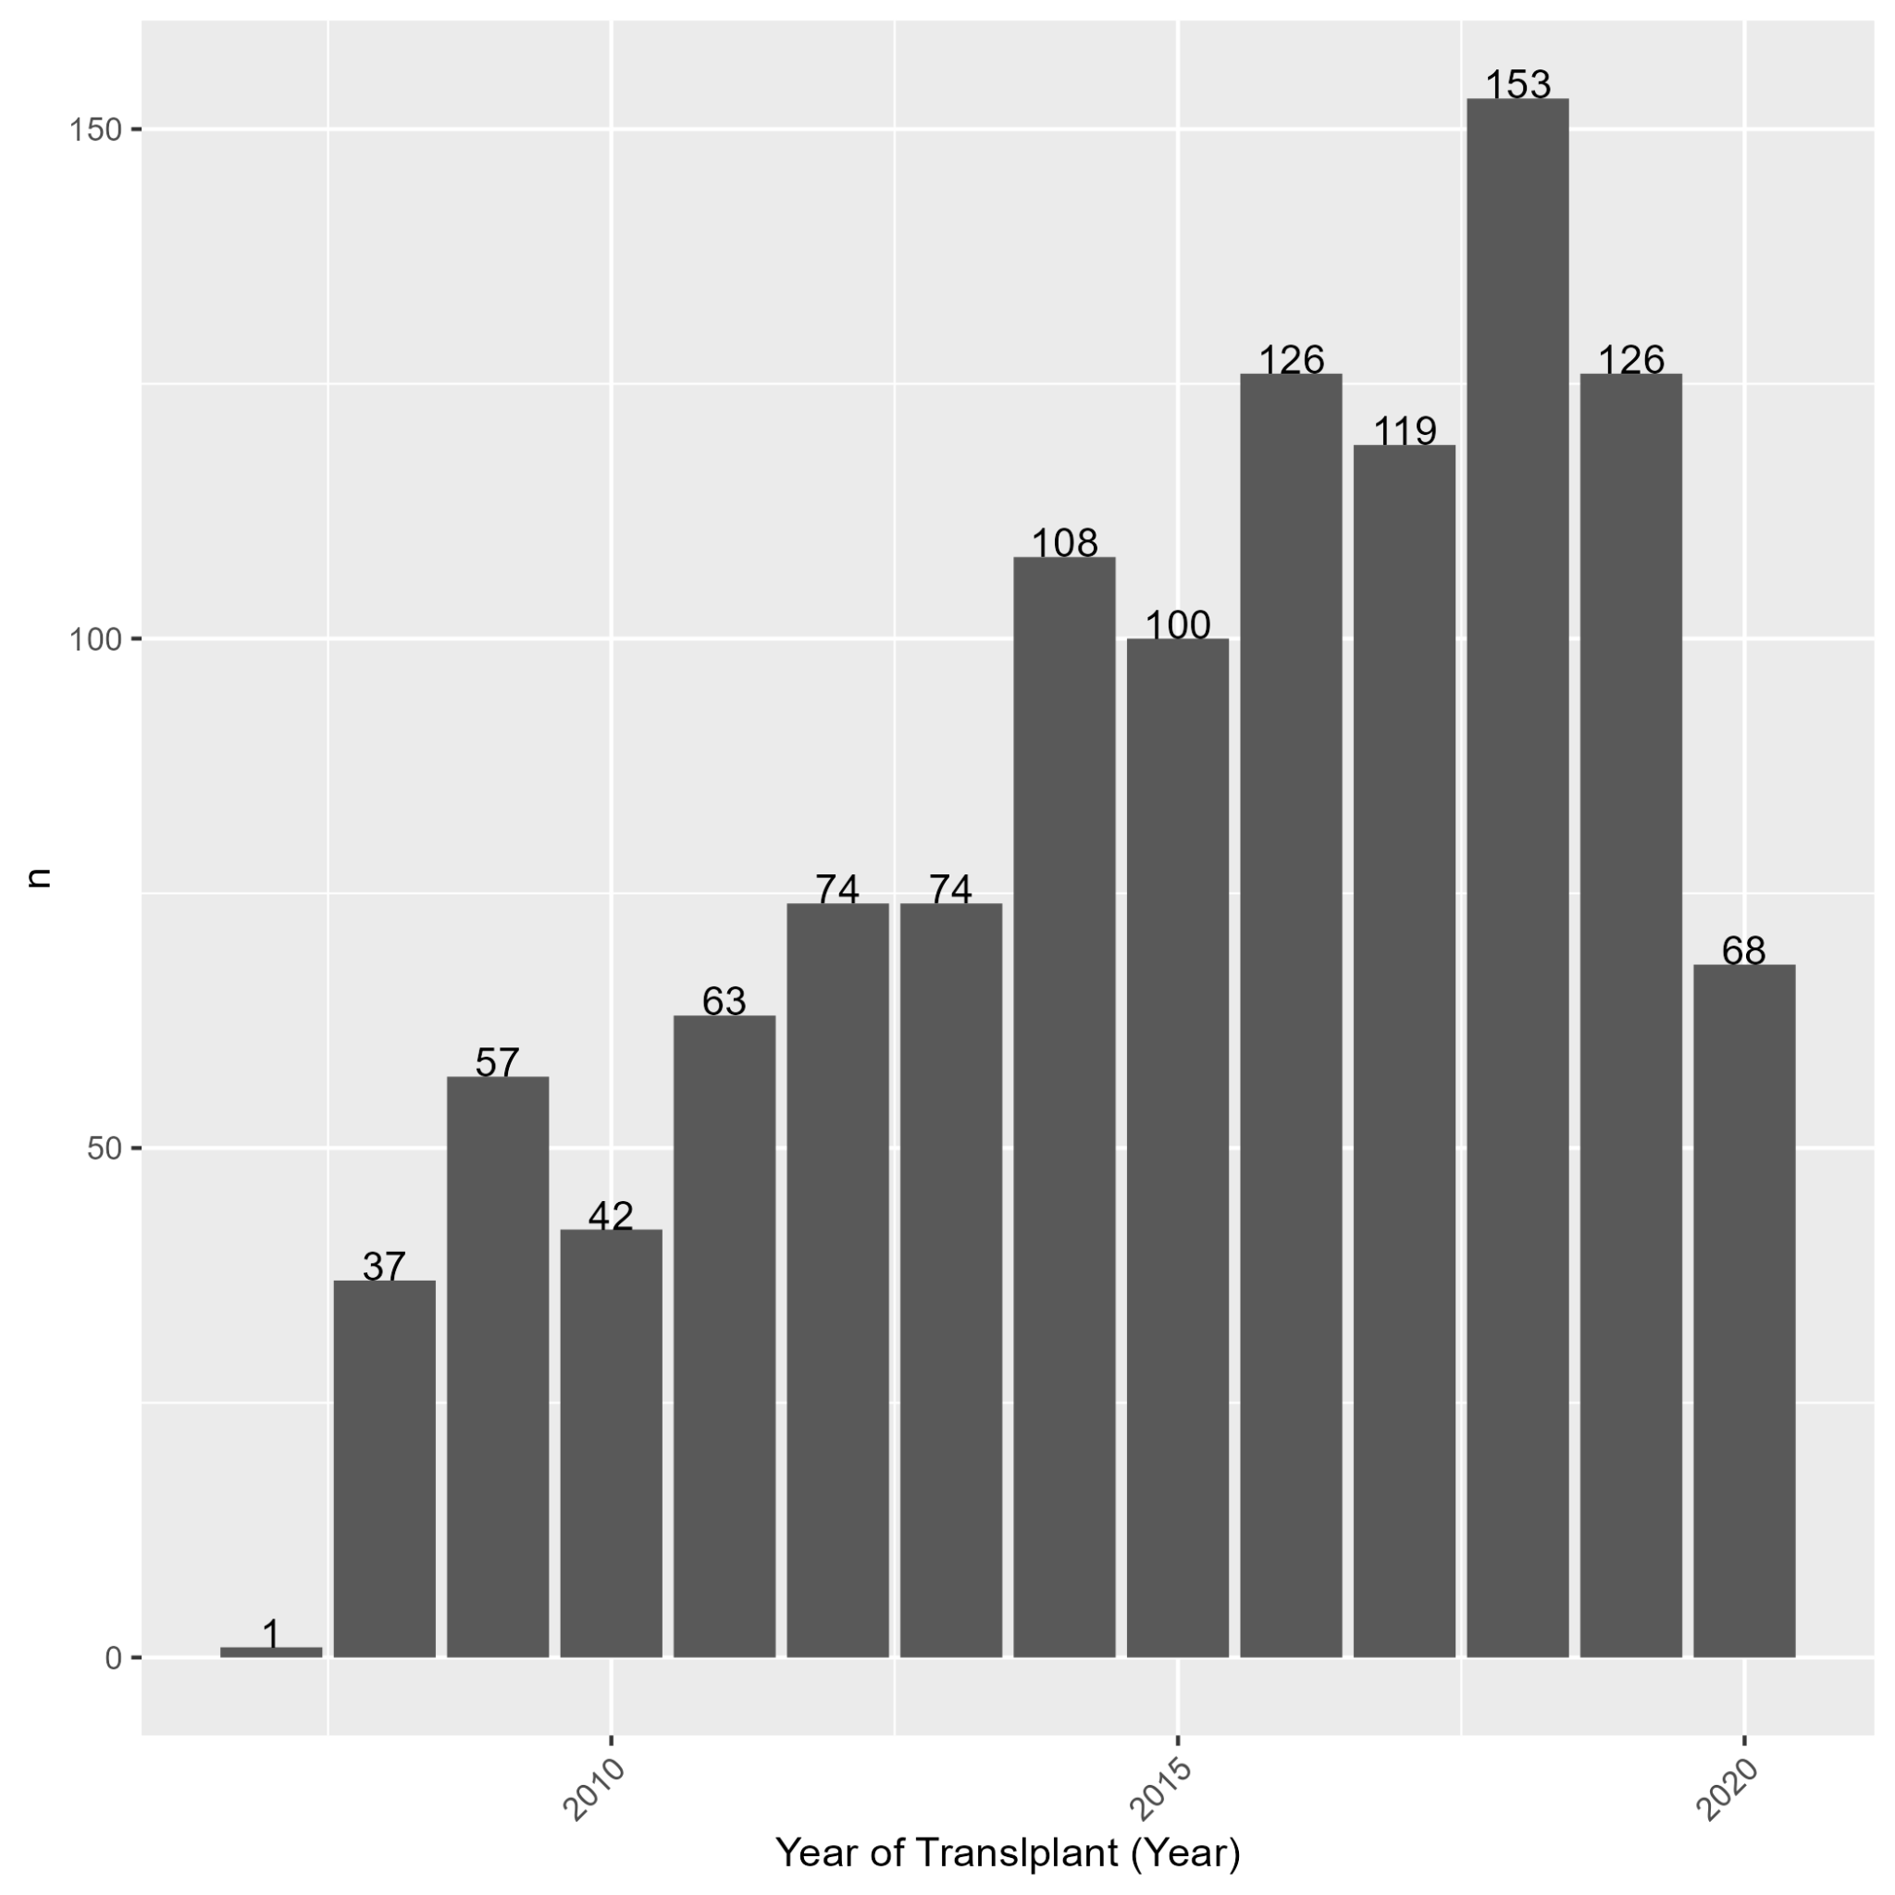

Section C:

Table 10: Coefficient Estimations in the Cox Hazard Model of Second Malignancy

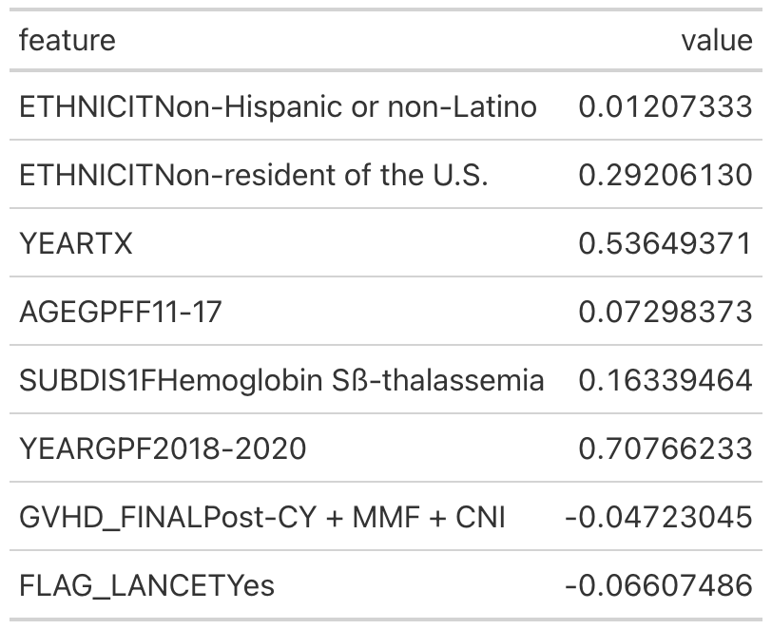

Table 11: Coefficient Estimations in the Cox Hazard Model of Platelet Recovery

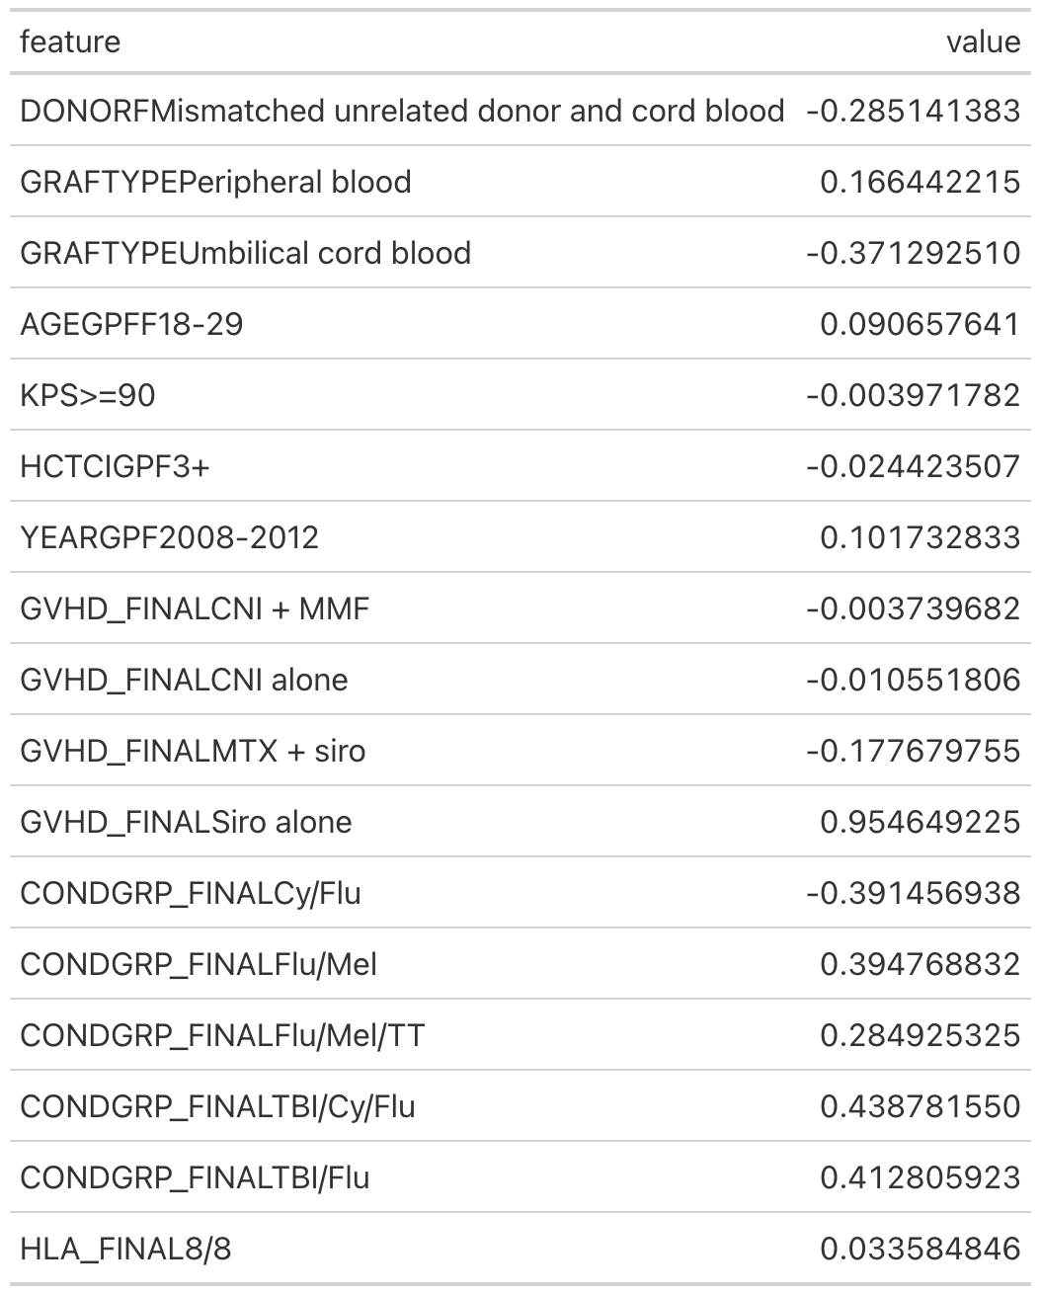

Table 12: Coefficient Estimations in the Cox Hazard Model of Graft Failure

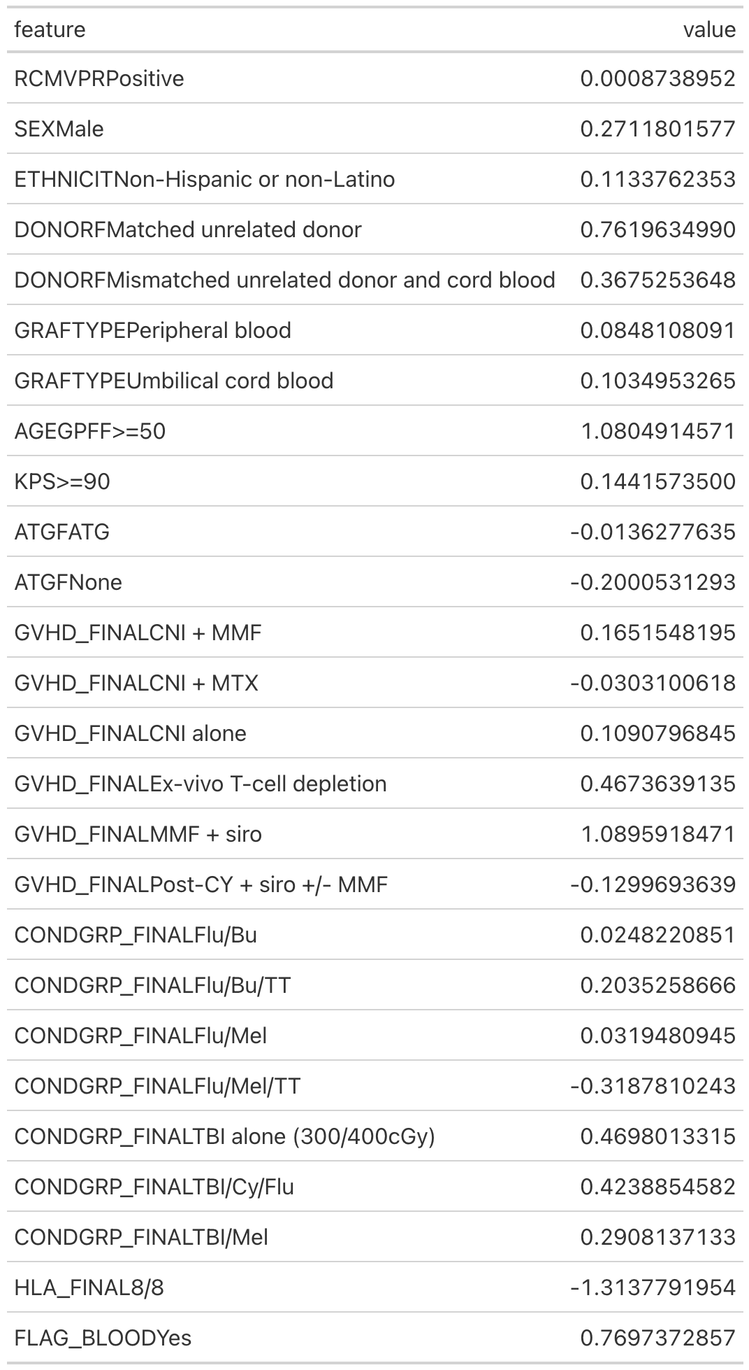

Table 13: Coefficient Estimations in the Cox Hazard Model of PTLD

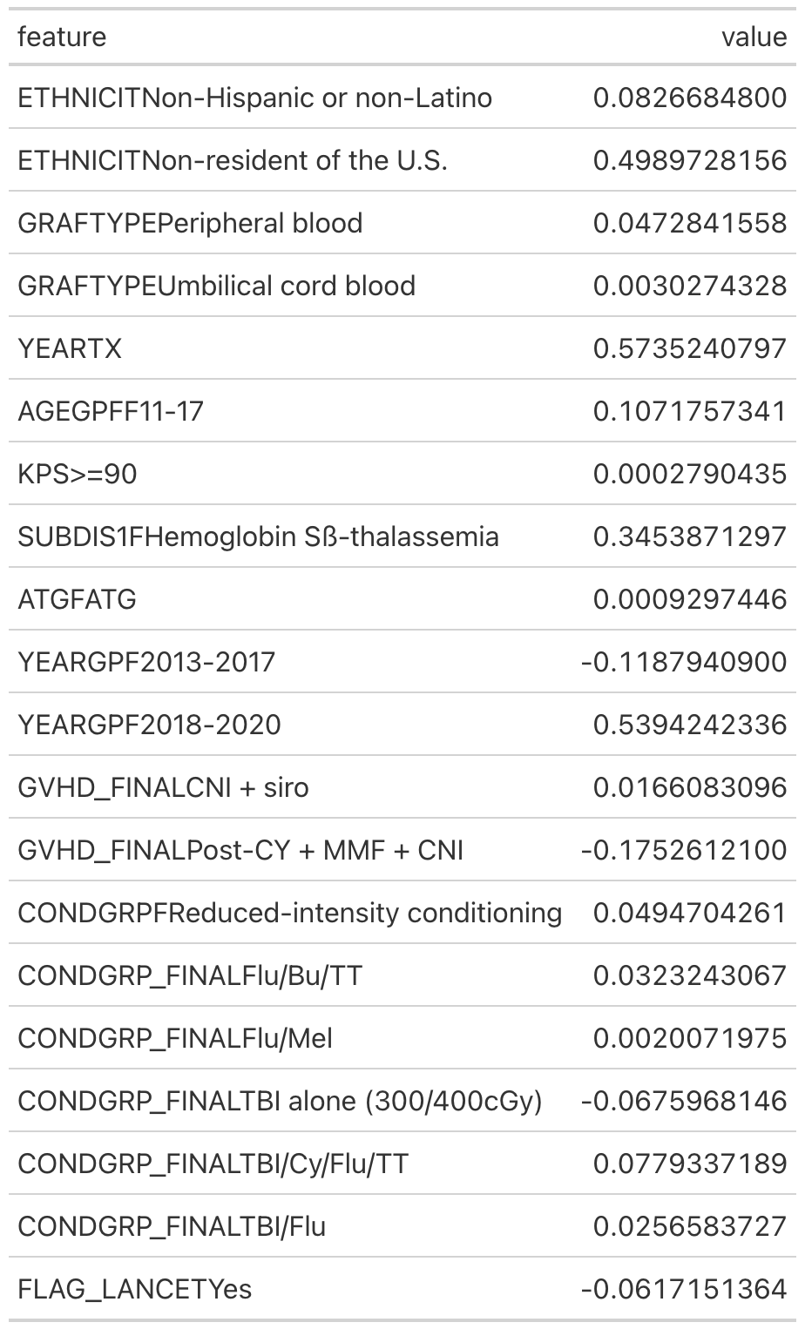

Table 14: Coefficient Estimations in the Cox Hazard Model of Death or Last Contact

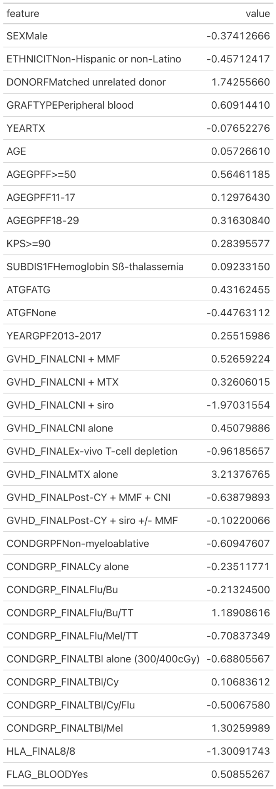

Table 15: Coefficient Estimations in the Cox Hazard Model of Chronic GVHD

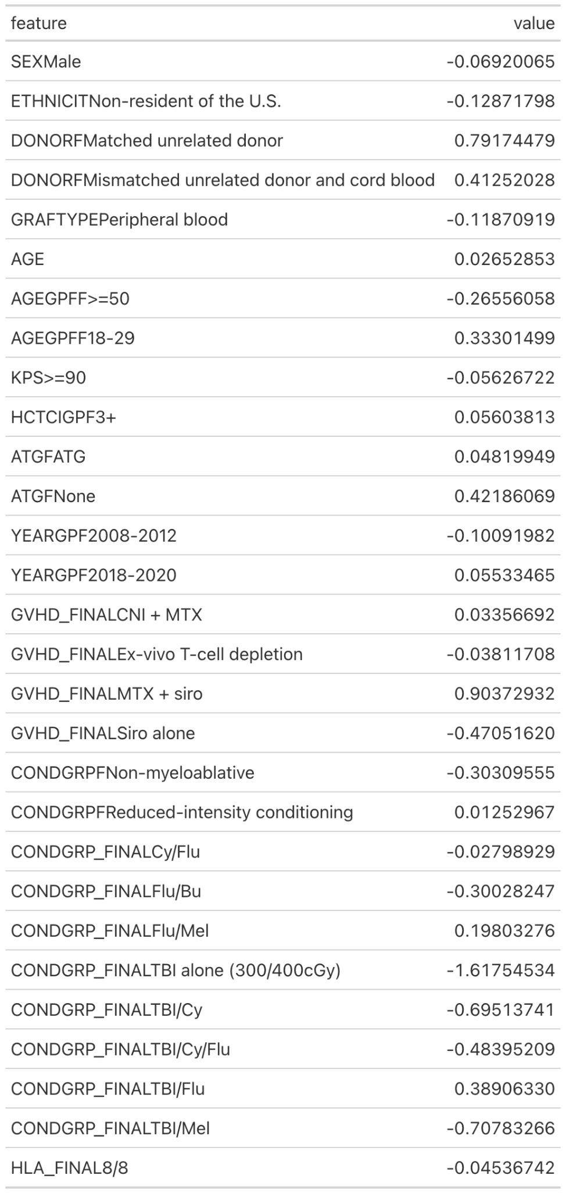

Table 16: Coefficient Estimations in the Cox Hazard Model of Neutrophil Recovery

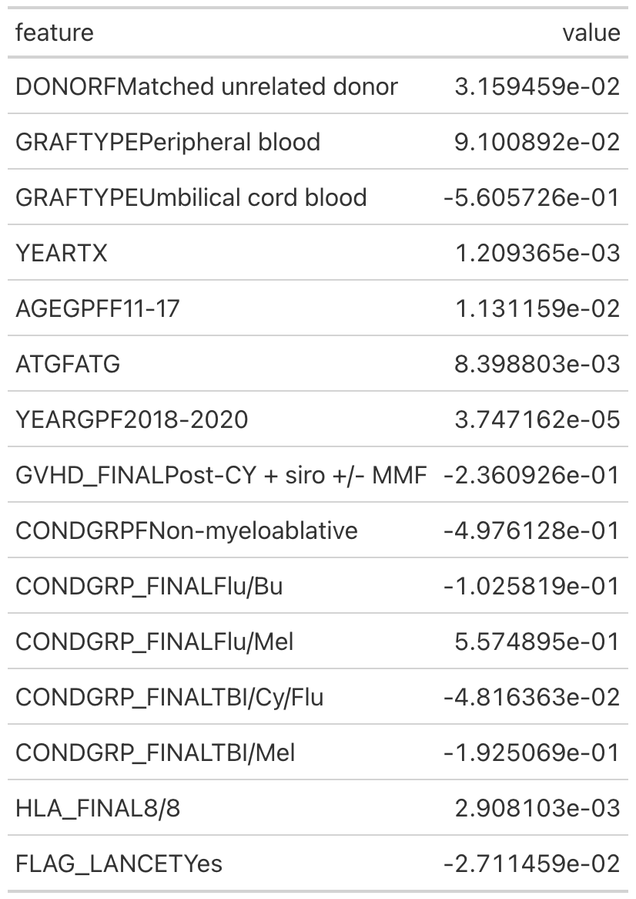

Table 17: Coefficient Estimations in the Cox Hazard Model of Acute GVHD

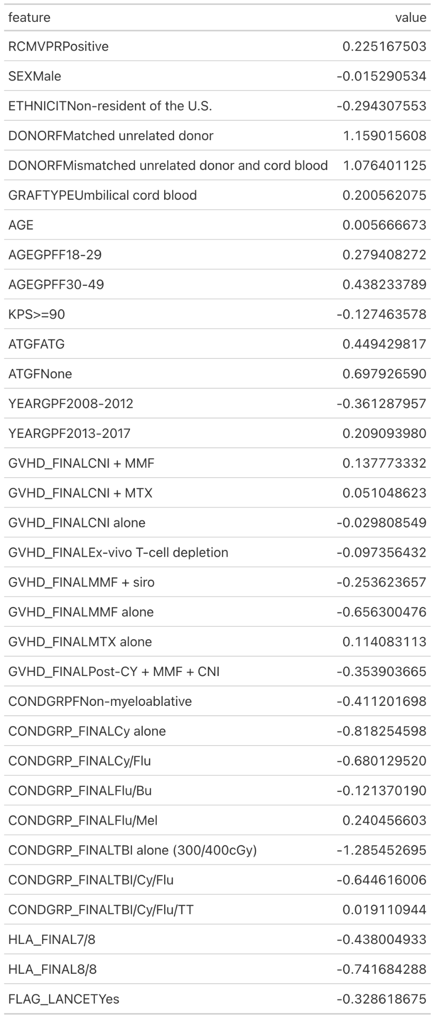

Section D:

Illustration A

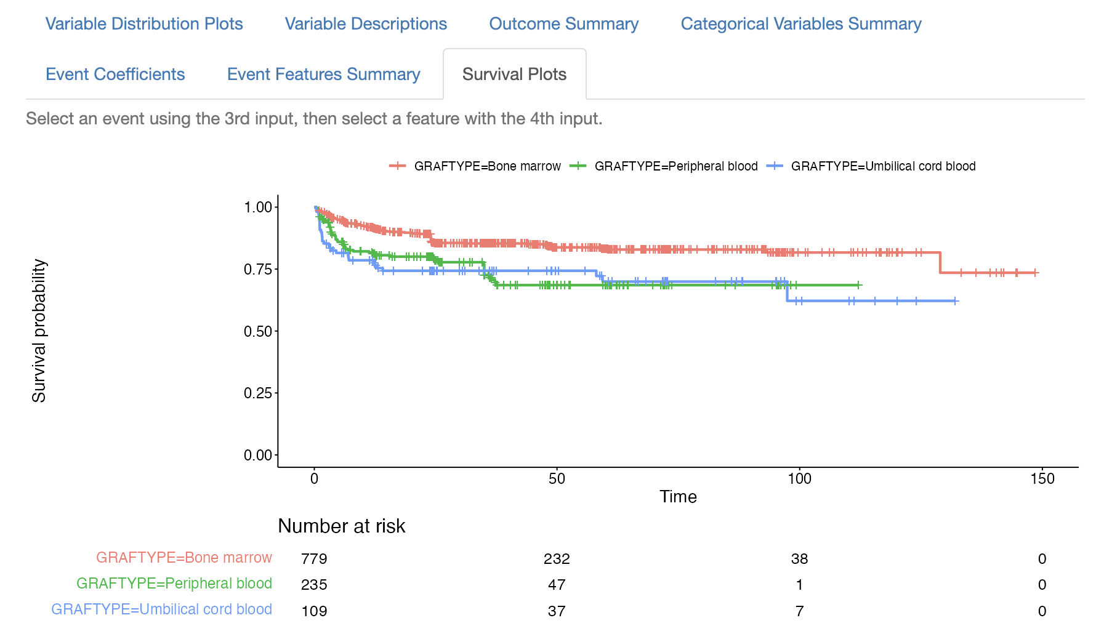

**References**

Centers for Disease Control and Prevention. (2023a, July 6). Data & statistics on Sickle Cell Disease. Centers for Disease Control and Prevention. https://www.cdc.gov/ncbddd/sicklecell/data.html

Centers for Disease Control and Prevention. (2023b, July 6). What is sickle cell disease?. Centers for Disease Control and Prevention. https://www.cdc.gov/ncbddd/sicklecell/facts.html

Chen, D.-P., Wen, Y.-H., Wang, P.-N., Hour, A.-L., Lin, W.-T., Hsu, F.-P., & Wang, W.-T. (2021). The adverse events of haematopoietic stem cell transplantation are associated with gene polymorphism within human leukocyte antigen region. Scientific Reports, 11(1). https://doi.org/10.1038/s41598-020-79369-w

Sickle cell disease – outcomes & advances. bethematchclinical.org. (n.d.). https://bethematchclinical.org/transplant-indications-and-outcomes/disease-specific-indications-and-outcomes/sickle-cell-disease/

St. Martin, A., Hebert, K. M., Serret-Larmande, A., Jouhet, V., Hughes, E., Stedman, J., DeSain, T., Pillion, D., Lyons, J. C., Steinert, P., Avillach, P., & Eapen, M. (2022). Long-term survival after hematopoietic cell transplant for sickle cell disease compared to the United States population. Transplantation and Cellular Therapy, 28(6). https://doi.org/10.1016/j.jtct.2022.03.014

ggplot2: Wickham, H. (2016). ggplot2: Elegant Graphics for Data Analysis. Springer-Verlag New York. ISBN: 978-3-319-24277-4

dplyr: Wickham, H., François, R., Henry, L., & Müller, K. (2021). dplyr: A Grammar of Data Manipulation. R package version 1.0.7. https://CRAN.R-project.org/package=dplyr

haven: Wickham, H., & Miller, E. (2021). haven: Import and Export 'SPSS', 'Stata' and 'SAS' Files. R package version 2.4.3. https://CRAN.R-project.org/package=haven

tidyr: Wickham, H. (2021). tidyr: Tidy Messy Data. R package version 1.1.4. https://CRAN.R-project.org/package=tidyr

readr: Wickham, H., Hester, J., & Francois, R. (2021). readr: Read Rectangular Text Data. R package version 2.1.1. https://CRAN.R-project.org/package=readr

stringr: Wickham, H. (2019). stringr: Simple, Consistent Wrappers for Common String Operations. R package version 1.4.0. https://CRAN.R-project.org/package=stringr

readxl: Wickham, H., & Bryan, J. (2021). readxl: Read Excel Files. R package version 1.3.1. https://CRAN.R-project.org/package=readxl

gt: Iannone, R., Cheng, J., & Schloerke, B. (2021). gt: Easily Create Presentation-Ready Display Tables. R package version 0.3.0. https://CRAN.R-project.org/package=gt

kableExtra: Zhu, H. (2021). kableExtra: Construct Complex Table with 'kable' and Pipe Syntax. R package version 1.3.4. https://CRAN.R-project.org/package=kableExtra

survival: Therneau, T. (2021). A Package for Survival Analysis in R. R package version 3.2-11. https://CRAN.R-project.org/package=survival

glmnet: Friedman, J., Hastie, T., & Tibshirani, R. (2010). Regularization Paths for Generalized Linear Models via Coordinate Descent. Journal of Statistical Software, 33(1), 1-22. https://www.jstatsoft.org/v33/i01/

boot: Canty, A., & Ripley, B. D. (2021). boot: Bootstrap R (S-Plus) Functions. R package version 1.3-28. https://CRAN.R-project.org/package=boot

survminer: Kassambara, A., Kosinski, M., & Biecek, P. (2021). survminer: Drawing Survival Curves using 'ggplot2'. R package version 0.4.9. https://CRAN.R-project.org/package=survminer

knitr: Xie, Y. (2021). knitr: A General-Purpose Package for Dynamic Report Generation in R. R package version 1.33. https://CRAN.R-project.org/package=knitr

gtExtras: Merlino, D. & Rich, J. (2021). gtExtras: Additional Functions for Table Formatting with the gt Package. GitHub repository. https://jthomasmock.github.io/gtExtras/

purrr: Wickham H, Henry L (2023). purrr: Functional Programming Tools. R package version 1.0.2. https://CRAN.R-project.org/package=purrr

randomcoloR: Ammar R (2019). randomcoloR: Generate Attractive Random Colors. R package version 1.1.0.1. https://CRAN.R-project.org/package=randomcoloR

Shiny: Chang, W., Cheng, J., Allaire, J.J., Xie, Y., & McPherson, J. (2021). shiny: Web Application Framework for R. R package version 1.7.1. https://CRAN.R-project.org/package=shiny